TESTING THE REGRESSION MODEL

Introduction

As it was explained in the previous section, regression analysis aims to find the line that provides the best approximation for the relationship between the dependent and the independent variable. This line (whether straight or curved) is fitted on the data in such a way so that the sum of the squared distances between the actual data values and the predicted values of the dependent variable is minimised.

Once a regression model has been developed it should then be tested. In other words, the forecaster should test how well the model has fitted the data. A regression model which has given a good fit is expected to produce accurate forecasts, at least within the given range of values of the independent variable.

This section introduces a number of graphical and statistical tests which can be used to test the regression model.

When you have worked through this section, you should be able to:

- Produce graphs of residuals and interpret them.
- Compute and interpret the values of the standard error of the estimate and the coefficient of determination.
- Become familiar with the basic concepts of hypothesis testing.
- Test a hypothesis using appropriate statistical tests.

Residual analysis using graphical means

When a prediction is made using a regression model, there is normally an error associated with that prediction. The error of the prediction is the difference between the actual data value and the predicted value of the dependent variable for a particular observation. This difference is also known as residual.

Regression analysis assumes that the residuals are normally distributed. To test this assumption graphically we simply need to plot the residuals against the values of the predictor. If the resulting graph does not show any pattern, then there is evidence that the above condition has been satisfied. If, on the other hand, a pattern can be seen in the residuals, then we should consider changing the degree of the regression equation or adding more predictors to the regression model.

Consider the following two graphs. In the first graph the residuals are randomly distributed. In the second graph, on the other hand, the residuals have a pattern, which suggests that a non-linear or a multiple regression model should be considered.

Graph 3.1 Residual plot 1
Graph 3.2 Residual plot 2
Other types of graphical residual analysis include plotting the residuals against the predicted values of the response variable and plotting the actual values of the response variable against its predicted values. Graphical analysis of the residuals is generally thought to be an excellent diagnostic tool and may lead to suggestions of structure or point to information in the data that might be missed or overlooked if only basic summary statistics were evaluated.

Residual analysis using statistical means

Another type of residual analysis is through the use of the standard error of the estimate (Se). Se is a measure of the spread of actual data about the fitted line in the Y direction and it is analogous to the standard deviation of a sample of data.

In other words, Se measures the amount by which the actual values of Y differ from the estimated values of Y. For relatively large samples, we would expect about 67% of the differences to be within one Se of zero and about 95% of these differences to be within two Se of zero. Se can therefore be thought of as a single measurement of the regression error.

If the predicted values of the dependent variable produced by the regression model are the same as the actual values of that variable for all the observations, then Se will be zero. However, since this rarely occurs in practice, the lower the value of Se the more accurate the forecasts produced by the regression model.

A small value of Se means that all the data points lie very close to the fitted regression line. If, on the other hand, the value of Se is large, this indicates that the data points are widely dispersed around the fitted line.

A residual can be thought of as the vertical distance from the regression line to a data point. This means that since the vertical distances from the regression line to the data points cancel each other (i.e. positive residuals and negative residuals cancel out when added together), the sum of the residuals will always be near zero. To avoid the problem of having an Se value of zero, this estimate should be calculated using the squares of the residuals rather than the residuals themselves.

Summing the squares of the residuals produces the sum of squares of error (SSE) for the regression model. This is shown in relation 3.1.

SSE = ∑(Y-PredictedY)² (3.1)

The value of Se can then be calculated as follows:

Se = √[SSE/(n-k)] (3.2)

where:

n is the number of observations
k is the number of variables in the model (including the response variable)

The goodness of fit of the regression line

The goodness of fit of a regression line is measured by the coefficient of determination (r²). The coefficient of determination measures the proportion of variability of the dependent variable that is accounted for or explained by the regression line. In linear regression, the coefficient of determination is the square of the correlation coefficient (this however does not apply to non-linear regression).

If, for example, correlation analysis has produced a correlation coefficient value of
-0.73 (indicating some negative linear relationship between the two variables), the resulting value of the coefficient of determination relating to a linear regression model will be 0.5329. This means that 53.29% of the variation in the dependent variable can be explained by the fitted equation. The remaining 46.71% of the variation is caused by unexplained factors.

Hypothesis testing

A regression model is always based on sample data. In the case of the advertising cost example discussed in the previous section, a linear regression model was developed based on a random sample of 10 data values. The sample regression line was an estimate of the population regression line based on that sample. Other random samples of 10 data values would produce different fitted regression lines.

Hypothesis testing examines whether the relationship between X and Y holds for all choices of X&Y pairs. In other words, we are based on the sample evidence to examine whether a true relation holds for all X and Y.

As we have seen in the previous section, a simple linear regression model for a sample of data has the form Predicted Y = b₀ + b₁X, where b₀ and b₁ are the intercept and the slope of the sample regression line. A linear regression model for the entire population, on the other hand, would have the form Predicted Y = β₀ + β₁X, where β₀ and β₁ are the intercept and the slope of the population regression line.

In hypothesis testing we need to form a hypothesis (the null hypothesis) using our sample data. The null hypothesis (denoted by H₀) will be that the slope of the population regression line β₁ is equal to zero, indicating that there is no relation between X and Y in the population. This is because if the slope of the regression line is equal to zero, the predicted value of Y will be the same regardless of the value of X (i.e. the value of X will not be predicting the value of Y). In that case the regression line will be a horizontal line starting from the value of the intercept.

The alternative hypothesis (denoted by H₁ or H_{a}) will be that the slope of the population regression line β₁ is significantly different from zero, indicating that there is a relation between X and Y in the population.

The two hypotheses can therefore be expressed as follows:

H₀ : β₁ = 0
H₁ : β₁ <> 0

In hypothesis testing two outcomes are possible: we either have enough evidence to reject the null hypothesis or not. Rejecting the null hypothesis means that a relation between X and Y in the population exists. Failing to reject the null hypothesis means that, in spite of the fact that the sample has produced a fitted line with a non-zero value for b₁, we must conclude that there is not sufficient evidence to indicate Y is related to X.

The above hypothesis can be tested using a t test or an F test. These are two relevant tests which can indicate whether there is a true relation between X and Y. Both these tests are part of the regression output produced by Excel. As an example consider the following regression output which corresponds to a linear regression model developed for the advertising cost example that was introduced in the previous section (the last part of this section explains how this output is produced in Excel).

Table 3.1 Regression output for advertising cost data

SUMMARY OUTPUT
Regression Statistics
Multiple R | 0.948187931
R Square | 0.899060352
Adjusted R Square | 0.886442896
Standard Error | 2.73880952
Observations | 10
ANOVA
 | Df | SS | MS | F | Significance F
Regression | 1 | 534.4913793 | 534.4913793 | 71.25527941 | 2.96101E-05
Residual | 8 | 60.00862069 | 7.501077586
Total | 9 | 594.5
 | Coefficients | Standard Error | t Stat | P-value
Intercept | 8.327586207 | 2.211025401 | 3.766391016 | 0.005493904
X Variable 1 | 2.146551724 | 0.25429208 | 8.441284228 | 2.96101E-05
 | Lower 95% | Upper 95% | Lower 95.0% | Upper 95.0%
Intercept | 3.228949192 | 13.42622322 | 3.228949192 | 13.42622322
X Variable 1 | 1.560152757 | 2.732950691 | 1.560152757 | 2.732950691

The above regression output provides us with all the information we need in order to assess the suitability of the regression model. This output gives the values of β₀ (8.33) and β₁ (2.15), and a range of other useful statistics including the correlation coefficient (r=0.95), the coefficient of determination (r²=0.90) and the standard error of the estimate (Se = 2.74).

The regression output has also produced the values of the t and F statistics (t=8.44, F=71.25). These values will now be used to test the null hypothesis that β₁=0.

The t value from the regression output has been found to be 8.44 (note that we use the value associated with the X variable and not with the intercept). This value needs to be compared to the critical value taken from the t distribution table. A critical value is the point which separates the rejection region of the distribution (the area where we reject the null hypothesis) from the non-rejection region (the area where we do not reject the null hypothesis). If the absolute value of t is larger than the critical value, then there is enough evidence to reject the null hypothesis and to conclude that Y is related to X.

A copy of the t distribution table is given in Appendix 1. The number of the degrees of freedom (df) in the t distribution table is equal to the degrees of freedom associated with the sum of squares due to error (residual). This value has been found to be 8, which for a significance level of 5% corresponds to the value of 2.306 on the t distribution table. This is the critical value in the t distribution.

The critical values given in the t distribution table have been given at five different levels of significance. The significance level (denoted by α) shows the probability of rejecting a true null hypothesis (i.e. rejecting the null hypothesis where we shouldn’t be rejecting it). In this case we take the significance level to be 5% (which is the percentage normally used) and we split it into two, so that 2.5% (or 0.025) is taken in each tail of the distribution (this is the reason why the column associated with 0.025 was chosen). That 5% corresponds to the rejection region of the distribution.

As the value of t (8.44) is greater than the critical value in the t distribution (2.306), we have enough evidence to reject the null hypothesis and conclude that Y is related to X. We can then say that the test has shown with 95% confidence (i.e. 100-α) that Y is related to X.

The same outcome will be obtained if an F test is used. The F value has been found to be 71.25. This value needs to be compared to the critical value taken from the F distribution table. If the value of F is larger than the critical value in the F distribution, then there is enough evidence to reject the null hypothesis and to conclude that Y is related to X.

A copy of the F distribution table is given in Appendix 2. In that table, the number of the numerator degrees of freedom (the columns of the table) is equal to the degrees of freedom associated with the sum of squares due to regression. The number of the denominator degrees of freedom (the rows of the table) is equal to the degrees of freedom associated with the sum of squares due to error (residual). The regression output has given the number of degrees of freedom due to regression to be 1 and the number of degrees of freedom due to residual to be 8.

If we use a significance level of 5% (which was the one used in the t test), then the critical value in the distribution will be 5.32 (this is the value at the intersection of the first column and the eighth row). Note that in this case we can choose a significance level of 5% or 1% depending on what percentage we want to take as the probability of rejecting a true null hypothesis.

As the value of F (71.25) is greater than the critical value in the F distribution (5.32), we have enough evidence to reject the null hypothesis and conclude that Y is related to X. We can then say that the test has shown with 95% confidence (i.e. 100-α) that Y is related to X.

We can notice that, ignoring rounding error, F = t². Moreover, for a given significance level (5% in this case) and ignoring rounding error, the critical value from the F distribution equals the critical value from the t distribution squared. This indicates that, for a given significance level, the F test rejects the null hypothesis whenever the t test does and vice versa.

EXCEL APPLICATIONS

To produce the complete regression output:

- Click on Tools.
- Click on Data Analysis.
- Click on Regression.
- Click inside the Input Y Range box and then select the values of the Y variable (not the heading).
- Click inside the Input X Range box and then select the values of the X variable (not the heading).
- Click on the Output Range and then click inside the Output Range box and enter the location where the regression output will appear (make sure that there is enough empty space to take all the output).
- Click on Residual Plots.
- Click on OK.

In some cases, the Data Analysis option is not available in the Tools menu. If this happens, make sure that you haven't clicked on any of the graphs in your spreadsheet, then go to Tools, click on Add-Ins and make sure that the Analysis ToolPak has been ticked. The Data Analysis option should then be available to use.

PROBLEMS

Problem 1

Refer to the fast food data given in the previous section and re-printed here.

Competitors Sales
1 3600
1 3300
2 3100
3 2900
3 2700
5 2300
5 2000
6 1800

Use Excel to develop a linear regression model to relate sales to the number of competitors. Then produce a graph of the residuals and comment on it. Finally, interpret the values of r² and Se produced by Excel and use a t test and an F test to test the hypothesis that β₁=0. All your results must be clearly interpreted.

Problem 2

The following data shows the number of cinema admissions over a period of thirteen years.
Year Cinema admissions (millions)
1 104.23
2 106.18
3 116.45
4 108.25
5 111.67
6 126.82
7 127.42
8 122.19
9 125.54
10 131.76
11 134.34
12 129.10
13 128.56

Use Excel to develop a linear regression model that could be used to predict the number of cinema admissions. Then produce and clearly interpret the graph of the residuals, interpret the values of r² and Se and use a t test and an F test to test the hypothesis that β₁=0. All your results must be clearly interpreted.

APPENDIX 1: THE t DISTRIBUTION TABLE
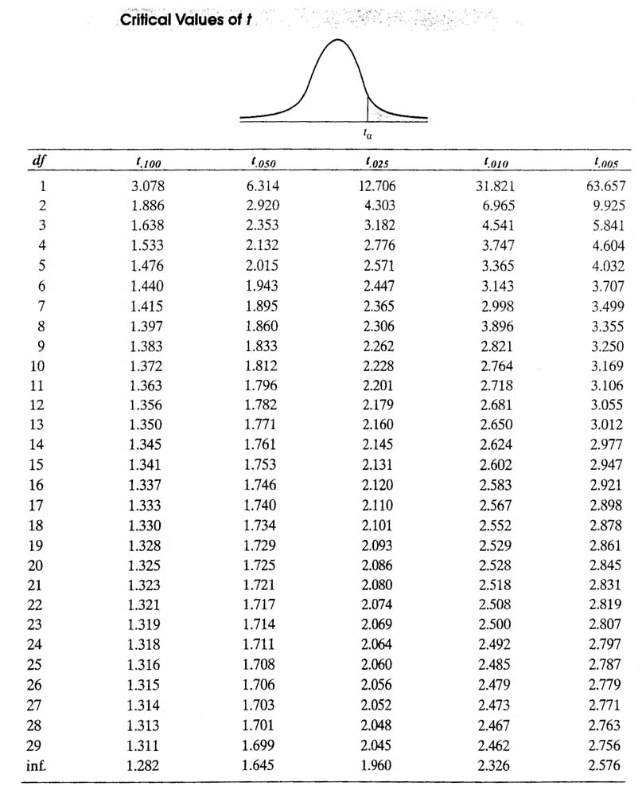

Source: Hanke et al (2001) Business Forecasting, Prentice Hall.
APPENDIX 2: THE F DISTRIBUTION TABLE

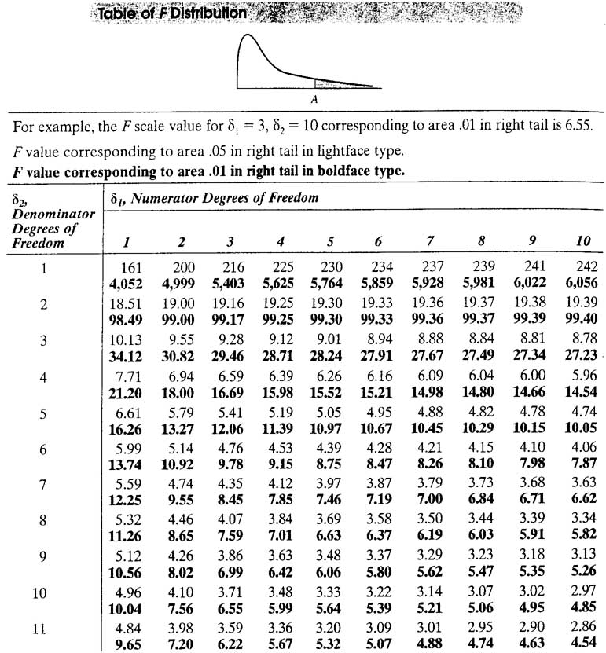

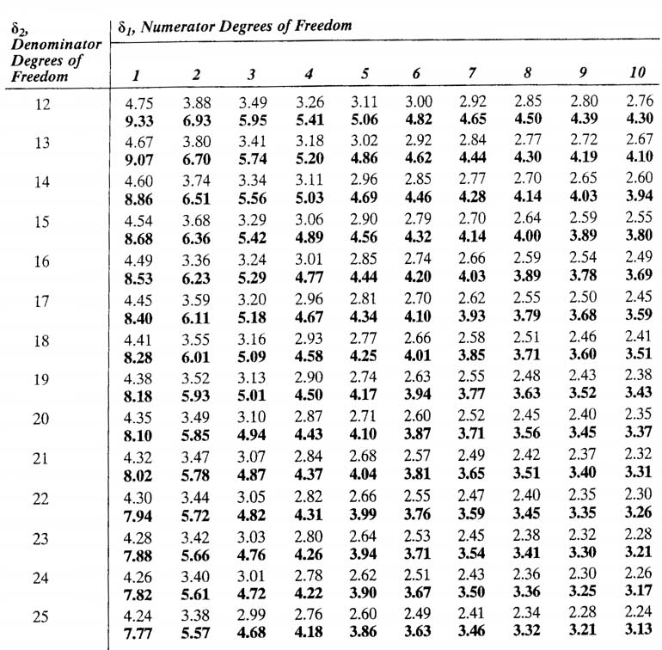

Source: Hanke et al (2001) Business Forecasting, Prentice Hall.

