CHAPTER 5 – EFFICIENCY AND EQUITY

I. Efficiency: A Refresher

- The use of resources is efficient (αποδοτική) when the most highly valued goods and services are produced. Efficiency is based on values, which are determined by people’s preferences. This means that we are prepared to pay more money for a good or service we consider more valuable.
- Marginal benefit is the additional (επιπλέον) benefit a person receives from the consumption of one additional unit of good. We can measure the marginal benefit from a good or service by the money value of other goods and services that a person is willing to give up to get one more unit of it. As more of a good is consumed, its marginal benefit decreases.
- Marginal cost is the opportunity cost of producing one more unit. As more of a good is consumed, its marginal cost increases (because its opportunity cost increases – you should remember that from Chapter 2).
- The efficient level of output is the quantity at which the marginal benefit equals the marginal cost. If the marginal benefit from a good is higher than its marginal cost, resources are used more efficiently by producing more of the good. If the marginal cost of a good is higher than its marginal benefit, resources are used more efficiently by producing less of the good.

II. Value, Price and Consumer Surplus

- The value of one more unit of a good or service is its marginal benefit. Marginal benefit is the maximum price that someone is willing to pay for another unit.
- The demand curve for a product shows the quantity demanded at each price; a demand curve also shows the maximum price that consumers are willing to pay at each quantity. The demand curve is the same as its marginal benefit curve because the demand curve shows the maximum price someone is willing to pay for another unit of the product.
- The value of a good can be different from the good’s price. Consumer surplus is the value of a good minus the price paid for it. Because the demand curve shows the marginal benefit or value for each unit of a good, consumer surplus is the area under the demand curve (the value) and above the market price. The consumer surplus is the area under the demand curve and above the market price (Figure 1).

III. Cost, Price and Producer Surplus

- Cost is what the producer pays to produce the good; price is what the producer receives when the good is sold. The opportunity cost of producing another unit of a good is its marginal cost and the minimum price that producers must receive in order to produce the good is at least equal to the marginal cost.
- The supply curve is the same as the marginal cost curve because the supply curve shows the minimum price that suppliers must receive in order to produce that unit of the good.
- If a firm sells for more than it costs to produce it, the firm receives a producer surplus. Producer surplus is the price of the good minus the opportunity cost of producing it. Because the supply curve is the marginal cost curve, producer surplus is the area under the market price and above the supply curve. Figure 2 shows a producers surplus.

IV. Is the Consumer Market Efficient?

- A competitive market is efficient. The equilibrium quantity is determined by the supply and demand for the product. In Figure 3, the price is €3 and the quantity produced 30 units determined by the demand and supply curves. The efficient quantity is the same as equilibrium quantity because that is the quantity at which the marginal benefit equals the marginal cost. In Figure 3, efficient quantity is 30 units determined by the marginal benefit and marginal cost curves. The sum of consumer surplus plus producer surplus is maximized at the efficient level of output.
- Adam Smith’s “invisible hand” idea in the Wealth of Nations concluded that competitive markets send resources to where they have the highest value; that is, competitive markets are efficient.
- Markets may not always be efficient. There are five major obstacles (εμπόδια) that can lead to inefficiency in which the market overproduces (produces too much) or underproduces (produces too little):
- Price ceilings and price floors. Government regulations that set the highest legal price to charge (price ceiling) or the lowest legal price to charge (price floor) can result in underproduction or overproduction because they prevent the market to reach its free equilibrium price and quantity.
- Taxes, subsidies and quotas. Taxes increase the price paid by buyers and lower the price received by sellers. Subsidies (επιδοτήσεις) decrease the price paid by buyers and raise the price received by sellers. Quotas directly limit production. Taxes and quotas can result in underproduction; subsidies in overproduction.
- Monopoly. A monopoly is a firm that has sole control of a market. A monopoly decreases the output it produces in order to raise its price and increase its profit. Monopolies result in underproduction.
- Public goods. A public good is a good or service that is consumed simultaneously by everyone, even if they did not pay for it. Public goods result in underproduction because people are not willing to pay for the product.
- External costs and external benefits. An external cost is a cost imposed on someone other than the producer of the product; an external benefit is a benefit enjoyed not by the buyer of a good but by others. External costs can result in overproduction and external benefits in underproduction.
- Inefficiency, either in the form of underproduction or overproduction, creates a deadweight loss. Deadweight loss is the decrease in consumer surplus and producer surplus that results from an inefficient level of production. Deadweight loss is a loss to everyone in society. It is not something that the producer gains at the expense of the consumer or the consumer gains at the expense of the producer. In Figure 4 below, the deadweight loss triangles from underproduction (producing 20 units rather than 30) and overproduction (producing 40 units rather than 30), limit consumer and producer surplus. In other words, consumer and producer surplus are no longer maximized.

QUESTIONS

True/False

- Resource use is efficient when the goods with the lowest opportunity cost are produced.
- As more of a product is consumed, its marginal benefit decreases.
- The marginal cost of the one millionth pizza is the total cost of producing all million pizzas.
- If the marginal benefit from a good is greater than its marginal cost, resources are used more efficiently if less of the good is produced.
- Resource efficiency requires that the marginal benefit of a good equal its marginal cost.
- The price of a product always equals its value.
- The demand curve for hamburgers shows the maximum someone is willing to pay for the ten millionth hamburger.
- Consumer surplus equals the area above the demand curve and below the market price.
- Cost and price are the same thing.
- The supply curve and the marginal benefit curve are the same.
- Producer surplus equals the price of the good minus the opportunity cost of producing the unit.
- A competitive market is always efficient.
- When producing the efficient quantity of a good, the sum of consumer surplus plus producer surplus is as large as possible.
- Deadweight loss is the loss of consumer surplus and/or producer surplus.

Multiple choice

- In general, resources are used efficiently when the
a. opportunity cost of the goods being produced is as low as possible.
b. marginal benefit from a good exceeds its marginal cost by as much as
possible.
c. goods produced are those valued most highly.
d. None of the above.

- Helen is eating two slices of pizza. Which of the following statements is necessarily true?
  - Helen’s marginal benefit from the second slice of pizza is equal to the sum of the benefit she gets from the first slice plus her benefit from the second slice.
  - Helen’s marginal benefit from the second slice of pizza equals the maximum she is willing to pay for the second slice.
  - Helen has no consumer surplus from the second slice of pizza.
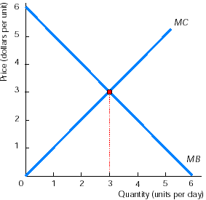
  - Helen has some consumer surplus from the second slice of pizza.

- What is the efficient amount of output in the graph on the right?
  - 0 units, where MB exceeds MC by as much as possible.
  - 3 units, where MB equals MC.
  - 6 units, where MC exceeds MB by as much as possible.
  - None of the above.

    - Which of the following statements is FALSE?
      - The value of one more unit of a good is the good’s marginal benefit.
      - A good’s marginal benefit is the maximum price people are willing to pay for another unit.
      - The maximum price people are willing to pay for one more unit of a good is its value.
      - All the above statements are true.
1
- The marginal benefit curve for a product is the same as the good’s
a. marginal cost curve.
b. supply curve.
c. demand curve.
d. consumer surplus curve.

- Helen is willing to pay €3 for the second slice of pizza she eats. The price she actually pays is €2. Helen’s consumer surplus for this slice of pizza equals
a. €3.
b. €2.
c. €1.50.
d. €1.
1

- Because of decreasing marginal benefit, the consumer surplus from the first unit of a good is …….. the consumer surplus from the second unit.
a. greater than
b. equal to
c. less than
d. not comparable to

- The cost of producing one more unit of a good is the good’s
a. price.
b. marginal benefit.
c. marginal cost.
d. producer surplus.
1
- The supply curve shows the
  - minimum price suppliers must receive in order to produce another unit of the good.
  - maximum price suppliers must receive in order to produce another unit of the good.
  - amount of producer surplus suppliers receive.
  - profit that suppliers receive from producing another unit of the good.

- The producer surplus from a good is equal to the
  - maximum amount a consumer is willing to pay for the good minus the price that actually must be paid.
  - actual price of the good minus the maximum amount a consumer is willing to pay for the good.
  - opportunity cost of producing the good minus its price.
  - price of the good minus its opportunity cost of production.

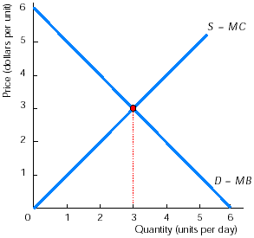
The graph on the right shows a perfectly competitive market without any external costs, external benefits, taxes, subsidies, quotas, price ceilings, or price floors. Use this graph for the next two questions.

- The equilibrium quantity produced equals
a. 0 units.
b. 3 units.
c. 6 units.
d. None of the above.

- The efficient quantity equals
a. 0 units.
b. 3 units.
c. 6 units.
d. None of the above.

Use the graph below for the next four questions.

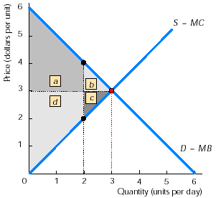

- When production is 3 units with a price of $3, consumer surplus in the market illustrated in the graph above equals
a. area a.
b. area b.
c. area a + b.
d. area a + d.

- When production is 3 units with a price of $3, producer surplus in this market equals
a. area a + b.
b. area c.
c. area c + d.
d. area a + c.

- If the quantity is restricted to 2, then the deadweight loss equals
a. area c.
b. area c +d.
c. area a +b.
d. area b + c.
- How do you compare the sum of the consumer surplus and producer surplus when 3 units are produced to the sum when 2 units are produced?
a. The sum is larger when 3 units are produced.
b. The sum is the same.
c. The sum is larger when 2 units are produced.
d. The sum cannot be compared between these two situations.

Short answers

Table 5.1 – Marginal benefit and marginal cost for video games
Quantity  (millions of video games) | Marginal benefit  ($/game) | Marginal cost  ($/game)
1 | 50 | 10
2 | 40 | 20
3 | 30 | 30
4 | 20 | 40
5 | 10 | 50

Table 5.2
Quantity  (millions of video games) | Marginal benefit  minus  Marginal cost
1
2
3
4
5
Figure 1
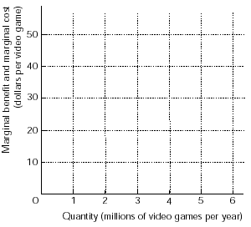
- Answer the following questions:
  - Table 5.1 presents the marginal benefit and marginal cost schedules for video games. There are no external costs or benefits. Based on Table 5.1, complete Table 5.2.
  - In Figure 1 draw the marginal benefit and marginal cost curves from Table 5.1.
  - What is the efficient number of video games to produce?
    - Answer the following questions
      - Using the data in Table 5.1, draw in Figure 1 the demand curve for video games and the supply curve for video games.
      - There are no price ceilings, price floors, taxes, subsidies, or quotas in this market. The market also is competitive, that is, it is not a monopoly. What quantity of video games will be produced?
      - Compare your answer to part (c) of problem 2 with your answer to part (c) of problem 1.

        - What is the relationship between the marginal benefit of a good, its value, and the maximum amount that a consumer is willing to pay for the good?
Figure 2
The demand for jeans
        - Answer the following questions:
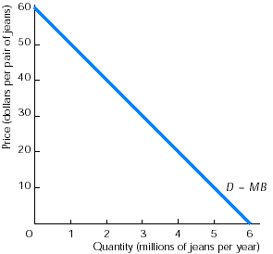
          - Figure 2 shows the market demand curve for jeans. In the figure, indicate consumer surplus if the market price is $40 for a pair of jeans. What is the amount of the consumer surplus?
          - In Figure 2, indicate the consumer surplus if the market price is $30 for a pair of jeans. What is the amount of the consumer surplus now?
          - When is the consumer surplus larger?
Figure 3
The supply of jeans

            - Answer the following questions:
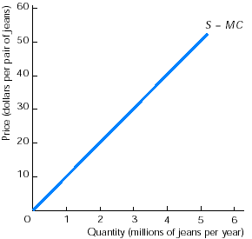
              - Figure 3 shows the market supply curve for jeans. Show the producer surplus if the market price is $40 for a pair of jeans. What is the amount of the producer surplus?
              - In Figure 3, show the producer surplus if the market price is $30 for a pair of jeans. What is the amount of the producer surplus now?
              - When is the producer surplus larger?

                - Answer the following questions:
  - Using the demand curve from Figure 2 and the supply curve from Figure 3, in Figure 4 determine the equilibrium price and quantity of jeans.
Figure 4
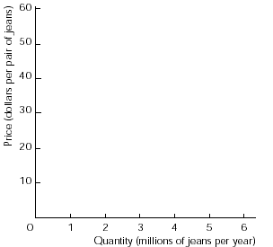
  - In Figure 4 illustrate the consumer surplus and the producer surplus. What are the amounts of consumer surplus and producer surplus? What are the total gains from trade?
  - Suppose that output is restricted to 2 million pairs of jeans. In a graph similar to Figure 4, show the deadweight loss. What is the deadweight loss equal to? What are the total gains from trade now?
  - Suppose that output is equal to 4 million pairs of jeans. In another graph similar to Figure 4, show the deadweight loss. What is the deadweight loss equal to? What are the total gains from trade now?
  - When are the gains from trade the largest: When 2 million jeans are produced? When 4 million jeans are produced? Or when the efficient quantity of jeans is produced?

ANSWERS

True/False

- F Resources are used efficiently when they produce the goods that people value most highly.
- T The principle of decreasing marginal benefit states that as more of a good is consumed, its marginal benefit decreases.
- F The marginal cost of the one millionth pizza is the cost of producing only the one millionth pizza.
- F If the marginal benefit is greater than marginal cost, resources are used more efficiently if production of the good is increased.
- T The equality between marginal benefit and marginal cost tells us that resources are being used efficiently.
- F The value of a product equals the maximum that someone is willing to pay for it, which often exceeds the price.
- T Because the demand curve shows the maximum someone is willing to pay for each unit, the demand curve is the same as the marginal benefit
- F Consumer surplus in a market equals the area under the demand curve and above the price.
- F Cost is what a producer pays to produce a good; price is what a producer receives when the good is sold.
- F The supply curve is the same as the marginal cost curve.
- T The statement defines producer surplus.
- F If the government has imposed a tax, a subsidy, a quota, a price ceiling, or a price floor, or if there are external costs or benefits, or if the good is a public good, the market will not necessarily be efficient.
- T The fact that the sum of consumer surplus and producer surplus is as large as possible indicates that the gains from trade are as large as possible.
- T A deadweight loss is a total loss to society; no one benefits from a deadweight loss.

Multiple choice

- c Efficiency occurs when the goods people value most highly are the goods being produced.
- b The marginal benefit from the second slice of pizza is measured as the maximum Helen is willing to pay for the slice.
- b Producing the quantity that sets MB equal to MC gives the efficient level of production.
- d All statements are correct. The value of a good equals the marginal benefit of the good which equals the maximum amount consumers are willing to pay for another unit of the good.
- c Because the marginal benefit is the maximum amount someone is willing to pay for another unit of the good, the demand curve, which shows this maximum price, is the same as the marginal benefit curve.
- d Helen’s consumer surplus equals the maximum she is willing to pay for the slice, €3, minus what she actually pays, €2.
- a With decreasing marginal benefit, the maximum a consumer is willing to pay for the first unit of a good consumed exceeds the maximum the consumer will pay for the second unit.
- c The question gives the definition of marginal cost.
- a For any unit of output, the supply curve shows the minimum price for which that unit will be produced and sold. Because the minimum price is the marginal cost of the unit, the supply curve is the same as the marginal cost curve.
- d Producer surplus goes to suppliers, and answer d is the definition of producer surplus.
- b The quantity produced is determined by the intersection of supply and demand curves.
- b The efficient quantity is determined by the intersection of the marginal benefit, MB, and marginal cost, MC, curves. In comparison with the last answer, when demand equals the marginal benefit and supply equals the marginal cost, the amount produced is the efficient amount.
- c Consumer surplus equals the area under the demand curve and above the price.
- c Producer surplus is the area above the supply curve and below the price.
- d The deadweight loss is the sum of the lost consumer surplus (area b) plus the lost producer surplus (area c).
- a When 3 units are produced, the sum of consumer surplus plus producer surplus is the area a + b + c + d; when 2 units are produced, the sum is only the area a + d.

Short answers
Table 5.2 (completed)
Quantity  (millions of video games) | Marginal benefit  minus  Marginal cost
1 | 40
2 | 20
3 | 0
4 | -20
5 | -40
- The answers are:
  - See the completed Table 5.2. For each quantity, the answer in the table is obtained by subtracting the marginal benefit from the marginal cost.
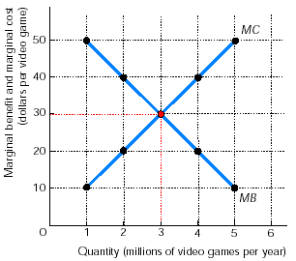
  - The graph on the right shows Figure 1 completed with the marginal benefit and marginal cost schedules.
  - Both the table and the figure demonstrate that the efficient number of video games is 3 million because this quantity sets the marginal benefit from an additional game equal to the game’s marginal cost.

    - The answers are:
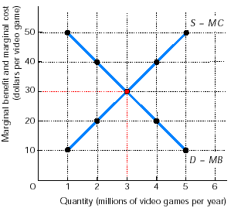
      - The graph on the right shows the demand and supply curves for video games. The key point in drawing this graph is the fact that the demand curve, D, is the same as the marginal benefit curve, MB, and the supply curve, S, is the same as the marginal cost curve, MC.
      - The quantity produced is 3 million video games, determined by the point where the supply and demand curves cross.
      - The two answers are identical, 3 million video games. In other words, the efficient quantity of video games is the same as the quantity actually produced.

        - All three concepts are the same. In other words, the marginal benefit of a good is defined as the good’s value. And the value of a good is the maximum amount that someone is willing to pay for it.

- The answers are
          - Figure 5 shows the consumer surplus as the area of the shaded triangle. The amount of consumer surplus is equal to the area of the triangle. Use the formula for the area of a triangle, (½)x(base)x(height). The base equals 2 million pairs of jeans, the quantity demanded. The height is $20 per jean. Thus consumer surplus is (½)x(2 million jeans)x($20 per jean) or $20 million.
          - Figure 6 shows the consumer surplus when the price of jeans is $30 a pair. The consumer surplus in this case is $45 million, from (½)x(3 million jeans)x($30 per jean). As the price falls, the consumer surplus rises.
          - Consumer surplus is larger when the price is lower. This result reflects the conclusion that consumers are better off when the prices of the products they buy are lower.
Figure 6
Figure 5
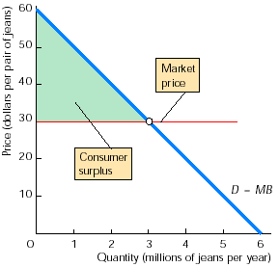
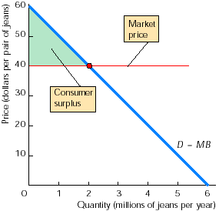

- The answers are:
  - Figure 7 shows the producer surplus as the area of the shaded triangle. The amount of the producer surplus can be determined by using the formula for the area of a triangle, specifically (½)x(base)x(height). The base equals 4 million pairs of jeans, the quantity supplied. The height equals $40 per jean. Producer surplus is (½)x(4 million jeans)x($40 per jean) or $80 million.
  - Figure 8 shows the producer surplus when the price of a pair of jeans is $30. Producer surplus equals (½)x(base)x(height) or, in this case, (½)x(3 million jeans)x($30 per jean) = $45 million.
  - Producer surplus is larger when the price is higher. This result illustrates the fact that producers are better off when the price of the product they sell is higher.

Figure 7
Figure 8
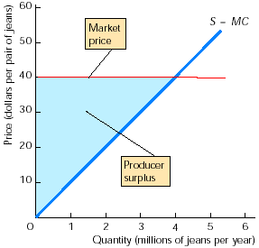
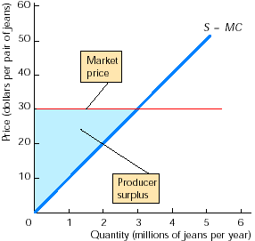
Figure 9

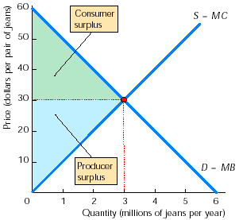
- The answers are:
  - Figure 9 demonstrates that the quantity is 3 million jeans and the price is $30 a pair.
  - Consumer surplus and producer surplus are illustrated in Figure 9. The price of a pair of jeans is $30. Hence from Problem 4 (b), the consumer surplus is $45 million. From Problem 5 (b), producer surplus is $45 million. (The result that the consumer surplus equals the producer surplus is a coincidence; in general there is no particular relationship between the amount of consumer surplus and the amount of producer surplus.) The total gains from trade equal the sum of consumer surplus plus producer surplus, so the total gains from trade are $90 million.
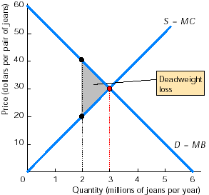
  - When the production of jeans is limited to 2 million pairs of jeans, Figure 10 illustrates the situation. The deadweight loss is the shaded triangle in the figure. The deadweight loss can be calculated by using the formula for the area of a triangle, (½)x(base)x(height). In this case, the base is 1 million pairs of jeans (the difference between the efficient amount, 3 million, and the amount produced, 2 million). The height is $20 per jean, the difference between what consumers are willing to pay for another pair of jeans, $40, and the amount suppliers need to receive to produce an additional pair, $20. Thus the deadweight loss equals (½)x(1 million jeans)x($20 per jean) or $10 million. The total gains from trade are most easily calculated by subtracting the deadweight loss from the gains from trade when the market is allowed to produce the efficient quantity of jeans. From part (b) of this problem, the gains from trade when the market is efficient are $90 million. Therefore when the market underproduces by producing only 2 million pairs of jeans, the total gains from trade equal $90 million minus $10 million or $80 million.
Figure 10
Figure 11
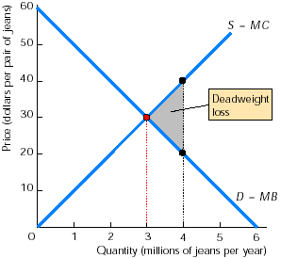
- Figure 11 shows the situation when 4 million pairs of jeans are produced. The deadweight loss is again illustrated by the shaded triangle. The amount of deadweight loss equals the area of the triangle, or (½)x(base)x(height). The base is 1 million pairs of jeans, the amount of overproduction. The height is $20, the difference between the marginal cost of another pair of jeans and the marginal benefit from another pair. Therefore, the deadweight loss is equal to (½)x(1 million jeans)x($20 per jean) = $10 million. The result that the deadweight loss in part (d) from overproducing 1 million pairs of jeans equals the deadweight loss from underproducing 1 million pairs of jeans, in part (c), is a coincidence (σύμπτωση). In general these amounts are not equal. The total gains from trade in this situation of overproduction equal the total gains from trade when the efficient quantity is produced, $90 million, minus the deadweight loss, $10 million, leaving total gains from trade of $80 million.
- The total gains from trade are largest when the efficient quantity of jeans is produced, that is, when 3 million pairs of jeans are produced.

