CHAPTER 4 – ELASTICITY

I. Price Elasticity of demand

An understanding of demand and supply gives us the fundamentals of how markets operate - the determination of prices and quantity in the market for a good or service. However, responses of output to a change in the price of the good are not the same for all goods.

In analyzing the consumer's demand curve for a good, we have seen that as the price of the good rises, quantity demanded for that good decreases (the law of demand). How much, if at all, quantity demanded of a good falls when the good's price rises, depends on the nature of the good. There are some goods that we do not want or we cannot sacrifice consumption when the price rises. Other goods have many close substitutes and we can easily shift our consumption towards them when the price of the good rises. The responsiveness of quantity demanded to a change in a good's price is known as the elasticity (ελαστικότητα) of demand. In this section we will explore the concept of elasticity as it relates to the demand and supply curves, to incomes and to the prices of related goods.

The price elasticity of demand (ελαστικότητα τιμής) measures how strongly the quantity demanded responds to a change in the price of a product. Using the slope of the demand curve as a measure of responsiveness has a problem: The slope of the demand curve depends on the unit of measurement (μονάδα μέτρησης). As a result, the slope changes with a change in the units of measurement (for example, instead of using pounds we use cents, or instead of using kilometers we use meters) so comparing the responsiveness of demand for different products is very difficult.

The price elasticity of demand is defined as the percentage change in quantity demanded divided by the percentage change in price, that is

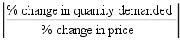
Price elasticity of demand (E_{d}) =

Make sure to recognize that when we speak of the price elasticity of demand for a good, we are referring to the change in the quantity demanded of the good when the price of the same good changes. Later we will look at the cross-price elasticity of demand which examines the change in the demand for a good when the price of another good changes.
Also, notice that the price elasticity of demand will always be expressed as a positive number (since the absolute value of a negative number is always positive).

When the price elasticity of demand between two points on a demand curve is being measured, the percentage change in the quantity demanded equals the change in quantity divided by the average quantity; the percentage change in the price equals the change in the price divided by the average price. For example, suppose that we wish to measure the elasticity of demand in the interval between a price of €4 and a price of €5. In this case, if we start at €4 and increase to €5, price has increased by 25%. If we start at €5 and move to €4, however, price has fallen by 20%. Which percentage change should be used to represent a change between €4 and €5? To avoid ambiguity (ασάφεια), the most common measure is to use a concept known as arc elasticity in which the midpoint of the interval is used as the base value in computing elasticity. Under this approach, the price elasticity formula becomes:

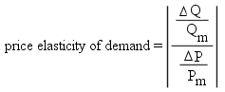

where:

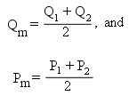

Let's consider an example. Suppose that quantity demanded falls from 60 to 40 when the price rises from €3 to €5. The elasticity measure is given by:

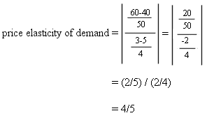

The elasticity of demand can be elastic, unit elastic or inelastic.
- A good is considered to be relatively elastic when the price elasticity of demand exceeds an absolute value of 1. This indicates that if the price of the good changes by 1%, the response in the quantity demand is greater than 1%. The demand curves for elastic goods are relatively flat in slope. For example, if the percentage increase in price is 10% and the percentage decrease in quantity demanded is 15%, calculating the price elasticity of demand (% change in quantity demanded / % change in price = 15%/10%) yields a price elasticity of 1.5. The price elasticity of demand of 1.5 calculated here, implies that for every 1% change in the price of the good, quantity demand changes by 1.5% - clearly a relatively elastic good.
- A good is considered to be relatively inelastic when the price elasticity of demand is below an absolute value of 1. This indicates that if the price of the good changes by 1%, the response in the quantity demand is less than 1%. The demand curves for inelastic goods are relatively steep in slope. For example, if the percentage increase in price is 10% and the percentage decrease in quantity demanded is 5%, calculating the price elasticity of demand (% change in quantity demanded / % change in price = 5%/10%) yields a price elasticity of 0.5. The price elasticity of demand of 0.5 calculated here, implies that for every 1% change in the price of the good, quantity demand changes by 0.5% - clearly a relatively inelastic good.
- A good has unitary elasticity when the price elasticity of demand exactly equals 1. This indicates that if the price of the good changes by 1%, the response in the quantity demand is also 1%. For example, if the percentage increase in price is 10% and the percentage decrease in quantity demanded is also 10%, calculating the price elasticity of demand (% change in quantity demanded / % change in price = 10%/10%) yields a price elasticity of 1. The price elasticity of demand of 1 calculated here, implies that for every 1% change in the price of the good, quantity demand changes also changes by 1%.
There are two extremes:
The demand for a good is considered perfectly elastic (πλήρως ελαστική) when the price elasticity of demand approaches infinity. This implies that the demand for the product is unlimited at the market price - the demand curve is horizontal. The elasticity measure in this case is infinite (notice that the denominator of the elasticity measure equals zero). The closest we get to a perfectly elastic demand curve is the demand curve facing a firm that produces a very small share of the total quantity produced in a market. In this case, the firm is such a small share of the market that it must take the market price as given. An individual farmer, for example, has no control over the price that it receives when it brings its product to market. Whether he supplies 100 or 20,000 tons of cotton, the price that it received per ton is that day's market price.
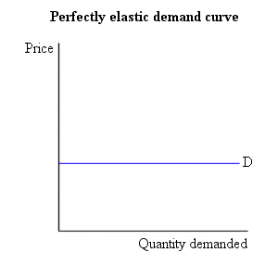
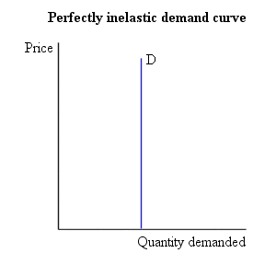
The demand for a good is considered perfectly inelastic (πλήρως ανελαστική) when the price elasticity of demand equals zero. This implies that changes in price have no effect on the quantity demand of a good - the demand curve is vertical. Note that the price elasticity of demand equals zero for a perfectly inelastic demand curve since the % change in quantity demanded equals zero. In practice, we do not expect to see demand curves that are perfectly inelastic. For some range of prices, the demand for insulin, dialysis, and other such medical treatments, is likely to be close to being perfectly inelastic. As the price for these commodities rises, however, we would eventually expect to see the quantity demanded fall because individuals have limited budgets.

Elasticity is not the same as slope. Along a downward sloping straight-line demand curve, elasticity varies. Moving downward and to the right along downward sloping straight-line demand curves, the price elasticity of demand becomes smaller. To see why this occurs, it is necessary to consider the distinction between a change in the level of a variable and the percentage change in the same variable. Suppose we consider the distinction by discussing the percentage change that results from a €1 increase in the price of a good.
- a price increase from €1 to €2 represents a 100% increase in price,
- a price increase from €2 to €3 represents a 50% increase in price,
- a price increase from €3 to €4 represents a 33% increase in price, and
- a price increase from €10 to €11 represents a 10% increase in price.
Notice that, even though the price increases by €1 in each case, the percentage change in price becomes smaller when the starting value is larger. Let's use this concept to explain why the price elasticity of demand varies along a linear demand curve.

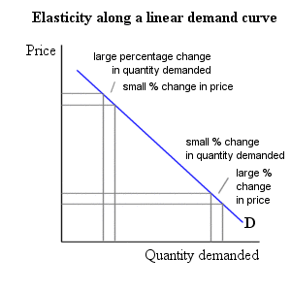
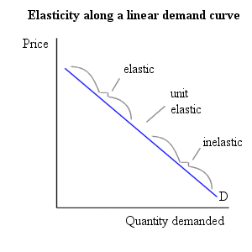
Consider the change in price and quantity demanded that are illustrated in the diagram on the right. At the top of the curve, the percentage change in quantity is large (since the level of quantity is relatively low) while the percentage change in price is small (since the level of price is relatively high). Thus, demand will be relatively elastic at the top of the demand curve. At the bottom of the curve, the same change in quantity demanded is a small percentage change (since the level of quantity is large) while the change in price is now a relatively large percentage change (since the level of price is low). Thus, demand is relatively inelastic at the bottom of the demand curve.

More generally, we can note that elasticity decreases continuously along a linear demand curve. The top part of the demand curve will be highly elastic and the bottom is highly inelastic. In between, elasticity gradually becomes smaller as price declines and quantity rises. At some point, demand changes from being elastic to inelastic. The point at which that happens, of course, is the point at which demand is unit elastic. This relationship is illustrated in the diagram to the right.

  - The size of elasticity of demand for a good depends on three factors:
- Availability of substitutes. The more other goods can be substituted for the product under study, the larger is the product’s elasticity of demand. Necessities generally have fewer substitutes and have an inelastic demand; luxuries often have many substitutes, so their demand is often elastic.
- The proportion of income spent on the good. The greater the proportion of income (ποσοστό εισοδήματος) spent on a good, the larger is the elasticity of demand.
- The time passed since a price change. In general, the more time that has passed since a price change, the larger is the elasticity of demand. Distinguishing between two time frames, the short-run demand and the long-run demand is useful. The first shows the initial response of buyers to a change in price and is often inelastic. The second describes the response of buyers to a price change after all adjustments have been made and generally is more elastic than the short-term demand.

The concept of price elasticity of demand is extensively used by firms that are investigating the effects of a change in the prices of their products. Total revenue (συνολικά έσοδα) is defined as:
Total Revenue = Price x Quantity
TR = P x Q
Suppose that a firm is facing a downward sloping demand curve for its product. How will its revenue change if it changes its price?
When, for example, price falls, quantity demanded by consumers rises. The lower price received for each unit of quantity demanded lowers total revenue while the increase in the number of units sold raises total revenue. Total revenue will rise when price falls if quantity rises by a large enough percentage to offset (αντισταθμίσει) the reduction in price per unit. In particular, we can note that total revenue will increase if quantity demanded rises by more than one percent when the price falls by one percent. Alternatively, total revenue will decline if quantity demanded rises by less than one percent when the price declines by one percent. If the price falls by 1% and quantity demanded falls by 1%, total revenue will remain unchanged (since the changes will offset each other).
Using the logic discussed above, we can note that a reduction in price will lead to:
- an increase in total revenue when demand is elastic,
- no change in total revenue when demand is unit elastic, and
- a decrease in total revenue when demand is inelastic.
In a similar manner, an increase in price will lead to:
- a reduction in total revenue when demand is elastic,
- no change in total revenue when demand is unit elastic, and
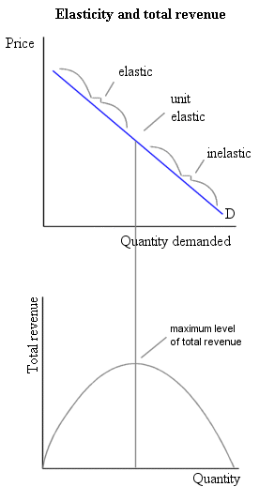
- an increase in total revenue when demand is inelastic.
The diagram to the right illustrates the relationship that exists between total revenue and demand elasticity along a linear demand curve. As this diagram shows, total revenue increases as quantity increases (and price decreases) in the region in which demand is unit elastic. Total revenue falls as quantity increases (and price decreases) in the inelastic portion of the demand curve. Total revenue is maximized at the point at which demand is unit elastic.
Does this mean that firms will choose to produce at the point at which demand is unit elastic? This would only be the case if they had no production costs. Firms are assumed to be concerned with maximizing their profits, not their revenue. The optimal level production can be determined only when we consider both revenue and costs. This topic will be studied at later chapters.

For an example of the change in revenue with different values of the elasticity consider a firm that raises it price by 1%.
Assume:
P₀ = €100, Q₀ = 1,000 units and TR = €100,000 (P₀ x Q₀)
Also assume that the price elasticity of demand is equal to 0.5. With a 1% increase in price we have.
P₁ = €101, Q₁ = 995 units and TR = €100,495 (P₁ x Q₁)
If the elasticity is equal to 0.5, then a 1% increase in price will lead to a 0.5% decrease in quantity demanded. In this example, we can see if the good has an inelastic demand, total revenue will increase in response to a price rise.
Let us change our example to show what happens when price is increased by 1%, but the demand for the good is elastic. For example, assume the price elasticity of demand is equal to 2.0.
Assume:
P₀ = €100, Q₀ = 1,000 units and TR = €100,000 (P₀ x Q₀)
Also assume that the price elasticity of demand is 2. With a 1% increase in price we have.
P₁ = €101, Q₁ = 980 units and TR = €98,980 (P₁ x Q₁)
If the elasticity equals 2.0, then a 1% increase in price will lead to a 2% decrease in quantity demanded. In this example, we can see if the good has an elastic demand, total revenue will decrease in response to a price rise.
Summary of Price Elasticity of Demand

Elasticity | Description | Change in Q_{d} with a 1% Increase in Price | Change in Revenue with an Increase in Price | Change in Q_{d} with a 1% Decrease in Price | Change in Revenue with a Decrease in Price
Zero | Perfectly inelastic - vertical demand curve | Zero | Increased by 1% | Zero | Decreased by 1%
Between 0 and 1 | Inelastic | Decreased by less than 1% | Increased | Increased by less than 1% | Decreased
1 | Unitary elasticity | Decreased by 1% | No change | Increased by 1% | No change
Greater than 1 | Elastic | Decreased by more than 1% | Decreased | Increased by more than 1% | Increased
Infinite | Perfectly elastic - horizontal demand curve | Decreased to zero | Decreased to zero | No change | Increased by 1%

II. More Elasticities of Demand

The cross elasticity of demand (σταυροειδής ελαστικότητα) shows how the demand for a good reacts to a change in the price of another product. The cross-price elasticity of demand between the goods j and k can be expressed as:

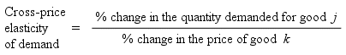

In other words, the cross-price elasticity of the goods j and k, measures the percentage change in the quantity demanded of good j, when the price of good k changes by 1%. Cross-price elasticities are given two categories: complements and substitutes.
- Complements - Two goods that have a negative value for their cross-price elasticity are considered complementary goods such as compact disc (CD) players and compact discs. If the price of CD players increases then our consumption of CD's decreases, leading to a negative relationship between the two. Conversely, if the price of CD players falls (a negative coefficient), our consumption of CD's rises (a positive coefficient).
- Substitutes - Two goods that have a positive value for their cross-price elasticity are considered substitutes such as gasoline prices and the demand for public transportation. If the price of gasoline rises, so does consumer demand for less expensive transportation alternatives such as public transportation (buses, subways).
Cross-price elasticity can be used by firms in making pricing and output decisions. McDonald's, for example, might want to know the cross-price elasticity of demand between its chicken sandwiches and its Big Macs if it is considering the effect of a 20% decrease in the price of its Big Macs. If the cross-price elasticity of demand is 0.5, then a 20% decrease in the price of its Big Mac would result in a 10% decrease in the number of chicken sandwiches sold. A -0.9 cross-price elasticity of demand between Big Macs and chips, though, would indicate that a 20% decrease in the price of Big Mac would result in an 18% increase in the sale of chips. This sort of information would be useful in determining what prices to charge and in planning for the impact of such a price change.

Also, take the example of the airline industry and consider goods that are close substitutes. For example one good is the price of seat on Cyprus Airways, the other good is the demand for seat on Olympic Airways, each on an identical flight route - say Larnaca to Athens. In the case of the airline industry, the cross-price elasticity of demand for airline tickets is very high, and firms respond immediately to fare changes. If one airline such as Cyprus Airways starts a price war, competitors such as Olympic Airways quickly follow in reducing prices to prevent a loss of market share. Since there is a high cross-price elasticity, if Cyprus Airways lowers its fare from Larnaca to Athens, and Olympic Airways keeps its fares constant, consumers quickly shift consumption towards the lower priced Cyprus Airways tickets. The resulting decrease in the demand for Olympic Airways tickets is large.

So far, we have studied the effect of a change in the price of a good on the same good's quantity demanded. Now we turn our attention to the impact on the demand for a good when consumer incomes change, holding prices constant. The business cycle describes alternating periods of economic growth (οικονομική ανάκαμψη), when incomes generally increase, and recession (ύφεση) which lead to a decrease in consumer incomes. A firm needs to understand income elasticity to see how changes in the economy affect the demand for the good or service produced by the firm. Our consumption of some goods, such as luxuries, is very sensitive to changes in economic growth and consumer incomes. In contrast, necessities such as food and housing tend to be less affected by economic swings and the corresponding changes in consumer incomes.
The income elasticity of demand (εισοδηματική ελαστικότητα) measures how the demand for a good responds to a change in income. The income elasticity of demand is defined as the percentage change in the quantity demanded divided by the percentage change in income:

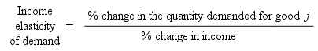

There are three possibilities for a good's income elasticity:
A good is income elastic if the income elasticity of demand is greater than 1. This implies that for a 1% change in income, demand for the good changes by more than 1%.
A good is income inelastic if the income elasticity of demand is greater than 0 but less than 1. This implies that for a 1% change in income, demand for the good changes by less than 1%.
A good is considered inferior if the associated income elasticity of demand is a negative number. In this case, if income increases, consumers actually buy less of the good.
The first two categories above, income elastic and income inelastic, both correspond to a normal good, where the income elasticity of demand is greater than zero. A normal good is one that we buy more of when our income increases. If the income elasticity of demand is greater than 1, the good is often considered a luxury such as a computer, mobile telephone, car or many types of entertainment. A necessity is a good that we buy more of when our income increases, such as health care or gasoline, but our consumption is not substantially affected; income elasticity for necessities is generally between 0 and 1. Finally, inferior goods are characterized by consumption that actually decreases with improvements in income. For many consumers, inferior goods include items such as canned food, frozen meat or fish, cheap seats at the football game or a concert.

III. Elasticity of Supply

The elasticity of supply measures the responsiveness of the quantity supplied of a good to a change in its price. The elasticity of supply is defined as the percentage change in the quantity supplied divided by the percentage change in price:

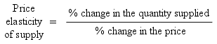

The elasticity of supply is perfectly inelastic if the supply curve is vertical. In this case, the elasticity of supply is 0 (zero). If, on the other hand, the supply curve is horizontal, the elasticity of supply is perfectly elastic and is infinite.

The size of the elasticity of supply depends on two general factors:
- Resource substitution possibilities: The more common, readily available resources are used to produce a product, the greater is the elasticity of supply.
- The time passed since the price change: The more time that passes after a price change, the greater is the elasticity of supply.
- If quantity supplied does not react immediately following a price change, the supply curve is very steep, almost vertical. This is called the momentary supply curve and it is very inelastic and probably perfectly inelastic.
- If quantity supplied responds to a change in price after some of the technological possible adjustments to production have been made, the supply curve is somewhat steep but not as steep as the momentary supply curve. It is called the short-run supply curve and it is less inelastic.
- If quantity supplied reacts to a change in price after all possible ways of adjusting supply have been utilized, the supply curve is rather flat. It is called the long-run supply curve and it is elastic and, perhaps, perfectly elastic.

In general, it is expected that supply will be more elastic in the long run than in the short run since firms can increase or decrease their capital in the long run. In the short run, an increase in the price of personal computers, for example, may result in increased employment, more overtime, and additional shifts in computer factories. In the long run, though, higher prices will lead to a larger expansion in output as new factories are built.

QUESTIONS

True/False

- The price elasticity of demand is the same as the slope of the demand curve.
- The price elasticity of demand ranges from 0 to ∞.
- The more consumers respond to a price change, the larger the price elasticity of demand.
- If the price elasticity of demand is positive, then demand is elastic.
- KEO beer is likely to have an elastic demand.
- Moving along a linear demand curve to lower prices and larger quantities, the price elasticity of demand does not change.
- People spend more on food than on chocolates, so the price elasticity of demand for food is likely to be larger than the price elasticity of demand for chocolates.
- The price elasticity of demand for food is largest in poor nations.
- As more time passes after a price change, the price elasticity of demand becomes smaller.
- Pizza Hut estimates that the price elasticity of demand for its pizzas is 4,00, so if it increases the price it charges for its pizza, its total revenue will increase.
- The cross elasticity of demand between tennis rackets and tennis balls is negative.
- A product has an elastic demand if its income elasticity of demand is greater than 1,0.
- An inferior good has a negative income elasticity while a normal good has a positive income elasticity.
- The elasticity of supply equals the change in the quantity supplied divided by the change in price.
- If a good has a vertical supply curve, its elasticity of supply equals 0.

Multiple choice

- Suppose that a 10% increase in the price of movie tickets decreases the quantity demanded by 2%. Then the price elasticity of demand for movies is
a. 0.2.
b. 2.0.
c. 5.0.
d. 10.0.

TABLE 4.1
Price/DVD (€) | Quantity demanded
38 | 110
42 | 90

- Two points on the demand curve for DVDs are shown in Table 4.1. What is the price elasticity of demand between these two points?
a. 2.5.
b. 2.0.
c. 0.5.
d. 0.4.

- The quantity of new cars increases by 5%. If the price elasticity of demand for new cars is 1.25, the price of a new car will
a. fall by 4%.
b. fall by 5%.
c. fall by 6.25%.
d. fall by 1.25%.

- Along a perfectly inelastic demand curve, the price elasticity of demand
a. equals 0.
b. is greater than 0 but less than 1.0.
c. equals 1.0.
d. is negative.

- A Perfectly elastic demand is represented by a demand curve that
a. is vertical.
b. is horizontal.
c. has a 45° slope.
d. none of the above.
1
- The demand for a good is more price inelastic if
a. its price is higher.
b. the percentage of income spent on it is larger.
c. it is a luxury good.
d. it has no close substitutes.
1

- Which of the following is likely to have the largest price elasticity of demand?
a. A car
b. A new car
c. A new SAAB car
d. A new SAAB Turbo convertible

- Moving upward along a linear demand curve, as the price rises and the quantity demanded decreases, the price elasticity of demand
a. falls.
b. does not change.
c. rises.
d. first rises and then falls.

- If the price elasticity of demand equals 1,0, then as price falls the
a. quantity demanded decreases.
b. total revenue falls.
c. quantity demanded does not change.
d. total revenue does not change.

- A rise in the price of a product increases total revenue from the product if
a. income elasticity of demand is greater than 1.
b. the good is an inferior product.
c. the product has an inelastic demand.
d. the product has an elastic demand.

- By looking at its sales records, TOSHIBA discovered that when it lowers the price of its laptop computers, the total revenue from the sale of its laptop computers increases. So we can conclude that
a. supply of TOSHIBA laptop computers is elastic.
b. demand for TOSHIBA laptop computers is elastic.
c. supply of TOSHIBA laptop computers is inelastic.
d. demand for TOSHIBA laptop computers is inelastic.

- If a 4% rise in the price of honey causes total revenue from sales of honey to fall by 8%, then honey has a(n)
a. elastic demand.
b. inelastic demand.
c. unit elastic demand.
d. There is not enough information given to determine whether the demand for
honey is elastic, unit elastic, or inelastic.

- When the price of a hamburger rises 10%, your expenditure on hamburgers increases. So, it is certain that
a. hamburgers are a normal good for you.
b. hamburgers are an inferior good for you.
c. your demand for hamburgers is elastic.
d. your demand for hamburgers is inelastic.

- For which of the following pairs of goods is the cross elasticity of demand positive?
a. CDs and CD players
b. Videotapes and toothpaste
c. Airline trips and textbooks
d. Beef and chicken

- A 10% increase in the price of a Pepsi increases the demand for a Coca Cola by 50%. So, the cross elasticity of demand between Pepsi and Coca Cola is
a. 50.0.
b. 10.0.
c. 5.0.
d. 0.2.

- A fall in the price of a book from €6 to €4 causes a decrease in the quantity of magazines demanded from 1.100 to 900. What is the cross elasticity of demand between books and magazines?
a. 0.5
b. –0.5
c. 2.0
d. not possible to calculate the cross elasticity of demand.

- Suppose that the income elasticity of demand for apartments is –0.2. This value shows that
a. the demand for apartments is price inelastic.
b. the demand for apartments is unit elastic.
c. a rise in the rent for apartments lowers the total revenue from renting
apartments.
d. apartments are an inferior good.

- Frozen meat is an inferior good; fresh beef is a normal good. When people’s incomes rise, the demand for frozen meat ……… and the demand for fresh beef ………
a. increases; increases
b. increases; decreases
c. decreases; increases
d. decreases; decreases

- A 10% increase in income increases the demand for coffee by 3%. Then the income elasticity of demand for coffee is
a. –0.3.
b. 3.3.
c. 0.3.
d. 10.0

- All normal goods have
a. income elasticities of demand greater than 1.0.
b. price elasticities of demand greater than 1.0.
c. negative price elasticities of demand.
d. positive income elasticities of demand.

- Suppose that the price elasticity of supply for oil is 0.1. Then, if the price of oil rises by 20%, the quantity of oil supplied will increase
a. by 200%.
b. by 20%.
c. by 2%.
d. by 0.2%.

- When the price of a CD is €13 per CD, 39,000,000 CDs per year are supplied. When the price is €15 per CD, 41,000,000 CDs per year are supplied. What is the elasticity of supply for CDs?
a. 2.86
b. 0.35
c. 0.14
d. 0.05

- If the long-run supply of rice is perfectly elastic, then
a. as people’s incomes rise, the quantity of rice supplied decreases.
b. as the price of corn falls, the quantity of rice demanded decreases.
c. in the long run, a large rise in the price of rice causes no change in the
quantity of rice supplied.
d. in the long run, an increase in the demand for rice leaves the price of rice
unchanged.

- The elasticity of supply does NOT depend on
a. resource substitution possibilities.
b. the proportion of income spent on the product.
c. the time passed since the price change.
d. none of the above

Short answers
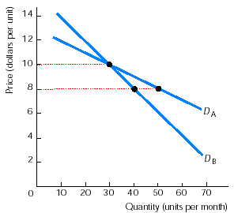
- Assume that the price elasticity of demand for oil is 0.2 in the short run and 0.8 in the long run. To raise the price of oil by 10% in the short run, what must be the decrease in the quantity of oil? In the long run, to have a 10% rise in the price of oil, what must be the decrease?

- In the graph on the right, which demand is more elastic between prices $10 and $8?

- Why is the price elasticity of demand for food larger in poor nations than in rich nations?

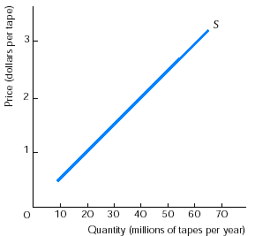
- Explain what perfectly elastic demand means. Describe an example of a demand curve for a good with perfectly elastic demand. When will perfectly elastic demand occur?

  - The supply curve for tapes is illustrated in the diagram on the right. Perhaps because of a rise in wages, the supply of tapes decreases so that for every possible quantity, the new supply curve lies above the old supply curve by $1.
a. Suppose the demand for tapes is
perfectly elastic and is such that the initial equilibrium price is $2 for a tape. After the decrease in supply, by
how much does the price of a tape rise? Draw a diagram to illustrate your answer.
b. Suppose the demand for tapes is perfectly inelastic and is such that the
initial equilibrium price of a tape is $2. In this case, by how much does
the price of a tape rise? Draw a diagram to illustrate this situation.
c. Based on your answers to parts (a) and (b), when will an increase in costs
raise the price of a product the most: When demand is elastic or when it is
inelastic? When will it decrease the quantity the most? When demand
is elastic or inelastic? Is there any situation under which the price does not
change?

Table 4.2 – The demand for hamburgers
Price  (€/hamburger) | Quantity demanded (hamburgers/week) | Total revenue  (per week)
8 | 30
7 | 40
6 | 50
5 | 60
4 | 70
3 | 80
2 | 90
1 | 100
- Table 4.2 gives eight points on a demand curve for hamburgers.
a. Calculate the price elasticity of demand between €1 and €2; €2 and €3; €3 and €4; €4 and €5; €5 and €6; €6 and €7; and €7 and €8.
b. In Table 4.2, complete the last column.
c. Based on your answer
to part (a), how does the price elasticity of demand
change for a movement downward along this demand curve? How does this
change relate to your answers in part (b) for total revenue at the different
prices?

Table 4.3 – The demand for pizza
Price  ($/slice of pizza) | Quantity demanded (slices of pizza/week) | Total revenue  ($ per week)
8 | 12.5
7 | 14.3
6 | 16.7
5 | 20
4 | 25
3 | 33.3
2 | 50
1 | 100
- Table 4.3 gives eight points on a demand curve for slices of pizza.
a. Graph the demand curve.
b. Calculate the price elasticity of demand between €1 and €2; €2 and €3; €3
and €4; €4 and €5; €5 and €6; €6 and €7; and €7 and €8.
c. Complete the last column in Table 4.3.
d. Based on your answers to parts (b) and (c), how does the total revenue per
week relate to the price elasticity of demand at the different prices?

- You are the manager of a local restaurant. You notice that when you lower the price of your meals, your total revenue rises. What conclusion can you draw about the demand for your restaurant’s meals?

- For cars, why does the elasticity of supply generally increase as more time passes after a price change?

- The demand for a product permanently increases. Suppose that the long-run supply is more elastic than the short-run supply. When will the price of the product rise the most? Immediately after the demand change or in the long run? When will the quantity increase the most? Draw a graph to illustrate your answers.

ANSWERS

True/False

- F The slope of the demand curve equals ΔP/ΔQ, whereas the price elasticity of demand equals ΔQ/ ΔQ_{ave} / ΔP/ ΔP_{ave}
- T The smallest value for the price elasticity of demand, 0, shows a perfectly inelastic demand; the largest, ∞, indicates perfectly elastic demand.
- T The stronger the response to a price change, the larger is the elasticity.
- F Demand is elastic when the price elasticity of demand exceeds 1.0.
- T Other beers, such as Carlsberg or Heineken, are close substitutes for KEO, so the demand for KEO is likely to be elastic.
- F As we move downward along a linear demand curve, the price elasticity of demand falls.
- T Generally, the larger the proportion of total income spent on a product, the greater is the price elasticity of demand.
- T In poor nations food takes a larger portion of consumer spending, so the price elasticity of demand is larger.
- F As more time passes, more changes in demand can take place, so demand becomes more elastic.
- F The demand for Pizza Hut is elastic, so rising the price decreases the quantity by so much that total revenue declines.
- T Tennis rackets and tennis balls are complements, so the cross elasticity of demand is negative.
- F To be elastic, the price elasticity of demand must be greater than 1.0.
- T An increase in income decreases the demand for inferior goods and increases it for normal goods.
- F The price elasticity of supply equals the percentage change in the quantity supplied divided by the percentage change in price.
- T When the elasticity of supply equals zero, the supply is perfectly inelastic.

Multiple choice

- a The price elasticity of demand is equal to (2%)/(10%) = 0.2.
- b The price elasticity of demand between two points equals ΔQ/ ΔQ_{ave} / ΔP/ ΔP_{ave.} In this case we get (10/50)/(€2/€20) = 2.
- a Rearranging the formula for the price elasticity of demand gives (percentage change in price) = (percentage change in quantity demanded)/(elasticity of demand). So, the percentage change in price equals (5%)/(1.25) = 4%.
- a When a product has a perfectly inelastic demand, the price elasticity of demand equals zero and the demand curve is vertical.
- b “Perfectly elastic” means that a very small rise in the price will decrease quantity demanded to 0, which is the situation with a horizontal demand curve.
- d If there are no close substitutes, consumers continue to buy the product even if its price is increased substantially, which means that the demand is inelastic.
- d There are many more substitutes for a new SAAB Turbo convertible than for the other goods. This answer is an example of the proposition that the more narrow the definition of a good is, the larger is its price elasticity of demand.
- c Moving upward along a linear demand curve, the price elasticity of demand increases in value.
- d If demand is unit price elastic, a change in the price of the product creates an offsetting change in the quantity demanded so that total revenue does not change.
- c If demand is inelastic, the percentage increase in price is greater than the percentage decrease in quantity demanded, so total revenue from sales of the good increases.
- b When demand is elastic, the percentage increase in the quantity demanded is greater than the percentage fall in the price, so total revenue rises.
- a When demand is elastic, a rise in the price of the product decreases the quantity demanded by proportionally more, so that total revenue falls when price increases.
- d When an increase in the price of a product increases your expenditure on the product (for example, cigarettes, if you are a smoker) your demand for the product is inelastic.
- d The cross elasticity of demand is positive for substitutes. Beef and chicken are substitutes, so their cross elasticity of demand is positive.
- c The cross elasticity of demand equals the percentage change in the quantity of Coca Cola divided by the percentage change in the price of a Pepsi. So, the cross elasticity of demand equals (50%)/(10%) = 5.0.
- a The cross elasticity of demand is calculated ΔQ/ ΔQ_{ave} / ΔP/ ΔP_{ave} in which “quantity” refers to magazines and the “price” to books. Using the formula for the cross elasticity gives (–200/1,000)/(– €2/€5) = 0.5.
- d If income elasticity is negative, the product is an inferior good.
- c For an inferior good an increase in income decreases demand; for a normal good an increase in income increases demand.
- c Income elasticity of demand equals in this case equals (3%)/(10%) or 0.3.
- d An increase in income increases the demand for a normal good.
- c Rearranging the formula for the price elasticity of supply gives (percentage change in quantity supplied) = (price elasticity of supply) × (percentage change in price) = (0.1) × (20%) = 2 percent.
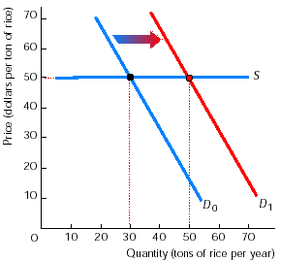
- b Analogous to the price elasticity of demand, the elasticity of supply is ΔQ/ ΔQ_{ave}/ΔP/ΔP_{ave} or (2,000,000/40,000,000)/( €2/€14)= 0.35.
- d When the supply is perfectly elastic, an increase in demand has no effect on the equilibrium price. This result is in the graph on the right where the increase in demand from D₀ to D₁ leaves the price constant at $50 a ton.
- b The proportion of income spent on the product affects the price elasticity of demand, not the price elasticity of supply.

Short answers

- Rearranging the formula for the price elasticity of demand gives (price elasticity of demand) × (percentage change in price) = (percentage change in quantity). The price rise is 10%, so the amount by which the quantity must be restricted in the short run is (0.2) × (10%) = 2%. In the long run, the price elasticity of demand is 0.8, so the decrease in the quantity is (0.8)(10%) = 8 percent. To raise the price by 10%, the long-run decrease in the quantity must be four times the short-run decrease.
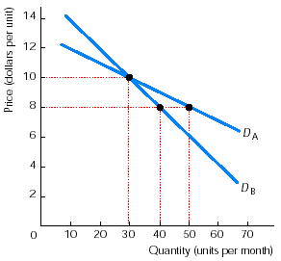
- The demand represented by D_{A} is more elastic than the demand given by D_{B}. To see why, recall the formula for the price elasticity of demand (percentage change in quantity demanded / percentage change in price). Along both demand curves, the percentage change in the price from $10 to $8 is the same. But the graph on the right shows that the percentage change in the quantity demanded is greater along D_{A} where the quantity demanded increases from 30 to 50, a 50% increase, whereas along D_{B} the quantity demanded increases to 40, only a 29% increase. Because the percentage increase in the quantity demanded is greater along D_{A} the price elasticity of demand over this price range is higher for D_{B}.

- The larger the percentage of their income that consumers spend on a product, the greater the price elasticity of demand. People in poor nations spend a larger proportion of their income on food than do people in wealthy nations, so the price elasticity of demand for food is larger in poor nations.

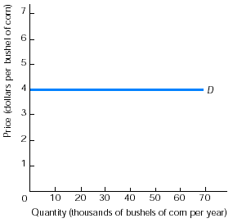
- A perfectly elastic demand is shown in the graph on the right. Demand is perfectly elastic when consumers can find perfect substitutes (τέλεια υποκατάστατα) for a product. For example, consider corn grown by one farmer. Corn that other farmers grow is a perfect substitute for the first farmer’s corn. If there are perfect substitutes for the product, even the smallest rise in the price of the product leads the quantity demanded to decrease to 0. The horizontal demand curve indicates that any rise in the price above $4 a bushel will decrease the quantity demanded to 0.

- The answers are:
  - In Figure 4.6 the rise in costs shifts the supply curve from S_{A} to S_{B}. The arrow indicates $1, the amount by which the new supply curve lies above the old supply curve. The price stays at $2; in other words, the price does not rise. Quantity, however, decreases from 40 million to 20 million per year.
  - In Figure 4.7, the supply curve again shifts from S_{A} to S_{B} and the length of the arrow again indicates $1. In this case, when demand is perfectly inelastic, the price rises by the full amount indicated by the arrow; that is, the price climbs from $2 to $3 a tape, which is a rise of exactly $1. The quantity, however, remains constant at 40 million tapes.
  - As Figures 4.6 and 4.7 show, the rise in costs increases the price the most when demand is inelastic. When demand is perfectly inelastic, the price goes up by the full amount of the rise in costs. Then, as demand becomes more elastic, the price rises by less. At the other extreme, when demand is perfectly elastic, the price does not change. The quantity decreases most when demand is perfectly elastic. As demand becomes less elastic, the change in the quantity becomes smaller.
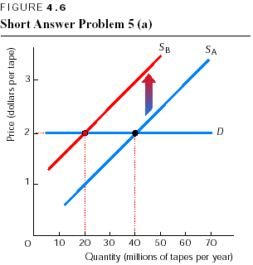
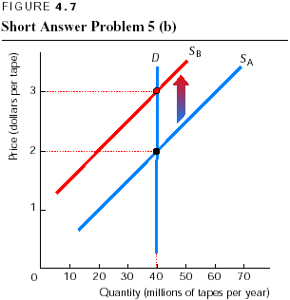

- The answers are:
Table 4.4
Prices (€) | Elasticity
7 to8 | 2.14
6 to 7 | 1.44
5 to 6 | 1.00
4 to 5 | 0.69
3 to 4 | 0.47
2 to 3 | 0.29
1 to 2 | 0.16
  - Table 4.4 contains the price elasticities of demand. To see how these elasticities are calculated, take the elasticity between €1 and €2 as an example. The elasticity of demand is defined as ΔQ/ΔQ_{ave}/ΔP/ΔP_{ave} which in this case gives (10/95)/(€1/€1.50) = 0.16.
  - The total revenues are given in Table 4.5. Total revenue equals (P ) x (Q ), so at a price of €6, (€6)(50) = €300.
Table 4.5
Prices (€) | Total revenue (€)
8 | 240
7 | 280
6 | 300
5 | 300
4 | 280
3 | 240
2 | 180
1 | 100
  - Moving along the demand curve from €8 to €1 results in the elasticity falling, from 2.14 when the price is between €8 and €7, to 0.16 when the price is between €2 and €1. When demand is elastic, between €8 and €6, a fall in price (with its corresponding increase in sales) raises total revenue. When demand is unit elastic, between €6 and €5, total revenue is at its maximum and a drop in price (with the increase in sales) does not change the total revenue. Finally, over the range when demand is inelastic, from a price of €5 to a price of €1, even though a fall in price raises the quantity sold, it does so by a smaller percentage so that in this range the fall in price lowers total revenue.

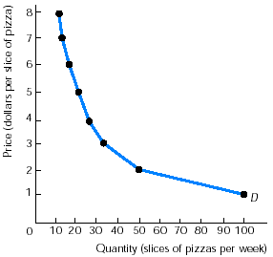
    - The answers are:
      - The graph on the right illustrates the demand curve.
      - Table 4.6 contains the price elasticities of demand. For example, at a price between $4 and $5, the price elasticity of demand equals ΔQ/ΔQ_{ave}/ΔP/ΔP_{ave} = (5/22.5)/($1/$4.50) = 1.00.
      - Total revenues are in Table 4.7. Total revenue equals (P) x (Q). So, to calculate the total revenue at a price of, say, $2, multiply the price times the quantity, or ($2)(50) = $100.
      - The price elasticity of demand along this demand curve always equals 1.00. In other words, this demand is always unit elastic. With unit elasticity, changes in price do not change total revenue, which is precisely what Table 4.7 illustrates.

Table 4.6
Prices (€) | Elasticity
7 to8 | 1.00
6 to 7 | 1.00
5 to 6 | 1.00
4 to 5 | 1.00
3 to 4 | 1.00
2 to 3 | 1.00
1 to 2 | 1.00
Table 4.7
Prices (€) | Total revenue ($)
8 | 100
7 | 100
6 | 100
5 | 100
4 | 100
3 | 100
2 | 100
1 | 100

- The demand for restaurant meals is elastic. Why? When demand is elastic, a fall in price raises total revenue, which is exactly what you have observed.

- The elasticity of supply increases as time passes after a price change because it is easier to make in the production process (παραγωγική διαδικασία). For example, to meet a permanent increase in the demand for cars, car industries may at the beginning only be able to add an additional shift (επιπρόσθετη βάρδια) of workers at existing factories. But as time passes, the companies can make larger changes, such as building more factories. As more capacity (δυναμικότητα) is added, more cars will be made, increasing the elasticity of supply.

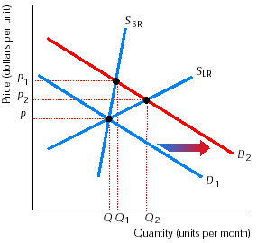
- The price of the product rises the most immediately after the increase in demand, and the quantity increases the most in the long run. These results are illustrated in the graph on the right. Here, the short-run supply curve is S_{SR} and the long-run supply curve is S_{LR}. Demand increases from D₁ to D₂. Immediately after the increase, the price rises from P to P₁ and the quantity increases from Q to Q₁. In the long run, supply becomes more elastic and so the long run supply curve, S_{LR} becomes relevant. Hence the price rises ultimately only to P₂ while the quantity increases all the way to Q₂.

