CHAPTER 3 – DEMAND AND SUPPLY

I. Price and Opportunity Cost

- The money price of a product is the pounds (or euros, or dollars) that must be spent to buy it; the relative price (σχετική τιμή) of a product is the ratio of its money price to the money price of another product. In other words, the relative price of a commodity is a measure of how expensive a good is in terms of units of some other good or service. If, for example, a beer costs €2 and a hamburger costs €6, the relative price of a hamburger is 3 beers (and the relative price of a beer is 1/3 of a hamburger). Economists argue that people respond to changes in relative prices since these prices reflect the opportunity cost of acquiring a good or service. The opportunity cost of having a good or a service may be measured by the relative price of the commodity.

II. Demand

- The quantity demanded of a good is the amount consumers are willing and able to buy in a given period of time at a particular price. Wants are the unlimited desires or wishes people have for products; the quantity demanded shows the amount people are actually willing to buy.

- The law of demand states that “other things remaining the same”, the higher the price of a good, the smaller the quantity demanded” or, the lower the price of a good, the larger the quantity demanded. In other words, there is a negative or inverse (αντίστροφη) relationship between price and quantity demanded.
The law of demand is the result of two effects:
- The substitution effect points out that when the price of a product relative to another rises, people buy less of it because they switch to similar cheaper products.
- The income effect points out that a higher price for a product relative to income effectively lowers people’s incomes and, as a result, reduces their purchases of most goods.

The demand curve graphs the relationship between the quantity demanded of a good and its price. One way of presenting demand is through the demand schedule (πίνακα ζήτησης) such as in Table 1 below. In other words, the demand curve is a graphical representation (γραφική απεικόνιση) of the demand schedule.
The demand (ζήτηση) for a product is the entire relationship between all possible prices and the quantities that people demand at every possible price, that is, the entire demand schedule or the entire demand curve. The quantity demanded (ζητούμενη πόσοτητα) is the amount people will buy at a particular price. A row in the demand schedule or a point on the demand curve represents a specific quantity demanded.

Table 1 – The Demand Schedule

Price | Quantity Demanded
1 | 100
2 | 80
3 | 60
4 | 40
5 | 20

Figure 1 – The Demand Curve

The demand curve also shows people’s willingness and ability to pay; that is, for any given quantity, it shows the highest price people are willing to pay for the last unit purchased. Because the amount that people are willing to pay measures their benefit from the good, the demand is also the marginal benefit curve.
A change in the price of the good results in a change in the quantity demanded, but does not change the demand for the good. As Figure 2 below shows, an increase in the price from €2 to €3 reduces the quantity demanded of the good from 80 to 60 but does not reduce demand. Similarly, a fall in price from €3 to €2 increases quantity demanded from 60 to 80 but does not increase demand.

The demand curve shifts (μετατοπίζεται) so that there is a change in demand (μεταβολή της ζήτησης) when some influences other than the price of the product itself change. Figure 3 below shows a change in demand.

Factors that shift a product’s demand curve are:

- Prices of related goods which have two possible relationships:
Substitutes (υποκατάστατα) – goods that can be used in place of each other. Chicken and beef, for example, may be substitute goods. Coffee and tea are also likely to be substitute goods. Figure 4 below illustrates the effect of an increase in the price of coffee. A higher price of coffee reduces the quantity of coffee demanded, but increases the demand for tea. Note that this involves a movement along the demand curve for coffee since this involves a change in the price of coffee. (Remember: a change in the price of a good, other things equal, results in a movement along a demand curve; a change in demand occurs when something other than the price of the good changes.) As a rule, a rise (fall) in the price of a substitute shifts the demand curve rightward (leftward).

Complements (συμπληρωματικά) – goods used in combination with the good under study. A rise (fall) in the price of a complement shifts the demand curve leftward (rightward). Examples of likely pairs of complementary goods include: bread and butter, motorbikes and safety helmets, cars and petrol, cameras and film, CDs and CD players, and DVDs and DVD players. Figure 5 below illustrates the effect of an increase in the price of DVDs. Note that an increase in the price of DVDs would reduce both the quantity of DVDs demanded and the demand for DVD players.

- Income, again with two possible relationships:
A normal good (κανονικό αγαθό) is one for which an increase (decrease) in consumers’ incomes shifts the demand curve rightward (leftward). It is expected that the demand for most goods will increase when consumer income rises (the demand curve will shift to the right). Think about your demand for CDs, meals in restaurants, movies, etc. Is it likely that you would increase your consumption of most goods and services if your income increases.
An inferior good (κατώτερο αγαθό) is a good for which an increase (decrease) in consumers’ incomes shifts the demand curve leftward (rightward).
- The larger (smaller) the population, the larger (smaller) is the demand for all goods. An increase in the number of buyers would cause demand to increase (the demand curve will shift to the right). As the population rises, the demand for cars, TVs, food, and virtually all other goods and services, is expected to increase. A decline in population will result in a reduction in demand (shift of the demand curve to the left).
- Changes in people’s tastes and preferences affect the demand for a product. Obviously, any change in tastes that raises the evaluation of a good (i.e., consumers like it) will result in an increase in the demand for a good (the demand curve will shift to the right). Demand will also decline if tastes change so the consumption of a good decreases. As DVDs are replacing video players, the demand for them falls (shift of the demand curve to the left).
- If the expected future price of the product is forecast to rise (fall) and the good can be stored, consumers increase (decrease) their current demand for it. First, let's talk about the effect of a higher expected future price. Suppose that you have been considering buying a new car or a new computer. If new information leads you to believe that the future price of the car or computer will increase, you are probably going to be more likely to buy it today. Thus, a higher expected future price will increase current demand. In a similar manner, a reduction in the expected future price will result in a reduction in current demand (since you'd prefer to postpone the purchase in anticipation of a lower price in the future).

Finally, remember again that the distinction between a “change in the quantity demanded” and a “change in demand” is very important. A change in the quantity demanded, that is, a movement along the demand curve, occurs when only the price of the product changes. A change in demand refers to a shift in the entire demand.

III. Supply

The quantity supplied (προσφερόμενη ποσότητα) of a good is the amount that producers are willing and able to sell in a given period of time at a specific price. The quantity supplied shows the amount producers are actually willing to sell.

The law of supply is that “other things remaining the same, the higher the price of a good, the greater is the quantity supplied” or, the lower the price, the lower the quantity supplied. In other words, there is a positive relationship between price and quantity supplied. A higher price increases the quantity supplied because producing larger quantities increases the opportunity cost of production. Hence, greater quantities are supplied only if the price rises to cover the higher marginal cost.

Supply (προσφορά) is the entire relationship between all possible prices and the quantity supplied at every price. The supply curve graphs the relationship between the quantity supplied of a good and its price. One way of presenting supply is through the supply schedule (πίνακα προσφοράς) such as in Table 2 below. In other words, the supply curve is a graphical representation of the supply schedule.

The supply for a product is the entire relationship between all possible prices and the quantities that producers supply at every possible price, that is, the entire supply schedule or the entire supply curve. The quantity supplied is the amount producers will sell at a particular price. A row in the supply schedule or a point on the supply curve represents a specific quantity supplied.

Table 2 – The Supply Schedule

Price | Quantity Supplied
1 | 20
2 | 40
3 | 60
4 | 80

Figure 6 – The Supply curve

The supply curve also shows firms’ minimum supply price; that is, for any quantity, it shows the minimum price that firms must receive in order to supply the last unit of the given quantity.

A change in the price of the good results in a change in the quantity supplied, but does not change the supply for the good. As Figure 7 below shows, an increase in the price from €2 to €3 increases the quantity supplied of the good from 60 to 80 but does not reduce supply. Similarly, a fall in price from €3 to €2 decreases quantity supplied from 80 to 60 but does not increase demand.

A change in supply (a shift in the supply curve) occurs whenever some factor that affects the supply of the good, other than its price, changes. A rightward shift in the supply curve indicates an increase in supply since the quantity supplied at each price increases when the supply curve shifts to the right. When supply decreases, the supply curve shifts to the left. Figure 8 below shows a change in supply.

Factors affecting supply include:

- Prices of productive resources (συντελεστές παραγωγής). A rise (fall) in the prices of resources (such as labor, raw materials) shifts the supply curve leftward (rightward). For example, an increase in the price of resources reduces the profitability (κερδοφορία) of producing the good or service. This reduces the quantity that suppliers are willing to offer for sale at each price.
- An increase in technology shifts the supply curve rightward. Technological improvements and changes that increase the productivity (παραγωγικότητα) of labor result in lower production costs and higher profitability.
- An increase (decrease) in the number of suppliers shifts the supply curve rightward (leftward).
- Prices of other goods produced, which have two possible relationships:
When the price of a substitute in production rises (falls), the supply curve for the good shifts leftward (rightward). For example, an increase in the price of corn (καλαμπόκι) may encourage (ενθαρρύνει) a farmer to reduce the supply of wheat (σιτάρι). In this case, an increase in the price of one product (corn) reduces the supply of another product (wheat).
A rise (fall) in the price of a complement in production shifts the supply curve rightward (leftward). To see this, consider the production of both beef and leather. An increase in the price of beef will cause farmers to raise more cattle. Since beef and leather are both produced from cows, the increase in the price of beef will also be expected to result in an increase in the supply of leather.
- If the expected future price of the product rises (falls), the supply curve in the present period shifts leftward (rightward). If, for example, the expected future price of petrol rises, refineries may decide to supply less today so that they can stock petrol for sale at a later date. Conversely, if the expected future price of a good falls, current supply will increase as sellers try to sell more today before the price declines.

Finally, as a reminder again, similar to demand, the distinction between a “change in supply” and a “change in the quantity supplied” is crucial. A “change in supply” refers to a shift in the entire supply curve whereas a “change in quantity supplied” refers to a movement along the supply curve.

IV. Market Equilibrium
Equilibrium (ισορροπία) is defined as a situation in which opposing forces balance. Unless something changes, the equilibrium will persist indefinitely. The equilibrium price is the relative price at which the quantity demanded equals the quantity supplied; at this price, each buyer is able to buy all that he/she wants and each producer is able to sell all that it wants to sell. The equilibrium quantity is the amount bought and sold at the equilibrium price. It can be seen in Figure 9 below that the demand and supply curves intersect (τέμνονται) at a price of €3 and a quantity of 60. We can also see that from Tables 1 and 2 where at a price of €3 quantity demanded (60) is equal to quantity supplied (60).
A price below the equilibrium price causes a shortage(έλλειμα) because consumers are willing to pay more than the going price and this allows producers to raise the price, towards equilibrium.
A price above the equilibrium price causes a surplus (πλεόνασμα). Firms lower prices trying to sell the unwanted stock and the lower price moves the market to equilibrium.
At the equilibrium, the price does not change.

V. Predicting Changes in Price and Quantity

The demand and supply theory provides us with powerful ways of analyzing influences on prices and the quantities bought and sold. According to the theory, a change in price comes from either a change in demand or a change in supply or a change in both. Let's have a look first at the effects of a change in demand:
To isolate the effects of a change in demand, we assume, for now, that supply remains constant. A shift of the demand curve to the right (increase in demand) as a result of (1) a rise in incomes, (2) population, (3) a rise in the price of a substitute, (4) a fall in the price of a complement, (5) a favourable consumer preference towards a good or (6) an expectation of an increase in future prices brings about a rise in price and an increase in quantity as Figure 10 below shows. Note that the increase in demand has also caused an increase in the quantity supplied but no change in supply - an upward movement along, but no shift of, the supply curve.
Alternatively, a shift of the demand curve to the left (decrease in demand) as a result of a (1) fall in incomes, (2) population, (3) a fall in the price of a substitute, (4) a rise in the price of a complement, (5) an unfavourable consumer preference towards a good or (6) an expectation of a future fall in prices causes a fall in price and a decrease in quantity as Figure 10 shows. Note, again, that the decrease in demand has also brought about a decrease in the quantity supplied but no change in supply - a downward movement along, but no shift, of the supply curve.

Again, to isolate the effects of a change in supply, we assume that demand remains constant. A shift of the supply curve to the right (increase in supply) as a result of (1) a rise in the number of the producers of a good, (2) a technological improvement, (3) a fall in the prices of inputs, (4) a rise in the price of a complement in production or (5) a fall in the price of a substitute in production causes the price to fall and the quantity to increase as Figure 11 below shows. Note that the increase in supply has also brought about a decrease in the quantity demanded but no change in demand - a downward movement along, but no shift of, the demand curve.
In contrast, a shift of the supply curve to the left (decrease in supply) as a result of a (1) fall in the number of the producers of a good, (2) a deterioration in technology, (3) a rise in the prices of inputs, (4) a fall in the price of a complement in production or (5) a rise in the price of a substitute in production brings about a rise in price and a decrease in quantity. Note, again, that the decrease in supply has also caused an increase in the quantity demanded but no change in demand - an upward movement along, but no shift of, the demand curve.

To summarize (see also Table 3 below):
- An increase in demand causes an increase in both the equilibrium price and the equilibrium quantity
- A decrease in demand causes a fall in both the equilibrium price and the equilibrium quantity
- An increase in supply causes a fall in equilibrium price and an increase in equilibrium quantity
- A fall in supply causes an increase in equilibrium price and a decrease in equilibrium quantity.

Changes in both demand and supply

Until now we were able to predict the effects of a change in either demand or supply on the price and quantity. But what happens if both demand and supply change together as, indeed, they do in the real world? If both demand and supply change, without further information it is not possible to tell what happens to both the price and quantity.

Let's first see what happens if demand and supply change in the same direction - either both increase or both decrease. For example, if the price of a complement falls (e.g., when considering CDs, a drop in the price of a CD player) and also the level of firms’ technology advances, the demand and supply curve of tapes both shift to the right. We know that an increase in demand increases both price and quantity while an increase in supply lowers price and increases quantity.

Table 3 – Changes in either demand or supply

Quantity Demanded |  | Quantity Supplied
Increases if: | Decreases if: | Increases if: | Decreases if:
If the good's price falls | If the good's price rises | If the good's price rises | If the good's price falls
Changes in Demand |  | Changes in Supply
Shifts to the right if: | Shifts to the left if: | Shifts to the right if: | Shifts to the left if:
The price of a substitute rises | The price of a substitute falls | Prices of inputs fall | Prices of inputs rise
The price of a complement falls | The price of a complement rises | The number of firms in the industry rises | The number of firms in the industry falls
Income rises | Income falls | The prices of a substitute good falls | The price of a substitute good rises
Population rises | Population decreases | Prices of complementary goods used in production fall | Prices of complementary goods used in production rise
Preferences for the good rises | Preferences for the good falls | Related technology improves | Related technology declines
The good's price is expected to rise | The good's price is expected to fall

Alternatively, a decrease in demand decreases both price and quantity whereas a decrease in supply raises price and decreases quantity. Thus, if both demand and supply increase, we can predict with certainty that quantity will increase (the combined effect of an increase in demand and supply) but the effect on price is uncertain and will depend on the relative size of the shifts. In other words, if the rightward shift in the demand curve is larger than the rightward shift of the supply curve, the demand effect will dominate: an increase in quantity and an increase in price, as Figure 12 shows.

If, on the other hand, the rightward shift in the demand curve is smaller than the rightward shift of the supply curve, the supply effect will dominate: an increase in quantity and a fall in price, as Figure 13 shows. If both shifts are of equal size, no effect will dominate: an increase in quantity with no change in price. The opposite holds true in the case of a leftward shift in both curves.

If supply and demand change in opposite directions, we can always determine the effect on the price but the impact on the quantity is ambiguous (ασαφές).

If the price of a substitute falls (thinking of tapes, a drop in the price of a CDs), the demand curve for tapes shifts to the left while simultaneously technological advances in the production of tapes cause the supply curve to shift to the right. As a result, the price of a tape falls, but the quantity may decrease if the supply shift is larger (left panel of Figure 14); increase if the supply shift is larger (right panel of Figure 14); or not change (if the shifts are of equal size).

- Technological progress in the production of a CD player has caused the supply curve to shift substantially rightward but the increase in demand has been relatively smaller. As a result, the equilibrium price of a CD player has fallen drastically and the quantity produced increased substantially.
- In the market for housing, the supply curve has shifted slightly rightward but the demand curve has shifted substantially rightward because of increased incomes, expectations of rising house prices and capital gains. As a result, there has been a large increase in the price of housing combined with a relatively smaller increase in the supply of housing.
- Changes in growing conditions cause large fluctuations in the supply curve of apples, but demand remains relatively constant. As a result, the price of apples fluctuates.

Table 4 below summarizes the effects of changes in both demand and supply.

Table 4 – Changes in both demand and supply

 | Demand Constant | Demand Increases | Demand Decreases
Supply Constant | P and Q constant | P increases  Q increases | P decreases  Q decreases
Supply Increases | P decreases  Q increases | P uncertain  Q increases | P decreases  Q uncertain
Supply Decreases | P increases  Q decreases | P increases  Q uncertain | P uncertain  Q decreases

QUESTIONS

True/False

- The law of demand states that, if nothing else changes, as the price of a good rises, the quantity demanded decreases.
- A decrease in income decreases the demand for all products.
- “An increase in demand” means a movement down and rightward along a demand curve.
- New technology in the production of computer chips shifts the demand curve for computer chips.
- A supply curve shows the maximum price required in order to have the last unit of output produced.
- A rise in the salaries of CD workers decreases the supply of CDs.
- A rise in the price of orange juice shifts the supply curve of orange juice rightward.
- Once a market is at its equilibrium price, unless something changes, the price will not change.
- If there is a surplus of a good, its price falls.
- If the expected future price of a good rises, its current price rises.
- A rise in the price of a product decreases the quantity demanded, so there can never be a situation with both the product’s equilibrium price rising and equilibrium quantity increasing.
- If both the demand and supply curves shift rightward, the equilibrium quantity definitely increases.
- If both the demand and supply curves shift rightward, the equilibrium price definitely increases.

Multiple choice

- The law of demand tells us that a rise in the price of beer ……. the quantity demanded and ……...
a. increases; shifts the demand curve rightward.
b. decreases; shifts the demand curve leftward.
c. decreases; creates a movement upward along the demand curve.
d. increases; creates a movement downward along the demand curve.
1
- If a rise in the price of CDs decreases the demand for CD palyers,
a. CDs and CD palyers are substitutes in consumption.
b. CDs and CD players are complements in consumption.
c. CDs are an inferior good.
d. CD players are an inferior good.

- A normal good is one
a. with a downward sloping demand curve.
b. for which demand increases when the price of a substitute rises.
c. for which demand increases when income increases.
d. None of the above.

- Which of the following quotations refers to a movement along the demand curve?
a. “Since our competitors raised their prices our sales have doubled.”
b. “It has been a mild (ήπιος) winter; our sales umbrellas have decreased.”
c. “We decided to cut our prices, and there has been a large increase in our
sales.”
d. None of the above.

- Which of the following could result in a rightward shift in the demand curve?
a. An increase in the quantity demanded
b. A rise in the price of a substitute good
c. A rise in the price of a complement
d. A fall in the price of the product

- A fall in the price of a good makes producers decrease quantity supplied of the good This result shows
a. the law of supply.
b. the law of demand.
c. a change in supply.
d. an inferior good.

- Which of the following influences does NOT shift the supply curve?
a. A rise in the salaries paid to workers
b. Technological improvements
c. People deciding that they want to buy more of the product
d. A decrease in the number of suppliers

- The price of jet fuel rises, causing the
a. demand for airplane trips to increase.
b. demand for airplane trips to decrease.
c. supply of airplane trips to increase.
d. supply of airplane trips to decrease.

- An increase in the number of apple producers ……. the supply of apples and shifts the supply curve of apples …….
a. increases; rightward
b. increases; leftward
c. decreases; rightward
d. decreases; leftward

- An increase in the cost of producing video tapes shifts the supply curve of video tapes ………. and shifts the demand curve for video tapes ……...
a. rightward; leftward
b. leftward; leftward
c. leftward; not at all
d. not at all; leftward

- To say that “supply increases” for any reason, means there is a
a. movement rightward along a supply curve.
b. movement leftward along a supply curve.
c. shift rightward in the supply curve.
d. shift leftward in the supply curve.

- If the market for cars is in equilibrium, then
a. cars must be a normal good.
b. producers would like to sell more at the current price.
c. consumers would like to buy more at the current price.
d. the quantity supplied equals the quantity demanded.

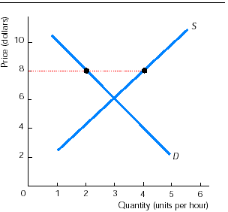
- If there is a shortage of a good, the quantity demanded is ……. than the quantity supplied and the price will ……….
a. less; rise
b. less; fall
c. greater; rise
d. greater; fall

- In the graph on the right, at the price of $8 there is a
a. shortage and the price will rise.
b. shortage and the price will fall.
c. surplus and the price will rise.
d. surplus and the price will fall.

- In a market, at the equilibrium price,
a. neither buyers nor sellers can do business at a better price.
b. buyers are willing to pay a higher price, but sellers do not ask for a higher
price.
c. buyers are paying the minimum price they are willing to pay for any amount
of output and sellers are charging the maximum price they are willing to
charge for any amount of production.
d. None of the above is true.

- For consumers, pizza and hamburgers are substitutes. A rise in the price of pizza ………. the price of a hamburger and ……… in the quantity of hamburgers.
a. raises; increases
b. raises; decreases
c. lowers; increases
d. lowers; decreases

- How does a cold winter affect the equilibrium price and quantity of heating oil?
a. It raises the price and increases the quantity.
b. It raises the price and decreases the quantity.
c. It lowers the price and increases the quantity.
d. It lowers the price and decreases the quantity.

- You notice that the price of milk rises and the quantity of wheat increases. This can be because the
a. demand curve for milk shifts rightward.
b. demand curve for milk shifts leftward.
c. supply curve of milk shifts rightward.
d. supply curve of milk shifts leftward.

- A technological improvement decreases the cost of producing coffee. As a result, the price of a kg of coffee ……… and the quantity of coffee ……...
a. rises; increases
b. rises; decreases
c. falls; increases
d. falls; decreases

- The number of firms producing computer memory chips decreases. As a result, the price of a memory chip ……. and the quantity of memory chips …….
a. rises; increases
b. rises; decreases
c. falls; increases
d. falls; decreases

For the next five questions, suppose that the price of paper used in books rises and at the same time more people decide they want to read books.

- The rise in the price of paper shifts the
a. demand curve rightward.
b. demand curve leftward.
c. supply curve rightward.
d. supply curve leftward.

- The fact that more people want to read books shifts the
a. demand curve rightward.
b. demand curve leftward.
c. supply curve rightward.
d. supply curve leftward.

- The equilibrium quantity of books
a. definitely increases.
b. definitely does not change.
c. definitely decreases.
d. might increase, or decrease, or remain the same.
- The equilibrium price of a book
a. definitely rises.
b. definitely does not change.
c. definitely falls.
d. might rise, or fall, or remain the same.

- Suppose that the effect from people deciding they want to read more books is larger than the effect from the increase in the price of paper. In this case, the equilibrium quantity of books
a. definitely increases.
b. definitely does not change.
c. definitely decreases.
d. might increase, or decrease, or remain the same.

- Which of the following definitely raises the equilibrium price?
a. An increase in both demand and supply.
b. A decrease in both demand and supply.
c. An increase in demand combined with a decrease in supply.
d. A decrease in demand together with an increase in supply.

- Is it possible for the price of a good to stay the same while the quantity increases?
a. Yes, if both demand and supply of the good increase by the same amount.
b. Yes, if demand increases by the same amount that supply decreases.
c. Yes, if supply increases and the demand does not change.
d. No, it is not possible.

Short answers

    - Answer the following questions.
- This year the price of a hamburger is €2 and the price of a compact disc is €12. In terms of hamburgers, what is the relative price of a compact disc? In terms of hamburgers, what is the opportunity cost of buying a compact disc? How are the two answers related?
- Next year the (money) price of a compact disc doubles to €24 and the (money) price of a hamburger stays at €2. Now what is the relative price of a compact disc?
- The following year the (money) price of a compact disc stays at €24 and the (money) price of a hamburger doubles to €4. What is the relative price of a compact disc?
- In the next year, the (money) price of a compact disc doubles to €48 and the money price of a hamburger triples to €12. What is the relative price of a compact disc?

  - Answer the following questions.
  - When drawing a demand curve, what five influences are assumed not to change?
  - If any of these influences change, what happens to the demand curve?
  - When drawing a supply curve, what five influences are assumed not to change?
  - If any of these influences change, what happens to the supply curve?

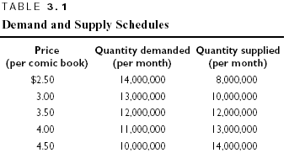

- Answer the following questions
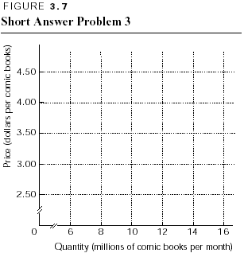
  - Table 3.1 presents the demand and supply schedules for comic books. Graph these demand and supply schedules in Figure 3.7. What is the equilibrium price? The equilibrium quantity?
  - Suppose that the price of magazines, a substitute for comic books, rises so that at every price of a comic book consumers now want to buy 2,000,000 more comic books than before. That is, at the price of $2.50, consumers now will buy 16,000,000 comics; and so on. Plot this new demand curve in Figure 3.7. What is the new equilibrium price? The new equilibrium quantity?

- New cars are a normal good. Suppose that the economy grows rapidly and people’s incomes increase significantly. Use a supply and demand diagram to determine what happens to the equilibrium price and quantity of new cars.

- Used records (LPs) and used compact discs are substitutes. Use a supply and demand diagram to determine what happens to the equilibrium price and quantity of used records when the price of a used compact disc falls because of an increase in the supply of used discs.

- Suppose we observe that the consumption of butter increases at the same time its price rises. What must have happened in the market for butter? Is this phenomenon (an increase in both price and quantity) consistent with the law of demand? Why or why not?

- Suppose that the salaries of oil workers fall. Use a supply and demand diagram to determine how this affects equilibrium price and quantity of gasoline (petrol).

- Chemical companies discover a new, more efficient technology for producing benzene (βενζόλιο – παράγωγο της βενζίνης). Use a supply and demand model to determine how this new method will affect equilibrium price and quantity of benzene.

- The price of a personal computer has continued to fall even though demand increases. Explain.

- Answer the following questions.
  - The market for chickens initially is in equilibrium. Suppose that eating chicken fillets becomes so fashionable that people eat them for breakfast, lunch, and dinner. Use a supply and demand diagram to determine how the equilibrium price and quantity of chicken change.
  - Return to the initial equilibrium (before chicken fillet became fashionable). Now suppose that a heat wave caused the death of thousands of chickens. Use a supply and demand diagram to determine what happens to the equilibrium price and quantity of chicken.
  - Now assume that both the heat wave and the fashion of eating chicken fillet happens at the same time. Use a supply and demand diagram to show what happens to the equilibrium price and quantity of chickens.
(Hint: Can you tell for sure what happens to the price? The quantity?)

ANSWERS

True/False

- T The law of demand points out the negative relationship between a product’s price and the quantity demanded.
- F Demand decreases for normal goods but increases for inferior goods.
- F The term “increase in demand” refers to a rightward shift in the demand curve.
- F Changes in technology is not a factor affecting demand and, therefore, does not shift the demand curve. (Changes in technology will shift the supply curve.)
- F The supply curve shows the minimum price that suppliers must receive in order to produce the last unit supplied.
- T Labour is a resource used to produce CDs, so a rise in its price (workers’ salaries) shifts the supply curve of CDs leftward.
- F The rise in the price of orange juice creates a movement along the supply curve to a larger quantity supplied (that is, upward and rightward), but it does not shift the supply curve.
- T Once at the equilibrium price, and since there is no desire for things to change (both consumers and suppliers are happy), the situation can go on indefinitely until something changes.
- T A surplus of a product brings a fall in its price until it reaches the equilibrium price.
- T The rise in the future price shifts the demand curve rightward and the supply curve leftward; price definitely increases.
- F The inverse relationship between the price and quantity demanded holds along a fixed demand curve. But if the demand curve shifts rightward, the equilibrium price rises and the equilibrium quantity increases.
- T The equilibrium quantity definitely increases when both the demand and supply increase.
- F The price rises if the shift in the demand curve is larger than that the shift in the supply curve; if the shifts are the same size, the price does not change and if the supply shift is larger, price falls.

Multiple choice

- a The law of demand points out that a higher price decreases the quantity demanded and creates a movement upward along the demand curve.
- b The definition of complementary goods is that a rise in the price of one decreases the demand for the other.
- c This is the definition of a “normal good.”
- c A reduction in the price of the product leads to a movement along its demand curve.
- b A rise in the price of a substitute shifts the demand curve rightward.
- a The law of supply points out the positive relationship between the price of a product and the quantity supplied.
- c A change in preferences shifts the demand curve, not the supply curve.
- d Jet fuel is a resource used to produce airplane trips, so a rise in the price (cost) of this resource decreases the supply of airplane trips.
- a An increase in supply is reflected by a rightward shift of the supply curve.
- c A change in the cost to produce a product shifts the supply curve but does not shift the demand curve.
- c An “increase in supply” means that the supply curve shifts rightward; a “decrease in supply” means the supply curve shifts leftward.
- d At equilibrium, consumers and suppliers are satisfied as long as the quantity consumers are willing to buy is equal to the quantity producers are willing to sell.
- c A shortage occurs when the price is below the equilibrium price. The quantity demanded exceeds the quantity supplied and the resulting shortage means price rises until it reaches its equilibrium.
- d There is surplus because the quantity supplied at the price of $8 is 4. This quantity exceeds the quantity demanded, which is 2.
- a Buyers cannot find anyone willing to sell to at a lower price and sellers cannot find anyone willing to buy at a higher price.
- a The rise in the price of a pizza increases the demand for hamburgers, which results in a rise in shift of the supply curve.
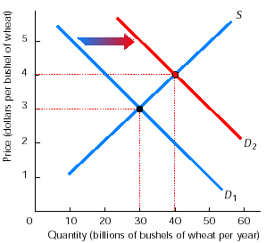
- a The cold winter shifts the demand curve rightward, as consumers increase their demand for heating oil; the supply curve does not shift. As a result, the equilibrium price rises and the quantity increases.
- a As the graph on the right shows, there is an increase in the demand for wheat, so that the demand curve shifts from D₁ to D₂ raises the price of wheat from $3 a bushel (δεμάτιο – μέτρο χωρητικότητας δημητριακών) to $4 and increases its quantity from 30 billion bushels of wheat a year to 40 billion.
- c The technological improvement increases the supply, that is, the supply curve shifts rightward. As a result, the quantity increases and the price falls.
- b The decrease in the number of firms producing memory chips decreases the supply of memory chips, which raises the price and decreases the quantity of chips.
- d Paper is a resource used in the manufacture of books, so a rise in the price of paper shifts the supply curve of books leftward.
- a When people’s preferences change so that they want to read more books, the demand curve for books shifts rightward.
- d The equilibrium quantity increases if the increase in demand is larger than the decrease in supply; it decreases if the change in supply is larger; it does not change if the changes are the same size.
- a Both the increase in demand and decrease in supply lead to a rise in the price, so the equilibrium price definitely rises.
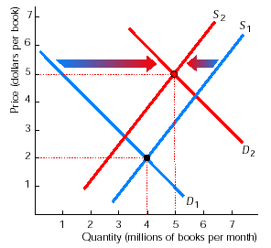
- a If the shift in the demand curve is greater than the shift in the supply curve, the equilibrium quantity increases. This result is illustrated in the graph on the right, where quantity increases from 4 to 5 million.
- c An increase in demand raises price and a decrease in supply also raises price; if the two of them occurring together, price definitely rises.
- a If both the demand and supply increase by the same amount, the price will not change and the quantity will increase.

Short answers

    - The answers are:
      - The money price of a compact disc is €12 per compact disc; the money price of a hamburger is €2 per hamburger. The relative price of a compact disc is the ratio of the money prices, €12 per compact/€2 per hamburger, or 6 hamburgers per compact disc. For the opportunity cost, buying 1 compact disc means using the funds that otherwise could purchase 6 hamburgers. Hence the opportunity cost of buying 1 compact disc is 6 hamburgers. The relative price and the opportunity cost are identical.

      - The relative price of a compact disc is €24 per compact/€2 per hamburger or 12 hamburgers per compact disc.
      - The relative price of a compact disc is €24 per compact/€4 per hamburger, or 6 hamburgers per compact disc.
      - The relative price of a compact disc is €48 per compact/€12 per hamburger, or 4 hamburgers per compact disc.

    - The answers are:
      - The five influences that do not change along a demand curve are prices of related goods, income, the expected future price, population, and consumer tastes and preferences.
      - If any of these factors change, the demand curve shifts.
      - The five influences that are constant when you draw a supply curve are prices of productive resources, technology, number of suppliers, prices of related goods produced, and the expected future price.
      - If any of these influences change, the supply curve shifts. It is very important to remember what influences shift a supply curve and what shift a demand curve.
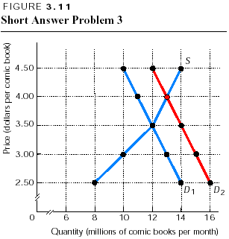
    - The answers are:
      - Figure 3.11 shows the graph of the supply and demand schedules as S and D₁. The equilibrium price is $3.50 a comic book, and the equilibrium quantity is 12,000,000 comic books.
      - The new demand curve is plotted in Figure 3.11 as D₂. The new equilibrium price is $4, and the new equilibrium quantity is 13 million.

    - Because new cars are a normal good, an increase in income increases the demand for them. So, the demand curve shifts rightward, as shown in Figure 3.12. As a result, the equilibrium price rises (from $19,000 to $20,000 in the figure) and the equilibrium quantity also increases (from 10 million a year to 11 million in Figure 3.12).

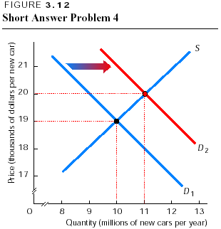
    - The fall in the price of a used compact disc, a substitute for used records, decreases the demand for used records. This change means the demand curve for used records shifts leftward, as shown in Figure 3.13. As a result, the price of a used record falls, (from $8 a record to $6 in the figure) and the quantity decreases (from 40,000 per month to 30,000 in the figure). Note that it is the shift in the demand curve that changed the price and that the shift in the demand curve did not shift the supply curve.

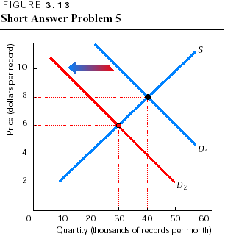
    - In order for both the equilibrium price and quantity of butter to increase, the demand for butter must have increased. The increase in demand leads to a rise in the price and an increase in the quantity of butter. The observation that both the price and quantity increased is consistent with the law of demand. The law of demand states that “other things remaining the same, the higher the price of a good, the smaller is the quantity demanded.” A key part of this law is the “other things remaining the same”, the ceteris paribus condition. When the demand curve for butter shifts rightward, something else that increased the demand for butter changed. So, “other things” have not remained the same and have resulted in a higher price and increased quantity of butter.

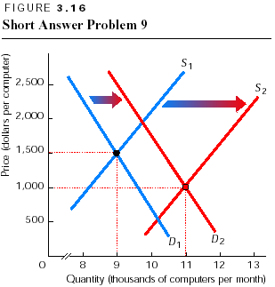
    - Lower wages reduce the price of a resource (labor) used to produce gasoline. As a result, the supply of gasoline increases. This change is shown in Figure 3.14, where the supply curve shifts rightward from S₁ to S₂. The increase in supply lowers the price of gasoline (from 80 cents a gallon to 70 cents in the figure) and increases the quantity (from 10 million gallons a month to 11 million).
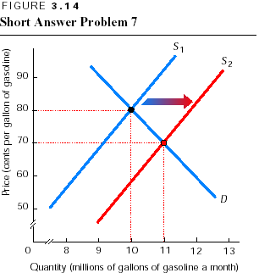
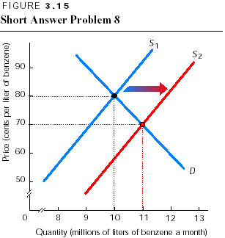
    - New technology increases the supply, so the supply curve shifts rightward. Then, as Figure 3.15 shows, the price falls (from 80 cents a liter to 70 cents in the graph) and the equilibrium quantity increases from (10 million liters of benzene a month to 11 million). This answer and the graph are virtually the same as those in problem 7. Even though a fall in wages and the development of new technology appear not to be similar, the demand and supply model reveals (αποκαλύπτει) that both have the same effect on the price and quantity of the product. This model can easily accommodate these quite different changes. For this reason the demand and supply model is a very important economic tool.

    - Personal computers have fallen in price although the demand for them has increased because the supply has increased even more rapidly. Figure 3.16 illustrates this situation. From one year to the next the demand curve shifted from D₁ to D₂. But over the year the supply curve shifted from S₁ to S₂. Because the supply has increased more than the demand, the price of a personal computer fell (from $1,500 for a personal computer to $1,000 in the graph). The quantity increased (from 9,000 personal computers a month to 11,000 in the graph).

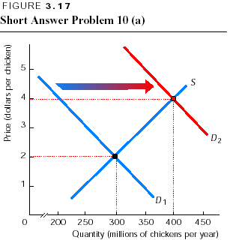
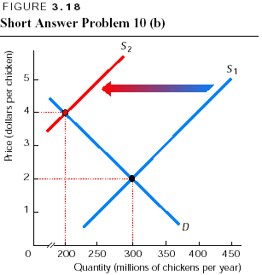
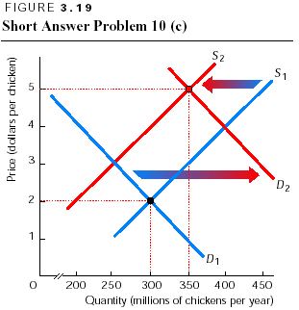
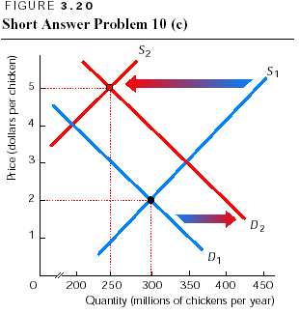
    - The answers are:
      - With the change in people’s preferences - so that they want more chicken fillets and hence more chickens - the demand for chickens increases. The increase in the demand for chickens means that the demand curve for chickens shifts rightward. Figure 3.17 shows this change. The equilibrium price rises (from $2 to $4 per chicken) and the equilibrium quantity of chickens increase (from 300 million to 400 million). Note that the change in people’s preferences does not affect the supply of chicken, so the supply curve does not shift.
      - The heat wave decreases the number of chickens that can be supplied. This change shifts the supply curve for chickens leftward, as Figure 3.18 shows. As a result, the heat wave raises the price of a chicken (from $2 to $4) and decreases the quantity (from 300 million to 200 million).
      - If the demand increases and the supply decreases, the equilibrium price of a chicken rises. But the effect on the quantity is not clear. Figures 3.19 and 3.20 show why. In Figure 3.19, the demand shift is larger than the supply shift, and the equilibrium quantity increases to 350 million chickens. But in Figure 3.20, the size of the shifts is reversed (αντιστρέφεται), and the supply shift is greater than the demand shift. Because the supply shift is larger, the equilibrium quantity decreases to 250 million chickens. So unless you know which shift is larger, you cannot determine whether the quantity increases (when the demand shift is larger); decreases (when the supply shift is larger); or stays the same (when both shifts are the same size). However, regardless of the relative sizes, Figures 3.19 and 3.20 show that the price will definitely increase, to $5 in both figures.

