CHAPTER 13 – MONOPOLISTIC COMPETITION AND OLIGOPOLY

I. Monopolistic Competition

Do you ever wonder why companies spend so much money trying to convince us that their washing powder will leave our clothes the cleanest or when a man opens one of their beers, he will be suddenly surrounded by beautiful women? This describes the essence (ουσία) of monopolistic competition (μονοπωλιακός ανταγωνισμός), a market structure that combines elements (στοιχεία) of perfect competition and monopoly.
Like perfect competition, firms produce goods that have many similar characteristics with other goods of their class. Even the most experience drinker will have a hard time tasting the difference between KEO, Carlsberg, Heineken, and a dozen or so other beers. But men, like any other consumer, can be innocent. When a man orders a specific beer, suddenly the place is filled with young, beautiful women in bikinis playing volleyball, even if it is snowing outside. If a woman is using a specific body cream, she suddenly looks ten years younger and all men are after her. Even if you realize that not all advertising is true, it must succeed somewhere otherwise European companies would not have spent €50 billion on television advertising alone in 2001.
The obvious goal of advertising is to give information about the advantages of a product, or to create the perception of differences when none really exist. It does not really matter if there are actual contrasts in products, as long as the consumer believes there is.
As we know from perfect competition, if products are identical (and known to be so) then the firm faces a horizontal demand curve and accepts the market price. Firms would prefer to face a downward sloping demand curve where they have some degree of control over the price they can charge for the good, since by charging a higher price, they may be able to increase profits. Contrasting a perfectly competitive firm to a monopolist facing a downward sloping demand curve shows that monopoly profits are higher.
Firms advertise to create some degree of brand loyalty among consumers who believe their product is superior, and may be willing to pay a bit more for that brand than another. By creating differences in goods, firms then have a downward sloping demand curve for their product, like a monopolist.

Figure 1
Demand and MR in
monopolistic competition

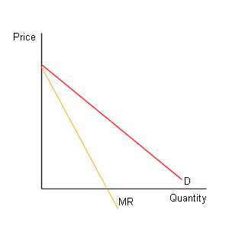
Remember that in the perfectly competitive industry, if a firm tries to raise price above the market price, demand falls to zero as consumers switch to perfect substitutes. However, in monopolistic competition where the firm faces a downward sloping demand curve, the firm can raise prices without losing all of its customers. As it was emphasized in the previous chapter, whenever a firm faces a downward sloping demand curve, its marginal revenue is below the demand curve. Figure 1 shows the relationship that exists between a monopolistically competitive firm’s demand and marginal revenue curves. The amount of sales it will lose depends on the elasticity of demand in the range of the demand curve where it is raising prices. A firm that estimates that the demand for its good in the relevant price range is inelastic can raise prices and profits as well. Or it can lower price to increase profits if the relevant range of the demand curve is elastic.

The reason why a monopolistically competitive firm faces a downward sloping demand curve is that even though the product of a monopolistically competitive faces competition from many similar brands, there are differences in the brands, either actual or imaginary. Consider corn flakes, for example. Walking down the supermarket shelves, we can choose from corn flakes with the name of Kellogg's, Alpen, and a few local brands. Why do we choose one brand over the other? Kellogg's charges more for their brand than the local or no-name brand. There probably is no significant difference in taste, variety or vitamin content between the two brands, yet many consumers are willing to pay a higher price for the Kellogg's box. The reason is advertising. Heavy advertising by Kellogg's convinces some shoppers that Kellogg's makes the better quality flake and these consumers are willing to pay a higher price. Brand loyalty allows Kellogg's to charge a higher price and for its corn flakes not loose all of its demand. However, since there are many close substitutes, the demand curve that Kellogg's faces will most likely be relatively elastic. As Kellogg's increases the price of its corn flakes, demand will fall as consumers will switch to substitute brands.
A monopolistically competitive market is characterized by:
- many buyers and sellers,
- differentiated (διαφοροποιημένα) products, and
- easy entry and exit.
The monopolistically competitive market is similar to perfect competition in that there are many buyers and sellers who can enter or leave the market easily in response to economic profits or losses. A monopolistically competitive firm, though, is similar to a monopoly in that it produces a product that is different from that produced by all other firms in the market. The restaurant market in Cyprus provides a good example of a monopolistically competitive market. Each restaurant has its own recipes, decoration, atmosphere, etc. but also must compete with many other similar restaurants.
Figure 2
Entry of new firms

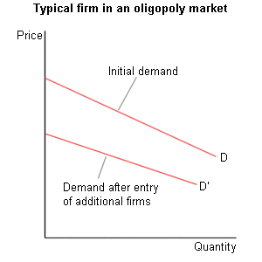
While Figure 1 seems similar to the demand and marginal revenue curves facing a monopolist, there is a critical difference. In a monopolistically competitive market, the number of firms changes as firms enter or leave the industry. When new firms enter the market, the customers are spread over a larger number of firms and the demand for each firm's product declines. An increase in the number of firms also tends to result in an increase in the elasticity of demand for each firm's products (since demand is more elastic when more substitutes are available). Figure 2 illustrates the shift in a typical firm's demand curve that occurs when additional firms enter a monopolistically competitive market.

II. Output and Price in Monopolistic Competition

Let's examine the determination of short-run equilibrium in a monopolistically competitive output market. Figure 3 illustrates a possible short-run equilibrium for a typical firm in a monopolistically competitive market. As with any profit-maximizing firm, a monopolistically competitive firm maximizes its profits by producing at a level of output at which MR = MC. In Figure 3, this occurs at an output level of Q₀. The price is determined by the amount that customers are willing to pay to buy Q₀ units of output. In the example below, the demand curve indicates that a price of P₀ will be charged when Q₀ units of output are sold.

In a monopoly industry, economics profits could persist indefinitely due to the existence of barriers to entry. In a monopolistically competitive industry, however, the existence of economic profits results in the entry of additional firms into the industry. As additional firms enter, the demand for each firm's product will fall and become more elastic. This reduction in demand, though, results in a reduction in the level of economic profit received by a typical firm. Entry into the market continues until a typical firm receives zero economic profits. This possibility is illustrated in Figure 4 which shows a monopolistically competitive firm in a state of long-run equilibrium. This firm maximizes its profit by producing an output level of Q'. The equilibrium price is P'. Since the price equals average total cost at this level of output, a typical firm receives a level of economic profit equal to zero.
Figure 4
Long-run profits
Figure 3
Economic profits

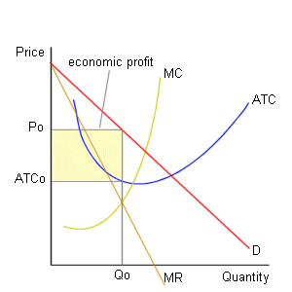
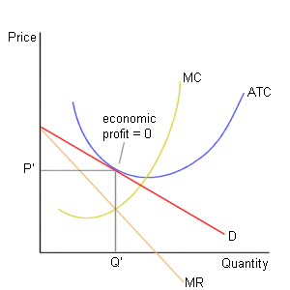

Oligopoly

An oligopoly market is characterized by:
- a small number of firms,
- either a standardized or a differentiated product,
- recognized mutual interdependence (αμοιβαία αλληλοεξάρτηση), and
- difficult entry.
Because there are few firms in an oligopoly industry, each firm's output is a large share of the market. Because of this, each firm's pricing and output decisions have a substantial effect on the profitability of other firms. Furthermore, when making decisions concerning price or output, each firm has to take into account the expected reaction of competitor firms. If McDonald's lowers the price of their Big Macs, for example, the effect on their profits would be very different if Burger King responded by lowering the price on their Whopper sandwiches by a larger amount. Because of this mutual interdependence, oligopoly firms engage in strategic behavior. Strategic behavior occurs when the best outcome for one party is determined by the actions of other parties. This requirement makes oligopoly theory difficult and no completely satisfactory model has been developed.

The kinked (τεθλασμένη) demand curve model describes a situation in which a firm assumes that other firms will match its price reductions but will not follow price increases. The kinked demand model explains the price inflexibility (ακαμψία των τιμών) that characterizes oligopoly. Let’s see the price strategy of an oligopolist selling Q₁ units of output at a price P₁. Point A in Figure 5 is called a kink. If the oligopolist lowers his price, his competitor will also lower their prices. So, the kinked demand curve D₁ shows that as he lowers his price, quantity demanded increases slowly. As price falls along the inelastic section of the curve (below A), total revenue (P x Q) will also fall. On the other hand, if the monopolist increases his price, his competitors will most probably not increase their prices. When this happens, the high priced product will no longer be attractive to consumers and quantity demanded will fall by a large amount. Here, the demand curve is quite elastic (above A) which means that a price increase brings a fall in total revenue since competitors do not follow a price increase. So, according to the kinked demand curve model, the oligopolist does not often raise or lower prices (unless, of course, costs change).

In a dominant firm oligopoly, the market consists of one very large firm that has a significant cost advantage over its many smaller competitors. The large firm operates as a monopoly, setting its price and output to maximize its profit. The small competitor firms then act as perfect competitors, taking as given the price set by the dominant firm. The dominant firm oligopoly model applies only to an industry in which one firm has a cost advantage over its competitors.
The dominant firm model can readily be observed in the airline and retail petrol stations industry. When a major airline announces a fare cut, the other airlines rapidly follow with their own price cuts to prevent a loss of market share. Local petrol station prices rarely diverge (διαφέρουν). It is not uncommon to see several petrol stations on the same neighbourhood with identical prices even though they appear to be in a very competitive environment. If one station cuts the price per litre, the others must quickly follow or they will rapidly lose market share as consumers switch to the lower priced station. Note that this situation is not yet observed in Cyprus because the government controls the price of petrol and all stations must charge the same price per litre. This situation will change as from May 2004 when Cyprus becomes a full member of the European Union.

QUESTIONS

True/False

- Product differentiation gives each monopolistically competitive firm a downward sloping demand curve.
- Monopolistically competitive firms compete only on price.
- Similar to a monopoly, a monopolistically competitive industry has large barriers to entry.
- In the short run, to maximize its profit, a monopolistically competitive firm produces the level of output that sets P = ATC.
- Monopolistically competitive firms can earn an economic profit in the long run.
- A monopolistically competitive firm can earn an economic profit if it develops new products.
- Monopolistically competitive firms have large marketing and selling costs.
- An oligopoly will consider the reactions of other competitor firms before it decides to cut its price.
- The kinked demand curve model of oligopoly predicts that the firm will not change its price often.

Multiple choice

- A monopolistically competitive firm is like a monopoly firm as long as
a. both face perfectly elastic demand.
b. both earn an economic profit in the long run.
c. both have MR curves that lie below their demand curves.
d. neither is protected by high barriers to entry.
1
- A monopolistically competitive firm is like a perfectly competitive firm as long as
a. both face perfectly elastic demand.
b. both earn an economic profit in the long run.
c. both have MR curves that lie below their demand curves.
d. neither is protected by high barriers to entry.
1
- Product differentiation means
a. that monopolistically competitive firms compete on quality and marketing.
b. that a firm makes a product that is slightly different from that of its
competitors.
c. makes the firm’s demand curve downward sloping.
d. All of the above answers are correct.
- In the graph on the right, how much output does the firm produce?
a. Q_{a}
b. Q_{b}
c. Q_{c}
d. None of the above
1
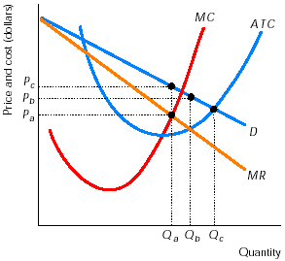
- In the graph on the right, what price does the firm charge?
a. P_{a}
b. P_{b}
c. P_{c}
d. None of the above
1
- In the graph on the right, what type of profit or loss is the firm earning?
a. An economic profit
b. A normal profit
c. An economic loss
d. An accounting loss

- In the graph on the right, in the long run,
a. new firms will enter, and each existing firm’s demand decreases.
b. new firms will enter, and each existing firm’s demand increases.
c. existing firms will leave, and each remaining firm’s demand decreases.
d. existing firms will leave, and each remaining firm’s demand increases.

- Monopolistically competitive firms constantly develop new products in an effort to
a. make the demand for their product more elastic.
b. increase the demand for their product.
c. increase the marginal cost of their product.
d. None of the above answers is correct.

- Which of the following statements about monopolistically competitive firms is correct?
a. They produce more than the capacity amount of output.
b. They have high selling costs.
c. They produce the efficient amount of output.
d. They rarely advertise.

- A firm that has a kinked demand curve assumes that, if it raises its price, …….. of its competitors will raise their prices and that, if it lowers its price, …….. of its competitors will lower their prices.
a. all; all
b. none; all
c. all; none
d. none; none

- In the dominant firm model of oligopoly, the large firm acts like
a. an oligopolist.
b. a monopolist.
c. a monopolistic competitor.
d. a perfect competitor.

- In the dominant firm model of oligopoly, the smaller firms act like
a. oligopolists.
b. monopolists.
c. monopolistic competitors.
d. perfect competitors.

Short answers

- Draw a graph illustrating a monopolistically competitive that earns economic profit in the short run.

- Draw the long run-equilibrium for a monopolistically competitive firm. What conditions must be satisfied for long-run equilibrium?

- Suppose that a monopolistically competitive firm is initially in long-run equilibrium and it succeeds in further differentiating its product. As a result, the demand for its product increases. Draw a graph showing what happens to this firm in the short run. Without drawing a diagram, explain what happens in the long run.

ANSWERS

True/False

- T By making its product different from those of its competitors, each monopolistically competitive firm has a unique product and a downward-sloping demand curve.
- F Because its product is differentiated, monopolistically competitive firms compete on product quality and marketing, as well as on price.
- F Similar to a perfectly competitive industry, a monopolistically competitive industry has many firms in it because there are no barriers to entry.
- F Monopolistically competitive firms use the same rule as all firms: to maximize their profit, produce so that MR equals MC.
- F The firms cannot earn an economic profit in the long run because there are no barriers to entry.
- T Monopolistically competitive firms constantly try to further differentiate their products, and developing new products is one method they use.
- T Marketing and advertising play key roles in monopolistically competitive firms’ efforts to differentiate their products.
- T This mutual interdependence (αμοιβαία αλληλοεξάρτηση) makes oligopoly a difficult industry structure to analyze.
- T Shifts in the MC curve that do not move it beyond the vertical section of the MR curve have no effect on the price that the firm charges nor on the quantity it produces.

Multiple choice

- c Both have downward-sloping demand curves, so both have MR curves that lie below their demand curves.
- d The absence of high barriers to entry is the reason for the large number of firms in each industry.
- d Answer b is the definition of product differentiation and answers (a) and (c) are results of product differentiation.
- a The monopolistically competitive firm maximizes its profit by producing so that MR = MC.
- c With the firm producing Q_{a} output, the demand curve shows that a price of Pc is the highest price that can be charged and still sell all that is produced.
- a The firm earns an economic profit because, at output of Q_{a}, P > ATC.
- a New firms enter because they, too, want to earn an economic profit. As these firms enter, they decrease the demand for the existing firms’ products, which reduces the economic profit.
- b If the firm can increase the demand for its product, it can temporarily earn an economic profit.
- b Monopolistically competitive firms have large selling costs trying to differentiate their products.
- b With this set of assumptions, the business believes that it will lose a large amount of sales if raises its price, but pick up only a small amount if it lowers its price.
- b When setting its price and quantity, the dominant firm acts as if it were a monopoly.
- d The smaller firms are unable to affect the price charged by the large firm.

Short answers

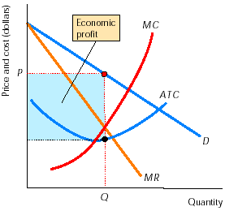
- The graph on the right shows the short-run equilibrium of a monopolistically competitive firm. To maximize its profit, the firm produces so that MR = MC. At this level of output, P > ATC, so the firm earns an economic profit, as illustrated by the shaded rectangle. This diagram is identical to that of a monopoly firm earning an economic profit. Both monopoly and monopolistically competitive firms face downward-sloping demand curves, both produce so that MR = MC, and, as long as P > ATC, both firms earn an economic profit.

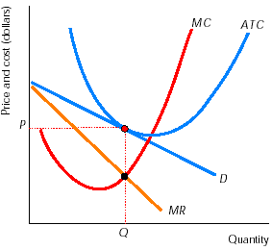
- The graph on the right shows the long-run equilibrium for a monopolistically competitive firm. Two conditions must be satisfied for this diagram to show the long-run equilibrium. Think of these requirements as a firm condition and a market condition. For the firm to be satisfied, it must maximize its profit, which requires that it produces the amount of output so that MR = MC. Then, for long-run equilibrium in the market, firms must have no incentive either to enter or exit the industry. As a result, there can be no economic profit, so P = ATC. (This second condition is not a choice of the firm; the firm would rather earn an economic profit. But it is required for the market to be in long-run equilibrium) Both conditions - production at MR = MC and P = ATC - are met in the graph so it does illustrate the long-run equilibrium.

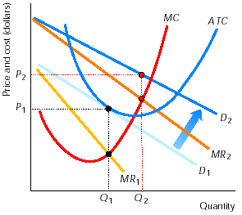
- The graph on the right shows the effect when a monopolistically competitive firm succeeds in differentiating its product more. The demand for the firm’s good increases, thereby shifting the demand curve and the MR curve rightward. As a result, the firm increases its output from Q₁ to Q₂ and raises its price from P₁ to P₂. The firm earns an economic profit.

In the long run, other firms copy its product. As they copy, the demand for the initial firm’s good decreases; that is, the demand curve and MR curve shift leftward. In the end, demand decreases enough that the initial firm - and all other firms that copied the product - no longer earn an economic profit. At this point, other firms do not have an incentive to copy the good and the market is in long-run equilibrium.

