CHAPTER 12 – MONOPOLY

I. Market Power

Market power is the ability to influence the market, and in particular the market price, by influencing the total quantity supplied. Monopolies face no competition and exercise market power.

- A monopoly is an industry in which there is only one supplier of a product with no close substitutes and in which barriers to entry prevent the entry of other firms. If there are close substitutes for the product, the firm is not a monopoly because it faces competition from producers of the substitutes.
- Barriers to entry are obstacles (εμπόδια) that prevent new firms from entering an industry. For instance, a firm may acquire control of all of a vital input. Barriers to entry may be legal or natural barriers.
1. Legal barriers to entry create legal monopolies. Examples of legal barriers include:
a) Public franchise. Granting a legal right that allows only one firm the liberty to produce the product. For example, CYTA has a public franchise to offer telecommunication services.
b) Government license. Requiring a license or certificate to work in an occupation. For instance, a license is required to practice law. Licensing does not necessarily create a monopoly but it does restrict competition.
c) Patent and copyright. Granting an exclusive right to the inventor of a product or service or to the creator of a literary, musical, dramatic, or artistic work.
- Natural barriers to entry create natural monopolies. Natural monopolies can occur when economies of scale allow one firm to supply the entire market at a lower cost than would be possible if two or more companies were in the industry. Public utilities often are deemed to be natural monopolies.
A monopoly may price discriminate or may charge a single price.
a) Price discrimination is the practice of selling different units of a good or service for different prices.
- A single-price monopoly sells each unit of its product for the same price.

II. A Single-Price Monopoly’s Output and Price Decision

The demand curve facing a monopoly is a normal downward sloping demand curve and the same as the industry demand curve, since monopoly is the only firm in the industry. Marginal revenue, MR, is the change in total revenue from producing and selling an additional unit of output. The key feature of a single-price monopoly is that marginal revenue is less than the price; that is, MR < P.

Figure 1

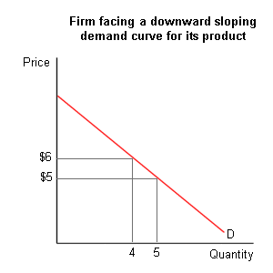
Marginal revenue is less than the price because the monopoly must lower its price to sell an additional unit of output. The increased sale raises the firm’s revenue by the amount of the price, but this increase is offset by the (now) lower price, which reduces the amount collected on the sale of the initial units produced. Let's use an example to see why this is true. Consider the situation described in Figure 1. When the price is $6, the firm can sell 4 units of output while receiving a total revenue equal to $6 x 4 = $24. If it wishes to sell the 5th unit of output, it must lower the price to $5. Its total revenue in this case will equal $25. Marginal revenue in this case equals: change in total revenue / change in quantity = $1 / 1 = $1. As this example illustrates, marginal revenue will always be less than the price of the good when the firm faces a downward sloping demand curve. This is because the firm has to lower the price not just on the last unit sold but instead on all units that it sells. In this case, the firm received an additional $5 in revenue from the same of the 5th unit, but it lost $4 in revenue when it lowered the price on the first 4 units by $1. Thus, total revenue increased by only $1 when the 5th unit is sold.

Figure 2 illustrates the relationship that exists between the marginal revenue curve and the demand curve. The demand curve provides the price that can be charged at each level of output. Since we know that MR is less than the price, the marginal revenue curve must lie below the demand curve. Using the results from the chapter on elasticity, we can also note that marginal revenue is positive in the elastic section of the demand curve (since a price decrease results in an increase in total revenue in this case), is zero when demand is unit elastic (since total revenue remains unchanged when the price falls when demand is unit elastic) and is negative when demand is inelastic (since total revenue declines when the price falls in this portion of the demand curve.) So,

- If demand is elastic, total revenue increases when the monopoly lowers its price to sell an additional unit of output. Hence the MR is positive (Fig. 12.3).
- If demand is unit elastic, total revenue does not change when the monopoly lowers its price to sell an additional unit of output, and MR = 0.
- If demand is inelastic, total revenue decreases when the monopoly lowers its price to sell an additional unit of output. As a result, the MR is negative.

Figure 2
Elasticity and Total Revenue

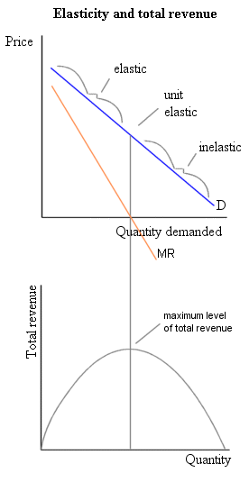
These relationships are illustrated in Figure 2. As this diagram illustrates, total revenue is maximized at the level of output at which demand is unit elastic (and MR = 0). It might be tempting to assume that this is the best output level for the firm to produce. This would be the case, though, only if the firm's goal is to maximize its revenue. A profit-maximizing firm must take its costs as well as its revenue into account in determining how much output to produce. As in all other market structures, average revenue (AR) is equal to the price of the good. (To see this note that AR = TR/Q = (PxQ)/Q = P.) Thus, the price given by the demand curve is the average revenue that the firm receives at each level of output.
So, a single-price monopoly never produces a level of output for which demand is inelastic. If it did, the firm could increase its profit by decreasing its production, thereby simultaneously raising its revenue and lowering its costs.

Figure 3

Monopoly’s economic profit
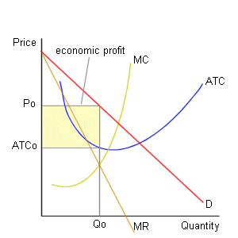
As discussed in Chapter 11, the monopoly maximizes its profit by producing the level of output at which its marginal revenue equals its marginal cost (MR = MC). The monopoly determines its price from the demand curve as the highest price possible to charge and still sell the amount it produces. For the monopoly firm described in Figure 3, MR = MC at an output level of Q₀. The price that this firm will charge is P₀ (the price that the firm can charge for this level of output given by the demand curve). Since the price (P₀) exceeds average total cost (ATC₀) at this level of output, the firm receives economic profit. These monopoly profits, though, differ from those received by a perfectly competitive firm in that these profits will persist in the long run because the barriers to entry protect the firm from competitors.
Figure 4
Monopoly’s economic losses

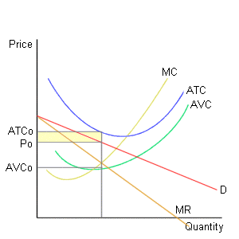
Of course, it is possible that a monopoly firm may experience losses. Figure 4 illustrates this possibility. In this diagram, the firm has economic losses equal to the shaded area. Since price is above AVC, though, it will continue operations in the short run, but will leave the industry in the long run. Note that the ownership of a monopoly does not guarantee the existence of economic profits. It is quite possible to have a monopoly in the production of a good that few people want.

III. Comparing Monopoly and Competition

The left-hand side section of Figure 5 illustrates the consumer and producer surplus that is received in a perfectly competitive market. The right-hand side section of Figure 5 illustrates the loss in consumer and producer surplus that results when a perfectly competitive industry is replaced by a monopoly. As this diagram indicates, the introduction of a monopoly firm causes the price to rise from P(pc) to P(m) while the quantity of output falls from Q(pc) to Q(m). The higher price and reduced quantity in the monopoly industry causes consumer surplus to fall by the area ACBP(pc). This does not all represent a cost to society, though, since the rectangle P(m)CEP(pc) is transferred to the monopolist as additional producer surplus. The net cost to society is equal to triangle CBF. This net cost of a monopoly is called deadweight loss. It is a measure of the loss of consumer and producer surplus that results from the lower level of production that occurs in a monopoly industry.

Figure 5 – Efficiency of perfect competition & monopoly

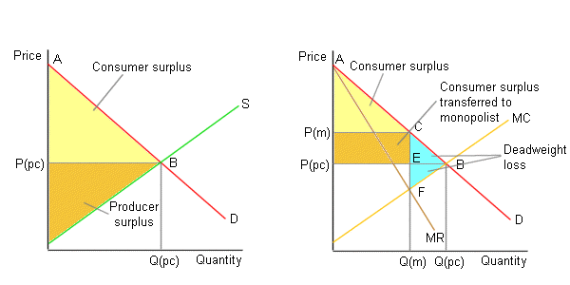

Some economists argue that the threat of potential competition may encourage monopoly firms to produce more output at a lower price than the model presented above suggests. This argument implies that the deadweight loss from a monopoly is smaller when barriers to entry are less effective. Fear of government intervention (in the form of price regulation or antitrust action) may also keep prices lower in a monopoly industry than would otherwise be expected.

A related point is that it is unreasonable to compare outcomes in a perfectly competitive market with outcomes in monopoly market that results from economies of scale. While competitive firms may produce more output than a monopoly firm with the same cost curves, a large monopoly firm produces output at a lower cost than could smaller firms when economies of scale are present. This reduces the amount of deadweight loss that might be expected to occur as a result of the existence of a monopoly.

QUESTIONS

True/False

- Barriers to entry are essential to a monopoly.
- Patents grant the patent owner a legal monopoly.
- A single-price monopoly charges each consumer the highest single price the consumer will pay.
- A difference between a perfectly competitive firm and a monopoly is that the monopolist’s decisions about how much to product affect the good’s price.
- For a single-price monopoly, marginal revenue, MR, equals price, P.
- To maximize their profits, both monopolies and perfectly competitive firms produce the level of output that sets MR = MC.
- When a single-price monopoly is maximizing its profit, P > MC.
- A monopoly can earn an economic profit indefinitely.

Multiple choice

- Suppose that one bus company in your city is granted a license by the Town Hall so that it is the only bus company that may operate within the city limits. Granting this license is an example of a
a. natural barrier to entry.
b. case in which a single firm controls a resource necessary to produce the
good.
c. price-discriminating monopoly.
d. legal barrier to entry.

- Which of the following is not a legal barrier to the entry of new firms in an industry?
a. Licensing
b. Economies of scale
c. Issuing a patent
d. Granting a public franchise

- In order to sell more output, a single-price monopoly must ……. its price and a price-discriminating monopoly must ……. its price.
a. raise; raise
b. raise; lower
c. lower; raise
d. lower; lower

- John has a monopoly on sales of Christmas trees. To increase his sales from 100 trees to 101 trees, he must drop the price of all his trees from €28 to €27. What is Max’s marginal revenue when he lowers his price and increases his sales from 100 to 101 trees?
a. €2,800
b. €28
c. €27
d. – €73

- A monopoly finds that when it produces 20 units of output, its demand is elastic. At this level of output,
a. its marginal revenue necessarily is positive.
b. its marginal revenue necessarily is zero.
c. its marginal revenue necessarily is negative.
d. none of the above is correct because the marginal revenue does not depend
upon the elasticity of demand.

- A monopoly finds that the marginal revenue from producing another unit of output exceeds the marginal cost of the unit. Then, to increase its profit, the monopolist will
a. produce the unit.
b. not produce the unit, but not cut back its production at all.
c. not produce the unit and cut back its production by at least one unit.
d. do none of the above.

- If a monopoly is producing a level of output such that marginal cost exceeds marginal revenue, to increase its profits the firm
a. should raise its price and decrease its output.
b. should lower its price and increase its output.
c. should lower its price and decrease its output.
d. none of the above because the firm has economic losses and it cannot
change this fact.
1
- Which of the following is true for a single-price monopoly?
a. Price always equals marginal cost, that is, P = MC at all levels of output.
b. For all levels of output, price equals marginal revenue, that is, P = MR.
c. In the short run, the monopoly might earn a normal profit or incur an
economic loss.
d. None of the above because all the statements are false.

- A single-price monopolist will maximize its profits if it produces the amount of output such that
a. price equals marginal cost, that is, P = MC.
b. price equals marginal revenue, that is, P = MR.
c. marginal revenue equals marginal cost, that is, MR = MC.
d. price equals average total cost, that is, P = ATC.

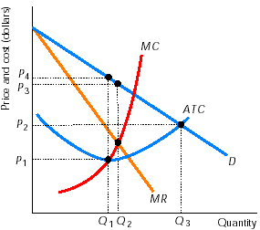
- In the graph on the right, a profit-maximizing single-price monopoly will produce
a. Q₁
b. Q₂
c. Q₃
d. None of the above.

- In the graph on the right, a profit-maximizing single-price monopoly will set a price of
a. P₁
b. P₂
c. P₃
d. P₄

- In the short run a monopoly can
a. earn only an economic profit.
b. earn only an economic profit or a normal profit.
c. earn only a normal profit.
d. earn an economic profit, or a normal profit, or incur an economic loss.

Short answers

- Why is marginal revenue less than price for a single- price monopoly?

- In a small college town, Helen’s Bookshop has a monopoly in selling textbooks. Helen’s fixed costs are $100, and her total costs are shown in Table 1.
  - Complete Table 1 by computing average total cost and marginal cost.
  - Table 2 lists points on the demand curve facing Helen’s Bookshop. Copy the marginal costs from Table 1 and complete the table.
  - What is Helen’s profit-maximizing quantity of output? At what price will she sell her books? What is her total economic profit?
  - Plot the demand curve and the MR, ATC, and MC curves corresponding to the data in parts (a) and (b). Show the equilibrium output and price. On your diagram, illustrate the area that equals Helen’s economic profit.

Table 1
Table 2
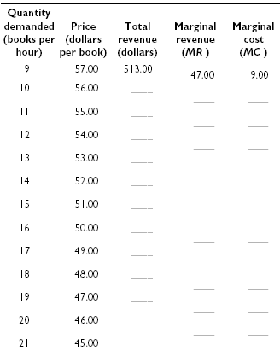
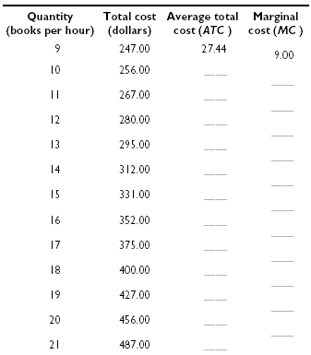

- “I don’t really understand how monopoly firms decide how much to produce and what price to charge. Can you give me some help? I would really like just a rule or two to remember.” Because you have studied this material, you are in a position to help this student. Offer a couple of rules that this student can use to determine, first, how much is produced, and second, what price is charged.

ANSWERS

True/False

- T Without barriers to entry, other firms will enter the industry so that it no longer is a monopoly.
- T Patents legally prohibit anyone else from producing the same good.
- F A single-price monopoly charges each consumer the same price.
- T The monopolist is the only producer in the market, so the monopolist’s decisions about how much to produce determine the market price.
- F For a single-price monopoly, P > MR.
- T No matter its industry type, a firm producing so that MR = MC earns the maximum profit.
- T A single-price monopoly produces at MR = MC. Because P > MR, the equality between MR and MC means that P > MC.
- T Barriers to entry limit the competition faced by the monopoly, so it is able to earn an economic profit indefinitely.

Multiple choice

- d The bus company has been granted a legal monopoly.
- b The other possibilities are legal barriers to entry.
- d All monopolies must lower their price in order to sell more output.
- d Total revenue when 100 trees are sold is €2,800; when 101 trees are sold, it is €2,727. Hence the marginal revenue from the 101st tree is –€73.
- a When demand is elastic, MR is positive; when demand is inelastic, MR is negative.
- a As long as MR exceeds MC, producing the unit adds to the firm’s total profit because it adds more to revenue than to cost.
- a Output should be decreased because the last units produced lower the firm’s profit and, by reducing output, the firm can raise its price.
- c Like any firm, if demand for its good declines or its costs rise, in the short run a monopoly might earn a normal profit or incur an economic loss.
- c All firms maximize their profit by producing the amount of output so that MR = MC.
- b The firm produces the level of output that sets MR = MC.
- c The firm produces Q₂ of output. The highest price the firm can charge and sell this amount of output is P₃.
- d In the short run, depending on demand and cost, any firm can earn an economic profit, a normal profit, or incur an economic loss.

Short answers

- To sell an additional unit of output, a monopoly must lower its price. The additional unit sold at the lower price adds to the firm’s revenue an amount equal to the price. But a single-price monopoly also lowers the price to previous customers who had been paying more. Marginal revenue equals the new revenue, the new price, minus the loss of revenue from lowering the price to previous customers, so marginal revenue is less than the price.
Table 3
Table 4
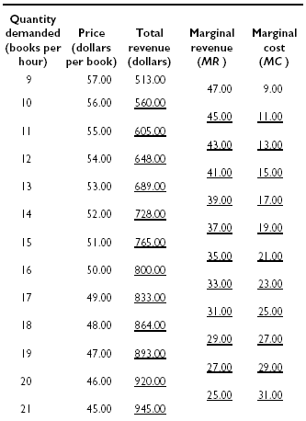
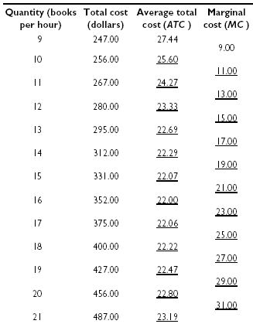

- The answers are:
  - Table 3 shows the average total costs and marginal costs. The average total costs are calculated by dividing the total costs by the total outputs. For instance, the average total cost when 10 books are sold is 256/10 or $25.60. The rest of the ATCs are calculated similarly. Marginal cost equals the change in the total cost divided by the change in output. For example, the marginal cost going from 10 to 11 units of output is (267-256)/(11-10) which equals $11.00. The rest of the MCs are calculated in the same way.
  - Table 4 gives the total revenue and marginal revenue. Total revenue equals (Quantity)x(Price). For example, total revenue at the quantity of 10 books is (10)x($56) = $560. After finishing with the total revenue, the marginal revenue can be calculated as the change in total revenue divided by the change in output. Take the marginal revenue going from 10 to 11 books sold per hour as an example. This marginal revenue equals (605-560)/(11-10) or $45. The rest of the marginal revenues are calculated the same way.
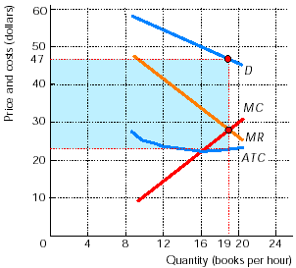
  - To maximize her profit, Helen produces at MR = MC. Between 18 and 19 books the marginal revenue is $29 and between 19 and 20, it is $27. So, at 19 books the marginal revenue is $28. Similarly, the marginal cost is $27 between 18 and 19 books and $29 between 19 and 20 books, which indicates that at 19 books the marginal cost is $28. Marginal revenue equals marginal cost at an output of 19 books, so this quantity is the profit-maximizing level of output. The data for the demand curve show that Laura can sell 19 books at a price per book of $47, so the monopoly price is $47 per book. (Note that the price, $47, is greater than the marginal cost, $28.) Helen’s economic profit equals her total revenue minus her total cost. From Table 4, the total revenue when selling 19 books is $893, and, from Table 3, the total cost of selling 19 books is $427. Helen’s total economic profit is $893 – $427 = $466.
  - The graph on the right shows the demand, MR, and cost curves. The area of the shaded rectangle equals Helen’s economic profit.

    - “A couple of mechanical rules might be helpful when we are studying how a monopoly selects its output and determines its price. First, decide how much the firm produces. Second, determine the price charged.

“To find the profit-maximizing quantity, use the MR and MC curves. The equilibrium quantity is where these curves cross: Draw a vertical line down to the horizontal axis and read the quantity. Then, to find the profit-maximizing price, continue this vertical line up to the demand curve. From the intersection of the demand curve and your vertical quantity line, draw a horizontal line over to the price axis. Where this line meets the price axis is the profit-maximizing

