CHAPTER 11 – COMPETITION

A market is perfectly competitive (πλήρως ανταγωνιστική) when:
  - Many firms are selling an identical (ίδιο ακριβώς, πανομοιότυπο) product.
  - Many buyers demand that product.
  - Entry into the industry is not restricted.
  - Firms already in the industry have no advantage over potential new entrants.
  - Firms and buyers are completely informed about each firm’s price for the product.
Perfect competition arises when each firm produces a good or service that has no unique characteristics, so consumers do not care from whom they buy. Each firm in a perfectly competitive market is a price taker (δέκτης τιμών), that is, a firm that cannot affect the price of its product. Price-taking behavior happens when a single firm produces a tiny (very small) fraction of the market’s total output. Although market demand is not perfectly elastic, demand for a price-taking firm’s product is perfectly elastic. Figure 1 below illustrates the relationship between the market and an individual firm. The equilibrium price is determined by the interaction of market demand and market supply. Since the output of each firm is such a small share of this total output, no individual firm can affect the market price. Thus, each firm faces a demand curve for its product that is perfectly elastic at the market price.

Figure 1 – Market and Individual demand curves in perfect competition

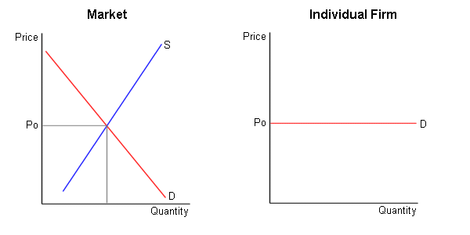
Economists assume that firms select prices and output levels that maximize their profits (μεγιστοποίηση κερδών). When economists discuss profits, however, they are referring to the concept of economic profit defined as:

Economic profit = total revenue - all economic costs

Total revenue (συνολικά έσοδα) is the number of units sold times price (P x Q). Average revenue (μέσο έσοδο) is total revenue divided by the number of units sold; average revenue is equal to the price of the product. Economic costs include all opportunity costs, regardless of whether these costs are explicit or implicit.
Explicit costs (φανερό κόστος) are the accounting costs of production. This includes what it costs the firm in wages, materials and other inputs to produce the good or service.
Implicit costs (αφανές κόστος) refer to the opportunity cost for the businessman of running his or her own firm.
For example, consider Mario who graduates from Oxford University with an MBA degree. However, Mario’s father is an electrician and he expects him to take over the business after his graduation. So, Mario turns down a €100,000 a year job with World Bank as an economic analyst. Now, let’s go forward a year and see Mario's accounting books for his first year in business.
- Total revenues = €500,000
- Total costs (explicit) = €440,000
- Profit (accounting) = total revenue - total explicit costs; €500,000 - €440,000 = €60,000
Did Marios make a wise choice?
Well, he is making money according to his accountant. However, we need to consider Mario's economic profit that includes his implicit costs as well. In this way we can judge what Mario is giving up by not working for another firm rather than running his own business. Mario's implicit cost equals the salary that he turned down when he rejected World Bank's job offer, an amount equal to €100,000.
As a result, Mario's total (economic) cost for his first year equals his explicit plus implicit costs or €540,000 (440,000 + 100,000).
Mario's economic profit equals his revenues (€500,000) minus his costs (€540,000) or a loss of €40,000.
Mario is incurring economic losses by running his own business and we conclude he would have been better off if he had taken the job with the World Bank. Should he stay with the family business and hope that next year's profit is higher, or should he take up the World Bank’s offer?
To see the other side of the story, let’s assume that Mario stays in the family profession for another year and due to his improving reputation, revenues rise to €620,000 and costs remain constant at €440,000. Now, Mario's accounting profits have risen to an impressive €180,000. And Mario has positive economic profits equal to €80,000. The presence of economic profits indicates that Mario is making more running his own business than he would earn working for someone else, or perhaps in some other business.
So, let’s summarize:
Accounting profit = Total Revenue – Explicit costs
Economic profit = Total Revenue – Economic Costs (Explicit and Implicit)

Since economic costs include both implicit and explicit costs while accounting costs consist of explicit costs, economic costs are always greater than accounting costs. The difference between these two measures of cost is the opportunity cost of resources supplied by the firm's owner. The opportunity cost of these owner-supplied resources is called normal profit (κανονικό κέρδος).

A firm produces the number of units where profit is maximized. Remember this very important point for the remainder of the course:
The profit maximizing level of output for a firm is where
marginal cost equals marginal revenue:
MC = MR

Marginal cost (οριακό κόστος) refers to the additional cost to the firm of producing another unit of output (MC = ΔTC/ΔQ). Marginal revenue (οριακό έσοδο) is the additional revenue of producing (and selling) one more unit of output (MR = ΔTR/ΔQ).

Assume that the firm produces another unit of output and marginal revenue is greater than marginal cost (MR > MC) for this unit. This is critical information to the firm since it indicates that the additional revenue gained from producing one more unit of output exceeds the cost of producing that unit. Total profits will rise if that unit is produced.

In contrast, assume that, as the firm in question produces another unit of output, marginal revenue is smaller than marginal cost (MR < MC) for this unit. This indicates that the additional revenue gained from producing one more unit of output is less than the cost of producing that unit. Total profits will fall if that unit is produced.
Figure 2

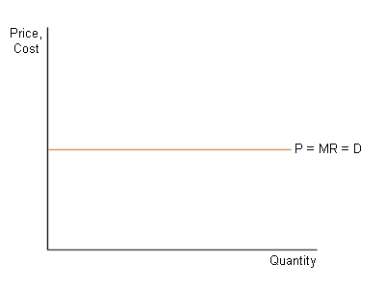
As long as MR > MC when another unit is produced, output should increase in order to rise total profits. When output reaches a level where
MR < MC for the additional unit, then output should fall to increase total profits. Firms maximize profits at an output level where MR = MC.

Figure 3
Profit maximizing output

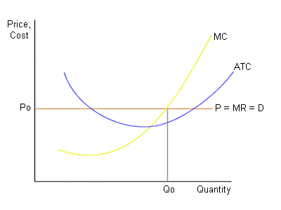
If a firm faces a perfectly elastic demand curve, the price of the good is the same at all levels of output. In this case, marginal revenue is simply equal to the market price. Suppose, for example, that corn sells for €1 per dozen. The marginal revenue received by a farmer from the sale of an additional dozen of corn is simply the price of €1. This possibility is illustrated in Figure 2.
Figure 4
Economic Profits

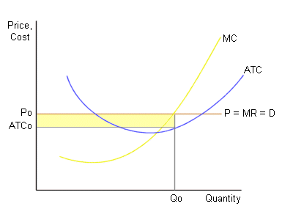
Marginal and average total cost curves have been added to Figure 3. As this diagram indicates, a profit-maximizing firm will produce at the level of output (Q₀) at which MR = MC. The price, P₀, is determined by the firm's demand curve. At an output level of Q₀, the firm faces average total costs equal to ATC₀. So, its profit per unit of output equals P₀ – ATC₀ (= revenue per unit or output - total cost per unit of output). Economic profits are equal to: profit per unit x number of units of output. An inspection of Figure 4 should confirm that economic profits equal the area of the shaded rectangle (notice that the height of this rectangle equals profit per unit of output and the base equals the number of units of output). If a firm has economic profits, the owners get a return on their investment that exceeds that which they could get if their resources had been used in an alternative manner. In this case, existing firms will stay in the market and new firms will enter the market.

Suppose that P < ATC at the level of output at which MR = MC. Will the firm continue operations? To determine this, we have to compare the firm's loss if it stays in business with its loss if it shuts down. If the firm decides to shut down, it's revenue will equal zero and its costs will equal its fixed costs. (Remember, fixed costs must be paid even if the firm shuts down.) So, the firm receives an economic loss equal to its fixed costs if it shuts down. It will stay in business in the short run even if it receives an economic loss as long as its loss is less than its fixed costs. This will occur if the revenue received by the firm is large enough to cover its variable costs and some of its fixed costs. In mathematical terms, this means that the firm will stay in business as long as:

TR = P x Q > VC
Figure 5 – Loss minimization
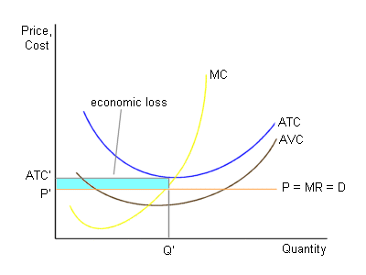
Dividing both sides of the above expression by Q, we can write this condition in an alternative form as:

P > AVC

What this means in practice, is that the firm will stay in business if the price is greater than average variable cost (AVC); the firm will shut down if the price is less than average variable cost (P < AVC). Consider the situation illustrated by Figure 5. In this case, losses are minimized at the level of output at which MR = MC. This occurs at an output level of Q'. Since the level of average total cost (ATC') exceeds the market price (P'), this firm receives economic losses. Since the price is greater than AVC, however, this firm will choose to stay in business in the short run.
Figure 6 – Shut down rule

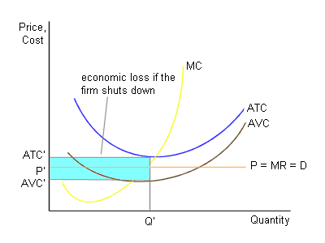
If the firm illustrated in Figure 5 were to shut down, it would lose its fixed costs. The shaded area in Figure 6 equals the firm's fixed costs (to see this, note that the height of this rectangle equals the firm's AFC and the base equals Q - therefore, the shaded area equals AFC x Q = TFC). A comparison of the firm's losses if it shuts down (the shaded area in Figure 6) with its losses if it continues to operate in the short run (the shaded area in Figure 5) indicates that this firm will have lower losses if it decides to remain in business in the short run. So, this discussion should suggest that the shut down rule for a firm is: shut down if P < AVC. In the long run, of course, firms will leave the industry if the have economic losses (remember, there are no fixed costs in the long run.)

Figure 7 – Break even

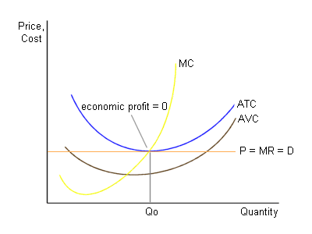
If the market price is just equal to the minimum point on the ATC curve, the firm will receive a level of economic profits equal to zero. In this case, the owners of the firm are receiving a rate of return on all of their resources that is just equal to that which they could receive in any alternative employment. When this occurs, there is neither an incentive to enter or leave this market. This possibility is illustrated in Figure 7.
Figure 8 – The supply curve

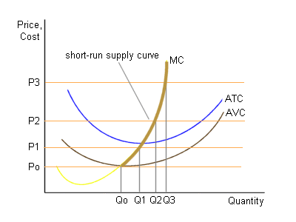
So far, we have seen that a perfectly competitive firm will produce at the point at which P = MC, as long as P > AVC. Figure 8 indicates that at prices of P₀, P₁, P₂, and P₃, this firm would produce output levels of Q₀, Q₁, Q₂, and Q₃, respectively. If you are observant enough you should see that the MC curve can be used to determine the quantity of output that this firm will supply whenever P > AVC. Since the portion of the MC curve that lies above the AVC curve indicates the quantity of output supplied at each price, it is the firm's short-run supply curve. In general, a perfectly competitive firm's short-run supply curve is the portion of its marginal cost curve that lies above the AVC curve. This is illustrated by the darker part of the MC curve in Figure 8.

In the long run, firms will enter the market if there are positive economic profits and will leave the market if there are economic losses. Let's think about the consequences of such entry and exit. Suppose that the current equilibrium price in a market results in economic profits for a typical firm. In this case, firms enter the market and the market supply curve shifts to the right. As market supply increases, the equilibrium price falls. This process will continue until firms no longer have an incentive to enter the market. As Figure 9 indicates, a typical firm will receive zero economic profits in this long-run equilibrium situation. Suppose instead that a typical firm has economic losses. In this situation, firms will leave the industry in the long run. As they exit, the market supply curve shifts to the left and the equilibrium price rises. Firms will continue to leave until the market supply curve has shifted enough so that a typical firm receives zero economic profits (as illustrated in Figure 9). So, a long-run equilibrium is characterized by zero economic profits by a typical firm. This means, of course, that the owners of a typical firm receive accounting profits just equal to normal profit.

Figure 9 – Long-run equilibrium

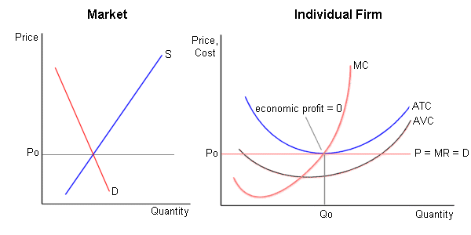

QUESTIONS

- In a perfectly competitive industry many firms produce very similar but slightly different products.
- In a perfectly competitive industry, no single firm can significantly affect the price of the good.
- The market demand curve in a perfectly competitive industry is horizontal.
- A perfectly competitive firm must decide what price to charge for its goods.
- If it does not shut down, to maximize its profit a perfectly competitive firm produces the level of output that sets MR = MC.
- If P > ATC, the firm has an economic loss.
- If the price is below a firm’s minimum ATC, it immediately shuts down.
- A perfectly competitive firm’s supply curve shows the quantities of output supplied at alternative prices as long as the firm earns an economic profit.
- A perfectly competitive firm’s supply curve is its ATC curve.
- A perfectly competitive firm can earn an economic profit, a normal profit, or incur an economic loss in the short run.
- A perfectly competitive firm can earn an economic profit, a normal profit, or incur an economic loss in the long run.
- Firms exit an industry whenever they cannot earn an economic profit.
- A firm making zero economic profit makes no profit at all.

Multiple choice

- Which of the following is NOT a characteristic of a perfectly competitive industry?
a. A downward-sloping market demand curve.
b. A perfectly elastic demand for each firm.
c. Each firm decides its quantity of output.
d. Each firm produces a good slightly different from that of its competitors.
1
- Of the following, which is a perfect competitor?
a. CYTA, the major provider of Internet services in Cyprus.
b. SIGMA, one of the major television networks in Cyprus.
c. A banana grower in Pafos.
d. DeBeers, the provider of more than 80% of the diamonds in the world.

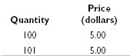
- Using the table on the right, what is the marginal revenue from selling 101 units of output rather than 100?
a. $5
b. $500
c. $505
d. $0

- For a perfectly competitive firm, MR always equals
a. ATC.
b. P.
c. AVC.
d. none of the above because MR is not always equal to the same thing.

- John runs a shop that sells printers. John’s business is a perfect competitor and can sell each printer for a price of €500. The marginal cost of selling one printer a day is €300, the marginal cost of selling a second printer is €400, and the marginal cost of selling a third printer is €550. To maximize his profit, John should sell
a. one printer a day.
b. two printers a day.
c. three printers a day.
d. more than three printers a day.

- Which of the following is necessarily true when a perfectly competitive firm is in short-run equilibrium?
a. MR = MC.
b. P = minimum LRAC.
c. P = ATC.
d. All of the above are true at short-run equilibrium.

- In the short run, a perfectly competitive firm can
a. earn an economic profit.
b. earn a normal profit.
c. incur an economic loss.
d. All of the above answers are possible.

- A perfectly competitive firm is definitely suffering an economic loss when
a. MR < MC.
b. P > ATC.
c. P < ATC.
d. P > AVC.

- The firm illustrated in the graph on the right (next page) will produce how much output?

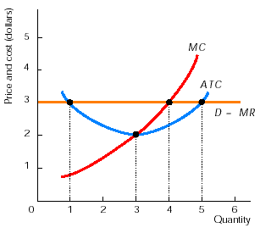
a. 1 unit
b. 3 units
c. 4 units
d. 5 units

- The firm illustrated in the graph on the right is
a. earning an economic profit.
b. earning a normal profit.
c. incurring an economic loss.
d. in long-run equilibrium.

- If a perfectly competitive firm is incurring an economic loss, it
  - always shuts down immediately.
  - continues to operate until either the price rises or its costs fall so that it no longer has an economic loss.
  - shuts down if P > AVC.
  - shuts down if P < AVC.

- For prices below the minimum average variable cost, a perfectly competitive firm’s supply curve is
a. horizontal at the market price.
b. vertical at zero output.
c. the same as its marginal cost curve.
d. the same as its average variable cost curve.

- In the short run, which of the following is FALSE?
  - Perfectly competitive firms can possibly earn an economic profit.
  - The number of firms is fixed.
  - To maximize its profit, a perfectly competitive firm produces enough output so that MR = MC.
  - Perfectly competitive firms always produce at the minimum ATC.

- When will new firms want to enter an industry?
a. When MR = MC for the existing firms in the industry.
b. Any time the price of the good has risen.
c. When the new firms can earn economic profits.
d. When there are external economies.

- Suppose that firms in a perfectly competitive industry are earning economic profits. As time passes by,
  - other firms enter the industry so that price rises and economic profits fall.
  - some firms leave the industry so that both the price and economic profits rise.
  - other firms enter the industry so that both price and economic profits fall.
  - nothing happens because there are no incentives for change.

- In the long run, a perfectly competitive firm can
a. earn an economic profit.
b. earn a normal profit.
c. incur an economic loss.
d. All of the above are possible.
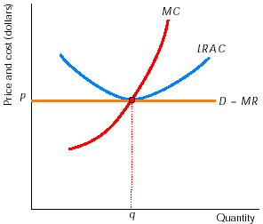
- In the graph on the right, the firm is producing q. Producing q
  - cannot be the long-run equilibrium because the firm is not maximizing its profit.
  - cannot be the long-run equilibrium because the firm is earning an economic profit.
  - cannot be the long-run equilibrium because the firm is incurring an economic loss.
  - is the long-run equilibrium.

- Which of the following is true when a perfectly competitive firm is in long-run equilibrium?
a. MR = MC.
b. P = minimum LRAC.
c. P = ATC.
d. All of the above conditions are true.

- If firms in an industry are incurring an economic loss, then as some exit, price …….. and the surviving firms’ economic losses ……..
a. rises; do not change
b. rises; become smaller
c. falls; become larger
d. falls; become smaller

Short answers

- Why will a firm in a perfectly competitive industry choose not to charge a price either above or below the equilibrium price?

- Answer the following questions:
a. Draw a diagram illustrating the case of a perfectly competitive firm that is earning an economic profit. In the diagram, show the amount of the economic profit.
b. In a diagram, show the case of a perfectly competitive firm that is earning only a normal profit, that is, it is not incurring an economic loss nor making an economic profit.
c. Draw a diagram to illustrate the case of a perfectly competitive firm that is incurring an economic loss but is continuing to operate. Be sure to include the AVC curve. Show the amount of the economic loss.

- Why will economic profits be zero at long-run equilibrium in a perfectly competitive industry? Be sure to mention the roles played by economic profits and losses.

- “I really don’t understand why a perfectly competitive firm wants to produce so that MR = MC. I understand that the goal of the firm is to earn the most profit possible. But why does it produce so that MR = MC? I think that it produce so that MR > MC so that revenues exceed costs and it earns a profit.” This student is making a basic error. Can you correct the student’s analysis?

- “You know, one thing that seems strange about this chapter is the claim that a business will operate even though it is losing money. I would think that the moment a business started to have economic losses, unless there was some chance that the loss would be reversed in the future, the business would shut down.” This student is right: A business operating even though it incurs an economic loss does seem strange. Can you explain why this situation happens?

ANSWERS

True/False

- F In a perfectly competitive industry, each of the many firms produces an identical product.
- T Each firm is a price taker.
- F The firm’s demand curve is horizontal, but the market demand curve slopes downward.
- F A perfectly competitive firm is a price taker, for instance, a farmer growing oranges can charge only the going price for his oranges.
- T Produce the level of output so that MR = MC is the rule followed to maximize profits.
- F If P < ATC, the firm suffers an economic loss.
- F If P < ATC, the firm suffers an economic loss but it continues to operate as long as P > AVC.
- F The supply curve shows the amount that will be produced regardless of whether the firm earns an economic profit or not.
- F The firm’s supply curve is its MC curve above its AVC curve.
- T In the short run, depending on market demand and the firm’s costs, a perfectly competitive firm can earn an economic profit, incur an economic loss, or earn a normal profit.
- F In the long run, the process of entry and exit means that a perfectly competitive firm earns only a normal profit.
- F Even if they do not earn an economic profit, firms remain in the industry as long as they earn a normal profit.
- F A firm making zero economic profit earns a profit equal to what its owners would earn elsewhere in the best alternative business.

Multiple choice

- d In perfect competition, each firm produces a good identical to that of its competitors.
- c The other possibilities describe industries with only a few firms, so they cannot be perfectly competitive firms.
- a MR = (ΔTR)/ΔQ so in this case MR = (505-500)/(101-100) = 5. More directly, for a perfectly competitive firm, marginal revenue equals price.
- b Because a perfectly competitive firm can always sell another unit of output at the going market price, the market price is the firm’s marginal revenue.
- b The second printer adds €100 to John’s total profit, so it will be sold; however, the third printer would lower John’s total profit by €50, so it will not be sold.
- a The condition MR = MC is necessary for the firm to be maximizing its profit.
- F If P < ATC, the firm suffers an economic loss but it continues to operate as long as P > AVC.
- F The supply curve shows the amount that will be produced regardless of whether the firm earns an economic profit or not.
- c The firm produces the level of output so that MR = MC, 4 units of output.
- a The price, $3, exceeds the average total cost of producing 4 units of output, so the firm earns an economic profit.
- d As long as P > AVC, the firm’s losses are smaller if it operates than if it shuts down.
- b At prices below the minimum average variable cost, the firm shuts down and produces zero.
- d In the long run, perfectly competitive firms produce at the minimum ATC, but that is not necessarily the case in the short run.
- c The possibility of earning an economic profit leads to entry into the industry.
- c The entry of new firms lowers the price and economic profits, thereby driving the industry toward its long-run equilibrium.
- b Free entry and exit into the industry mean that only a normal profit is possible in the long run.
- d The graph illustrates the long-run equilibrium for a perfectly competitive firm.
- d MR = MC means that the firm is maximizing its profit; P = minimum LRAC occurs because competition forces firms to produce as efficiently as possible; P = ATC means that the firm is earning only a normal profit.
- b Firms continue to leave as long as they incur an economic loss, thereby driving the price higher and reducing the survivors’ economic losses.

Short answers

- If a firm in a perfectly competitive industry charged a price even slightly higher than the going equilibrium market price, it would lose all of its sales. So, it will not charge a price above the equilibrium price. Because it can sell all it wants at the going price, the firm would not be able to increase its sales by lowering its price. So, the firm will not charge a price below the market price because such a lower price would decrease its total revenue and thereby decrease its profits.

- The answers are:
Figure 1

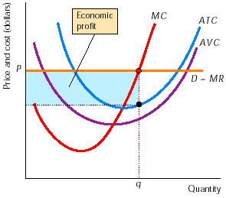
  - Figure 1 shows the case in which the firm earns an economic profit. To maximize its profit, the firm produces the level of output such that MR = MC. Because P > ATC, the firm is earning an economic profit, as shown in the figure.
  - A perfectly competitive firm earning a normal profit is illustrated in Figure 2. To maximize its profit the firm produces q, the level of output that makes MR = MC. Because P = ATC, the firm is earning only a normal profit.
  - Figure 3 illustrates the case of a firm that incurs an economic loss but continues to operate. The firm suffers an economic loss because, at the profit-maximizing (loss-minimizing) level of output q, P < ATC. But the firm minimizes its loss by operating because P > AVC.
Figure 2

Figure 3

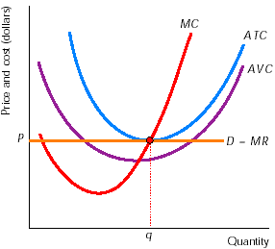
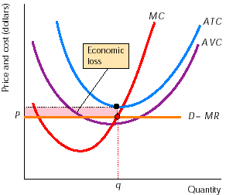

- In a perfectly competitive industry, the existence of positive economic profits attracts the entry of new firms. Entry of new firms shifts the market supply curve rightward, causing the price to fall and firms’ profits to decline. However, entry continues as long as there are positive economic profits. Similarly, the existence of economic losses results in firms exiting the industry. Exit shifts the market supply curve leftward, causing the price to rise and (surviving) firms’ losses to decline. Exit continues as long as economic losses are being incurred. So only when economic profits and losses are zero, so that a normal profit is earned, is there no tendency for firms to enter or exit the industry. The industry is in long-run equilibrium only when economic profits are zero because economic profits or losses are the signals to enter or exit an industry.

- “The student is making just one mistake. It is an easy mistake to make, but it is also a big one! The idea is that a firm wants to maximize its total profit. That is, it wants to maximize the difference between its total revenue and its total costs. The student is confusing these terms with marginal revenue and marginal cost. Remember that the word “marginal” means “additional”. So, marginal revenue means additional revenue, and marginal cost means additional cost.

“Now, suppose that MR is larger than MC. For example, suppose that a potato farmer finds that the marginal revenue from growing an additional acre of potatoes is €5,000 and that the marginal cost of doing so is only €3,000. Then, growing the additional acre of potatoes adds more to the farmer’s revenue than it adds to the cost, so this acre will add to the farmer’s total profit. In particular, this acre adds €2,000 (marginal revenue of €5,000 minus marginal cost of €3,000) to the farmer’s total profit. The farmer will want to grow this additional acre of potatoes.

“Next, suppose that the next acre still has a marginal revenue of €5,000, but that it has a marginal cost of €4,000. MR still is larger than MC, so this acre will continue to add to the farmer’s total profit. It adds less (only €1,000), but the key point is that it adds. So the farmer will plant this acre, too.

“You can see that the added profit from the second acre is not as much as the added profit from the first acre. But who cares? The important thing to note is that as long as the acre adds to the profit, the farmer, who wants to get the maximum possible total profit, will still grow the second acre of potatoes. The deal is that as long as the acre adds to total profit, the farmer will grow more potatoes. In other words, as long as MR > MC, the additional acre adds additional profit, so the farmer will go ahead and grow the additional acre. Only when MR = MC the additional acre does not add to profit. So the farmer simply stops adding acres when MR = MC.”

- “At first thought, it does seem strange that a business would continue to produce even though it loses money. A more careful thought will reveal to us that whenever the price of output falls below the break-even point (the minimum average total cost) but remains above the shutdown point (the minimum average variable cost), the firm continues to produce even though it has economic losses. The key here is that the firm’s owner, when suffering an economic loss, wants to make the loss as small as possible. “If the owner shuts down, the firm still must pay its fixed costs. (Recall that fixed costs are independent of output; whether the firm produces 10 million units or 0 units, fixed costs remain the same.) So if the owner shuts down, the total loss will equal the total fixed cost. The owner compares this loss to the loss when operating. If the price exceeds the average variable cost, the owner loses less by operating the business. When P > AVC, the firm earns enough revenue to pay all its variable costs and have some revenue left over to cover part of its fixed costs. In this case, by operating the business, the owner loses less than the total amount of the fixed costs. The loss is smaller than would be if the owner shut down, so the owner will operate the business as long as P > AVC. But, if P < AVC, the loss from running the business exceeds the total fixed cost because the business’s revenue is not enough to cover all of the variable costs. Hence when the average variable costs exceed the price, the owner will close the business.”

