CHAPTER 10 – OUTPUT AND COSTS
I. Decision Time Frames

- The firm has one objective: profit maximization. In order to have maximum profits, the firm must take many decisions. One of these is the decision of how to produce a given quantity of output. This decision depends on the relationship between a firm’s output and costs, which in turn depends on the time frame. There are two time frames:
1. the short run.
2. the long run.
- The short run is a period of time during which the quantity of at least one input (εισροή) is fixed and the quantities of the other inputs can be varied. Variable inputs are those for which it is possible to change the quantity used in the short run. Fixed inputs are those whose amount cannot be changed in the short run. There is not a specific amount of time that divides the short run from the long run for all industries. Short-run decision can be easily reversed.
- The long run is the time frame in which the quantities of all resources can be varied. Plant size (μέγεθος βιομηχανικής μονάδας), as well as labor and all other resources, are variable in the long run. Long-run decisions are not easily reversed.
II. Short-Run Technology Constraint
Table 1 - TP
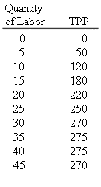
To increase output in the short run, a firm must increase the amount used of a variable input. In the short run, a simplified version of this relationship is provided by a firm's total product (TP) (also known more formally as total physical product - TPP). TP shows the relationship that exists between the maximum level of output that can be produced by a firm and its level of labor use, holding other inputs and technology constant. (Remember, the short run is defined to be the period of time in which capital cannot be changed.) Table1 shows an example of a possible total product function.

A careful inspection of Table 1 indicates that output initially increases more rapidly as the level of labor use increases, but ultimately increases by smaller and smaller amounts. In the example illustrated above, output even declines at higher levels of labor use (note that output declines from 275 to 270 when the level of labor use increases from 40 to 45). Economists argue that equal increases in the level of labor use will ultimately result in progressively smaller increases in output in virtually all production processes. This is a consequence of the law of diminishing returns, which is discussed below. TP can also be shown graphically by plotting the data in Table 1. As was true in the table above, Figure 1 suggests that output initially rises more rapidly as labor use increases. Beyond some point, however, TP starts to rise by less and less with each additional unit of labor. It is possible (as in the example here) that TPP may eventually fall when too many workers are present.
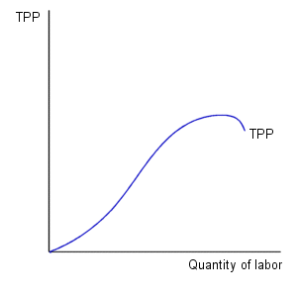

Figure 1
Table 2 – TP and AP
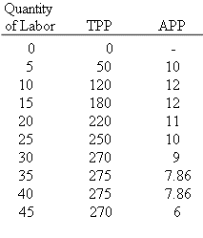
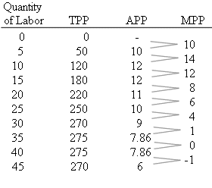
The relationship between the level of input use can also be represented through the average product (AP) of labor (also know more formally as average physical product – APP). The AP is defined as the ratio of total product to the quantity of labor (AP = TP/Q_{L}). The average product for the firm described above has been added to Table 1. Notice how the value of AP is equal to the ratio of TP to the quantity of labor in each row of this table. As in this example, economists expect that the AP may initially rises but will ultimately decline as a result of the law of diminishing returns. The average product of labor is what is meant when economists talk about labor productivity. So, when you hear references to rising or declining labor productivity, you'll now know that they're talking about changes in AP.

Table 3 - MP

The marginal product (MP) (also known more formally as just marginal physical product - MPP), is another useful and important concept. MP is defined as the additional output that results from the use of an additional unit of a variable input, holding other inputs constant. It is measured as the ratio of the change in output (TPP) to the change in the quantity of labor used. In mathematical terms, this can be expressed as:
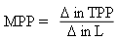
Table 3 continues the estimated MP for each of the reported intervals. Be sure that you understand how the MP is computed from the information contained in the first two columns of this table. For example, consider the interval between 10 and 15 units of labor. Note that since TP increases by 60 (from 120 to 180) when the quantity of labor increases by 5, the MP of labor in this interval equals 60/5 = 12. As Table 3 indicates, the MP is positive when an increase in labor use results in an increase in output; the MP is negative when an increase in labor use results in a decrease in output.

When the firm experiences diminishing marginal returns, the marginal product of labor curve falls; that is, the marginal product of an additional worker is less than the marginal product of the previous worker. The law of diminishing returns states that, as a firm uses more of a variable input without changing the quantity of fixed inputs, the marginal product of the variable input eventually diminishes. Figure 3 illustrates the law of diminishing returns and how the MP is associated with the TP curve (see also Table 3). MP rises in the range in which TP is increasing at a more rapid rate and declines in the range in which TP increases at a declining rate. MP equals zero at the point at which TP reaches a maximum and is negative when TP declines.

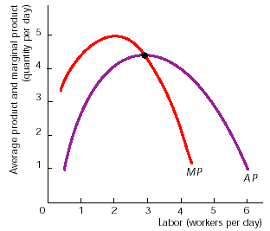
As Figure 3 shows, the MP and AP curves intersect at the maximum level of AP. The reason for this is clearly mathematical and has nothing to do with economics itself. For a number of workers below 3, MP is greater than AP. This means that an additional worker adds more to output than the average worker is producing. In this case, the average has to increase. An analogy is quite useful here. Suppose that your grade in a class at any point in time is formed by taking the average of all of the grades that you have achieved up to that point in time. If your score on an additional test (this may be thought of, quite appropriately in many cases, as a "marginal grade") exceeds your average, your average grade will rise. Using similar reasoning, if your marginal grade is less than your average grade, your average will decline. In the same manner, the average physical of labor will decline when the marginal product of labor is less than the average physical product of labor.
Figure 3 – AP and MP

Careful examination of Figure 3 shows that AP increases whenever the number of workers is less than 3. AP declines, however, when the number of workers is greater than 3. Since AP increases up to this point and declines after this point, AP must reach a maximum when 3 workers are employed (at the point at which MP = AP).
III. Short-Run Cost
Table 4
TFC and TVC

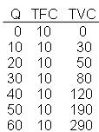
In the short run, total costs (TC) consist of two categories of cost: total fixed costs and total variable costs. Total fixed costs (TFC) are costs that do not vary with the level of output. The level of total fixed costs is the same at all levels of output (even when output equals zero). Examples of such fixed costs include rent, annual license fees, mortgage payments, interest payments on loans, and monthly connection fees for utilities (note that this last category includes only fixed monthly charges, not the portion of utility fees that varies with the level of use). Total variable costs (TVC) are costs that vary with the level of output. Labor costs, raw material costs and energy (electricity, petrol, etc) costs are examples of variable costs. Variable costs are equal to zero when no output is produced and increase with the level of output.
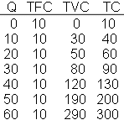
Table 4 contains a listing of a hypothetical set of total fixed cost and total variable cost schedules. As Table 4 shows, total fixed costs are the same at each possible level of output. Total variable costs are expected to rise as the level of output rises. As Table 5 indicates, we can use the TFC and TVC schedules to determine the total cost schedule for this firm. Note that, at each level of output, TC = TFC + TVC.
Table 5 - TC

Figure 4 below contains graphs of total fixed cost, total variable cost and total cost curves. Since total fixed costs are the same at all levels of output, a graph of the total fixed cost curve is a horizontal line. The total variable cost curve increases as output increases. Initially, it is expected to increase at a decreasing rate (since marginal productivity increases initially, the cost of additional units of output decline). As the level of output rises, however, variable costs are expected to increase at an increasing rate (as a result of the law of diminishing marginal returns). Since total cost equals the sum of total variable and total fixed costs, the total cost curve is just the vertical summation of the TFC and TVC curves.
Figure 4 – TFC, TVC and TC

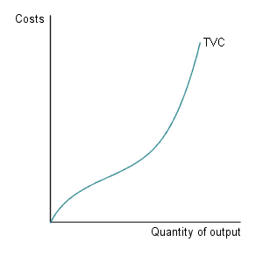
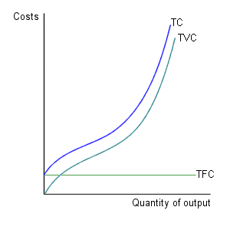
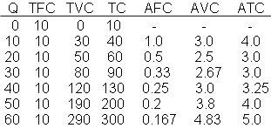
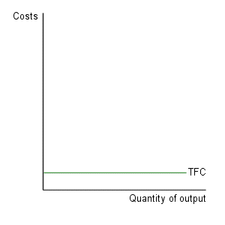
Average fixed cost (AFC) is defined as: AFC = TFC / Q. Note that average fixed costs always decline as the level of output increases .
Table 6 - AFC, AVC, ATC
Average variable cost (AVC) is defined as: AVC = TVC / Q. It is expected that average variable costs will initially decrease as output increases but will eventually increase as output continues to rise. The reason for the eventual increase in AVC is the law of diminishing returns discussed above. If each additional worker adds progressively less additional output, the average cost of the additional output must eventually increase.
Average total cost (ATC) is defined as: ATC = TC / Q. Note that ATC can also be measured as: ATC = AVC + AFC (since TC = TFC + TVC, TC/Q = TFC/Q + TVC/Q).

Table 6 shows how AFC, AVC and ATC are calculated.

In addition to these average cost measures, it is also useful to measure the cost of an additional unit of output. The cost of an additional unit of output is called marginal cost (MC). Marginal cost can be measured as:
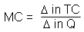
Table 7 – Marginal cost
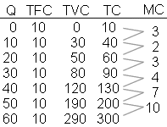
A marginal cost schedule has been added to Table 7 below. Be sure that you understand how marginal cost is computed in this table. Consider, for example, the interval between 10 and 20 units of output. In this case, total costs increase by 20 (from 40 to 60) when 10 additional units of output are produced, so in this interval, marginal cost is 20/10 = 2. You should remember that the MC and MP are related. When MP increases, MC decreases; when MP falls, MC increases – a direct consequence of the law of diminishing returns.
Figure 5

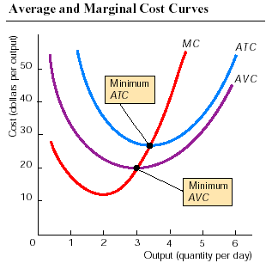
It is important that you understand the relationship between MC, AVC and ATC. You need to know three important points about Figure 5.
- First, both the ATC and AVC curves are U-shaped. The MC curve also is U-shaped, but the portion that slopes upward is the most important.
- Second, the MC curve intersects the ATC and AVC curves at their minimum points. In other words, when the MC equals the ATC, the ATC is at its minimum.
- Third, following the relationship between a marginal and an average, when the MC curve is below the ATC or AVC curves, the ATC or AVC slope downward (decrease). Similarly, when the MC curve is above the ATC or AVC curves, the ATC or AVC curves slope upward (increase).
IV. Long-Run Cost

In the long run, all inputs are variable. As the firm changes the amount of capital it uses, it will shift from one short-run average total cost curve (SRATC) to another. Figure 6 below illustrates this relationship. As a firm acquires (αποκτά) more capital, the minimum point on its average total cost curve is associated with a higher level of output. Thus, in this diagram, SRATC4 represents a firm with a relatively high level of capital while SRATC1 represents a firm with a low level of capital.

Figure 6 – The long-run average cost

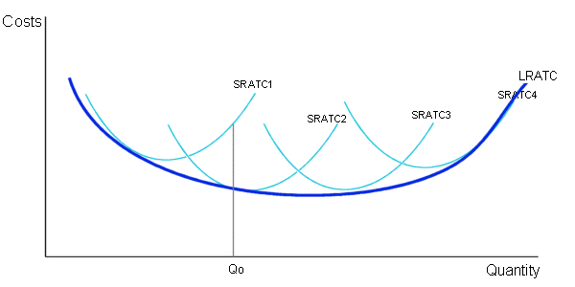

The long-run average total cost curve (LRATC) represents the lowest level of average cost that can occur in the long run at each possible level of output. It is assumed that firms producing any given level of output in the long run would always select the size of firm that has the lowest short-run average total costs at that level of output. In Figure 6, a firm would select a level of capital that places it on the short-run average total cost curve SRATC2 if it were to produce Q₀ units of output. (Notice that the costs of producing this level of output would be higher with either a smaller or a larger firm).

It is often argued that the long-run average cost curves has a shape similar to Figure 7 below. At low levels of output, it is suggested that economies of scale result in a decrease in long-run average costs as output increases. Economies of scale (οικονομίες κλίμακας) are factors that result in a reduction in LRATC as output rises. These factors include gains from specialization and division of labor, indivisibilities in capital, and similar factors. As the firm expands, it hires more workers and uses its capital in the most efficient way, decreasing the cost per unit of output. Diseconomies of scale (αρνητικές οικονομίες κλίμακας) are factors that result in higher levels of LRATC as output increase, are believed to be important at high levels of output. These factors include the increased cost of managing and coordinating a firm as the size of the firm rises, the unavailability of raw materials, laws and regulations that prevent a firm from expanding, overworked managers and employees and overuse of existing capital. Constant returns to scale occur when LRATC does not change when the firm becomes larger or smaller. It is believed that this happens over a relatively large range of output, as illustrated in Figure 7).

Figure 7 – Economies and diseconomies of scale

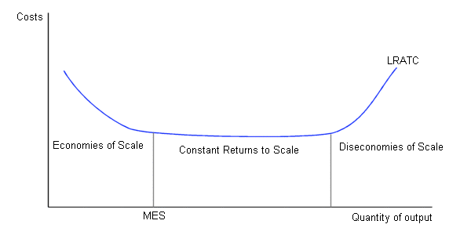

Figure 7 above also illustrates the concept of minimum efficient scale (MES). The minimum efficient scale of a firm is the lowest output level at which LRATC are minimized. The MES is important in determining the market structure for a particular output market. Competition among firms forces firms to produce at a level of output at which LRATC is minimized. If the MES is large, relative to the quantity of output demanded in a market, only a small number of firms can profitably coexist. If, for example, the MES is 10,000 and a quantity of only 20,000 units of output is demanded, at most two firms can survive in the market.
QUESTIONS

True/False

- The short run is the period of time over which only one resource is variable.
- In the long run, all resources are variable.
- If the marginal product of another worker exceeds the marginal product of the previous worker hired, the firm achieves economies of scale.
- The law of diminishing returns implies that the marginal product of an input eventually falls as more of the input is used.
- If the marginal product of labor exceeds the average product of labor, the average product of labor rises when more workers are hired.
- Total cost equals fixed cost plus variable cost.
- Total costs first fall and then, as diminishing returns begin, total costs rise as the firm increases its output.
- Total variable costs are always greater than total fixed costs.
- Marginal cost equals total cost divided by total output.
- Marginal cost is always greater than average total cost.
- The average total cost curve, like the average product of labor curve, has an upside-down U-shape.
- The ATC curve always passes through the minimum point of the MC curve.
- In the long run, all costs are variable costs and there are no fixed costs.
- No part of any short-run average total cost SRAC) curve lies below the long-run average total cost (LRAC) curve.
- Economies of scale occur when an increase in the number of workers employed increases total output.
- When the long-run average cost (LRAC) curve slopes upward, the firm is experiencing economies of scale.

Multiple choice

- The short run is a time period in which
a. one year or less passes by.
b. all inputs are variable.
c. all inputs are fixed.
d. there is at least one fixed input and the other inputs can be varied.
1
- In the long run,
a. only the amount of capital the firm uses is fixed.
b. all inputs are variable.
c. all inputs are fixed.
d. a firm experiences diseconomies of scale.

- Total product divided by the total quantity of labor equals the
a. average product of labor.
b. marginal product of labor.
c. average total cost.
d. average variable cost.
1
- Diminishing returns occurs when
a. all inputs are increased, output decreases.
b. all inputs are increased, output increases by a smaller proportion.
c. a variable input is increased, output decreases.
d. a variable unit is increased, its marginal product falls.
1
- The marginal product of labor equals the average product of labor when
a. the average product of labor is at its maximum.
b. the average product of labor is at its minimum.
c. the marginal product of labor is at its maximum.
d. None of the above answers are correct

- When the marginal product of labor curve is below the average product of labor curve,
a. the average product of labor curve has a positive slope.
b. the average product of labor curve has a negative slope.
c. the total product curve has a negative slope.
d. the firm experiences diseconomies of scale.

- ABC CATERING LTD finds that when it caters 10 meals a week, its total cost is €3,000. If, at this level of output, ABC CATERING has a total variable cost of €2,500, what is ABC CATERING’s fixed cost?
a. €250
b. €300
c. €500
d. €3,000

Table 1
Output | Total Variable Cost (TVC) | Total Cost (TC)
3 | €15 | €21
4 | 18 | 24
Use Table 1 above for the next three questions.

- The marginal cost of producing the fourth unit is
a. €6.
b. €5.
c. €3.
d. €2.
1
- The average total cost of the fourth unit is
a. €6.
b. €5.
c. €3.
d. €2.

- The average fixed cost of the third unit is
a. €6.
b. €5.
c. €3.
d. €2.

- If the company produces no output, it must pay
a. no costs.
b. a small amount of variable cost.
c. its fixed cost.
d. its owners a normal profit.

- The change in total cost from producing another unit of output equals the
a. average total cost.
b. variable cost.
c. average variable cost.
d. marginal cost.

- A farmer discovers that the total cost of growing 50 acres of potatoes is €50,000 and that the total cost of growing 51 acres of potatoes is €52,000. The marginal cost of the 51st acre of potatoes is
a. €52,000.
b. €50,000.
c. €2,000.
d. €1,000.

Use the graph below for the next three questions.

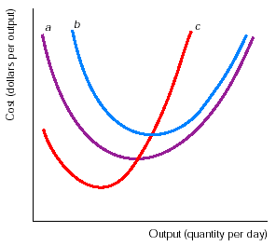

- In the graph above the MC curve is curve
a. a.
b. b.
c. c.
d. None of the curves is the MC curve.

- In the graph above the ATC curve is curve
a. a.
b. b.
c. c.
d. None of the curves is the ATC curve.

- In the graph above the AVC curve is curve
a. a.
b. b.
c. c.
d. None of the curves is the AVC curve.

- In the graph above the AFC is curve
a. a.
b. b.
c. c.
d. None of the curves is the AFC curve.

- Which curve intersects the minimum point of the average total cost (ATC) curve?
a. The marginal cost (MC ) curve
b. The average variable cost (AVC ) curve
c. The average fixed cost (AFC ) curve
d. The marginal product (MP ) curve

- If the average total cost (ATC ) curve slopes downward, then at that level of output the marginal cost (MC ) curve must be
a. sloping upward.
b. sloping downward.
c. above the ATC curve.
d. below the ATC curve.

- Over the range of output where the MP curve slopes upward, the
a. MC curve slopes downward.
b. AFC curve slopes upward.
c. firm is experiencing economies of scale.
d. total cost curve slopes downward.

- The concept of diminishing returns
a. applies to both labor and capital.
b. applies to labor but does not apply to capital.
c. applies to capital but does not apply to labor.
d. does not apply to either labor or capital.

- The LRAC curve
a. equals the minimum points on all the short-run ATC curves.
b. equals the lowest possible marginal cost of producing the different levels of
output.
c. equals the lowest attainable average total cost for all levels of output when
all inputs can be varied.
d. generally lies above the short-run ATC curves.

- The LRAC curve generally is
a. shaped as an upside-down U.
b. U-shaped.
c. upward sloping.
d. downward sloping.

- When a firm is experiencing economies of scale,
a. the MP curve slopes upward.
b. the LRAC curve slopes downward.
c. the firm experiences diminishing returns.
d. the MC curve slopes downward.

Short answers

- Where does the marginal product curve intersect the average product curve? Why?

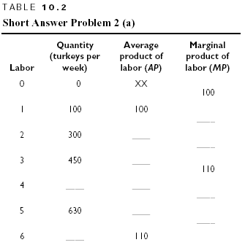
- Answer the following questions:
  - Table 10.2 gives the total weekly output of turkeys at Mike’s Turkey Farm. Complete this table. (The marginal product is entered midway between rows to emphasize that it is the result of changing inputs moving from one row to the next. Average product corresponds to a fixed quantity of labor and so is entered on the appropriate row.)
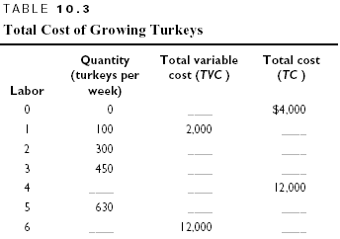
  - Label the axes and draw a graph of the total product curve (TP).
  - Label the axes and draw a graph of the marginal product (MP) and the average product (AP). (As in Table 10.2, plot the marginal products midway between the units of labor and the average products directly above the units of labor.) Where do the AP and MP curves cross?

    - Answer the following questions:
      - Now let’s examine Mike’s short-run cost of growing turkeys. The first two columns of Table 10.2 are reproduced in the first two columns of Table 10.3. The cost of 1 worker (the only variable input) is $2,000 per month. Total fixed cost is $4,000 per month. Complete Table 10.3 by using your answers from Table 10.2 and by calculating total variable cost and total cost.
      - Label the axes and draw the TC and TVC curves. What is the relationship between these two curves?
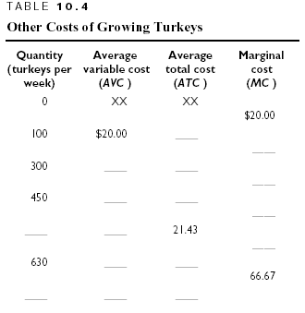
      - Table 10.4 contains spaces for some of Mike’s other costs, the average total cost (ATC), average variable cost (AVC), and marginal cost (MC). Complete this table by using your answers from Table 10.3 and calculating the new costs in Table 10.4.
      - Label the axes and draw the ATC, AVC, and MC curves. Be sure to plot the values for the MC between the relevant levels of output. What is the relationship between the ATC and AVC curves? Between the MC and AVC curves?

        - What is the difference between diminishing returns and diseconomies of scale?

        - “This chapter has a lot to say about firms: production, costs, and other things. But I don’t really see the purpose. In real life, businesses are a lot more complicated than this chapter says. Workers are different, different companies make different goods. IBM’s factory is not the same as what we see at this chapter. What is the use of this chapter?” This student is missing an essential point about economic theories. Can you help him/her?

        - “I get the idea that marginal cost is important, but I don’t know why. You have any ideas about it? ”Your friend is asking you for your ideas; you have a chance to help your friend, so explain why you think marginal cost is important.

ANSWERS

True/False

- F In the short run, at least one input is fixed.
- T The question presents the definition of the long run.
- F The firm has increasing marginal returns because only one input has been changed.
- T The question presents the definition of diminishing returns.
- T This result shows the relationship between marginal and average, which is purely mathematical.
- T Total cost is the sum of fixed cost and variable cost.
- F As output increases, total cost always rises.
- F The amount of variable cost and the amount of fixed cost are not necessarily related, except that in the long run all costs are variable costs.
- F Marginal cost equals the additional total cost divided by the additional output.
- F Marginal cost usually starts below the average total cost and then rises above it.
- F The average total cost curve has a “right-side-up” U shape.
- F The MC curve always passes through the minimum point of the ATC curve.
- T In the long run, all inputs can be varied so all costs are variable costs.
- T The long-run average cost curve shows the least possible cost to produce any level of output.
- F Economies of scale occur when an increase in all inputs increases output by a larger proportion.
- F When the LRAC curve slopes upward, average cost increases when output increases, so over this range of output the firm is experiencing diseconomies of scale.

Multiple choice

- d This is the definition of the short run.
- b The long run is the amount of time until all inputs become variable.
- a The average product of labor is total product (output) per worker.
- d Answer (d) is the definition of diminishing returns.
- a When MP >AP, the average product rises when employment increases; when MP <AP, the average product falls; and when MP = AP, the average product is at its maximum.
- b This answer reflects the average/marginal relationship that when the marginal is below the average, the average falls.
- c Total cost equals fixed cost plus variable cost, so fixed cost equals total cost minus variable cost.
- c The marginal cost equals the difference in total cost (€24 - €21 = €3) divided by the change in output (4 – 3 = 1) so the marginal cost is €3.
- a Average total cost equals total cost divided by total output, that is, €24/4 or €6.
- d Because total cost equals total fixed cost plus total variable cost, total fixed cost equals €6. Then, average fixed cost is total fixed cost divided by total output, so average fixed cost equals €6/3 = €2.
- c Fixed cost remains the same regardless of the level of output, that is, whether the firm produces a million units of output or no units of output.
- d Marginal cost shows the added cost from producing an added unit of output.
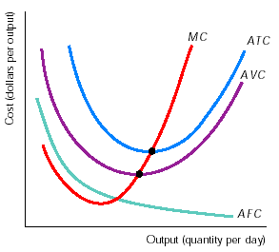
- c The marginal cost equals the change in total cost (€52,000 – €50,000, or €2,000) divided by the change in output (51 acres of potatoes – 50 acres of potatoes, or 1 acre). Therefore the marginal cost equals €2,000 per acre.
- c The graph on the right identifies the MC curve. Note that it goes through the minimum points of both the ATC and AVC curves.
- b Again, the graph on the right identifies the ATC curve.
- a The graph on the right shows that the AVC curve is the U-shaped curve that lies below the U-shaped ATC
- d None of the curves in the original figure was the AFC curve, but the graph on the right shows the AFC curve.
- a The MC curve intersects both the ATC and the AVC curves at their minimums.
- d When the marginal cost is less than the average cost, the average cost falls as output expands.
- a When the MP curve slopes upward, each additional variable input produces more additional output than the previous unit of the input. So the added cost of producing the added units falls - that is, the MC curve slopes downward - because each variable unit has the same additional cost as the previous unit, but each produces more additional output.
- a All inputs are subject to diminishing returns.
- c The long-run average cost curve, or LRAC curve, shows the lowest possible average total cost for producing any level of output.
- b The LRAC curve has a U shape: When output increases, at first the LRAC falls but as output increases still more, the LRAC rises.
- b Economies of scale means that increases in output lower the firm’s long-run average costs.

Short answers

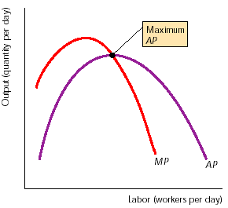
- The marginal product curve intersects the average product curve where the average product is at its maximum. To understand why, look at the graph on the right. To the left of the maximum point, MP > AP. That means that an additional worker produces more additional output than the average of the previously employed workers. As a result, the average product increases. So, as long as the MP exceeds the AP, the average product must be increasing. Now look to the right of the maximum point. Here MP < AP. Each new worker produces less additional output than the average of the previously employed workers, so the average product falls. As long as the MP is less than the AP, the average product must decrease. That means that whenever the marginal product exceeds the average product, which is the case at any point left of the intersection point, the average product increases with output; whenever the marginal product is less than the average product, which is true for any point right of the intersection point, the average product falls. So, when the marginal product equals the average product, the average product does not change. Left of this point the average product is rising and right it is falling. Therefore at this point the average product is at its maximum.

- The answers are:
  - Table 10.10 completes Table 10.2. The average product of labor column is calculated by dividing the total product by the total amount of labor; that is, AP_{L} = Quantity /Labour. So, the AP when 2 workers are employed is 300/2 or 150. The marginal product of labor is the extra output produced by an extra worker. In terms of a formula, the MP equals the change in quantity divided by the change in labor, so that MP = Δquantity/Δlabour. So, between 2 and 1 workers the MP is (300 – 100) / (2 –1) = 200. Because the MP equals the additional output when another unit of labor is employed, the quantity of output produced when 4 workers are employed equals the total quantity produced when 3 workers are employed (450) plus the additional amount the 4th worker produces, 110, or 560. Finally, for the total quantity when 6 workers are used, multiply the average product of labor, 110, by the total number of workers employed, 6, to get the total product of 660.
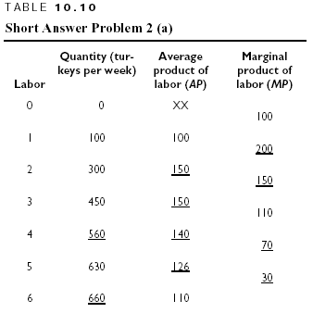
  - Figure 10.12 shows the graph of the firm’s total product curve.
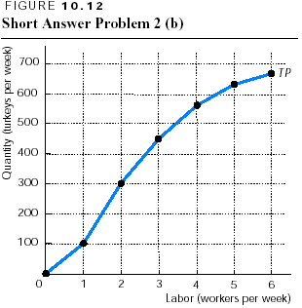
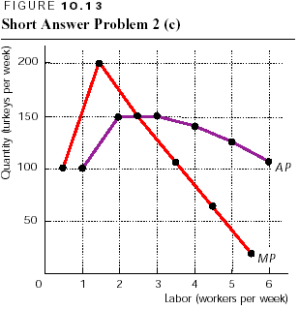
  - Figure 10.13 shows the firm’s AP and MP curves. The MP curve crosses the AP curve when the AP is at its maximum.

    - The answers are:
      - Table 10.11 shows the total cost for each quantity of labor. Total variable cost equals the number of workers (the variable input) multiplied by $2,000 per worker. Total cost then equals the total variable cost plus the total fixed cost, which is given in the problem as $4,000.
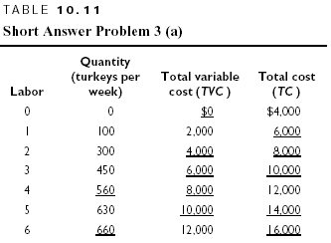
      - Figure 10.14 shows the firm’s total cost (TC) and total variable cost (TVC) curves. The TC curve always lies $4,000 above the TVC curve.
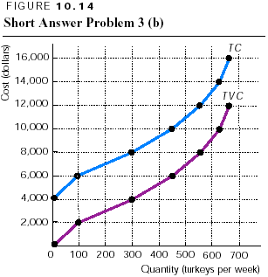
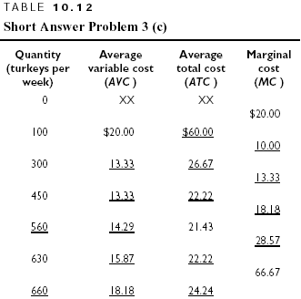
      - Table 10.12 completes Table 10.4. In Table 10.12 the average variable cost column was calculated by dividing total variable cost by the total quantity produced. So the AVC when 300 turkeys are produced is $4,000/300 = $13.33. Similarly, the average total cost column is calculated by dividing total cost by the total quantity produced. Finally, marginal cost equals the change in total cost divided by the change in quantity, that is, MC = ΔTC/ΔQ. So, the MC between 300 and 100 turkeys per week is ($8,000 - $6,000) / (300 – 100), or $10.00.
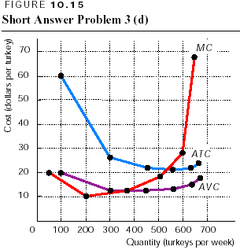
      - Figure 10.15 shows the ATC, AVC, and MC curves. The AVC curve lies below the ATC curve, but the vertical distance between the two (which equals AFC) shrinks (συρρικνώνεται) as output increases. The MC curve crosses the AVC curve where the AVC is at its minimum. (It also crosses the ATC curve where the ATC is at its minimum.)

        - The law of diminishing returns states that as a firm uses additional units of a variable input (such as labour), while holding constant the quantity of fixed inputs (such as capital), the marginal product of the variable input will eventually diminish (decrease). Diseconomies of scale occur when a firm increases all of its inputs by an equal percentage, and this increase results in a smaller percentage increase in output so that the long-run average cost rises. Diminishing (marginal) returns is a short-run concept because there is a fixed input. Diseconomies of scale is a long run concept because all inputs must be variable.

        - “We have talked about this before (Chapter 1). Economic theories are abstract on purpose; that is, they deliberately (επίτηδες) do not include all details of the real world. Instead they focus only on the most important issues. Sure, all companies employ lots of different types of labor - skilled labor, unskilled labor, managers, sales representatives, and so on. So what? Including this fact in a theory would just give us more details that do not tell us anything. “Consumers are different too. That did not stop us from developing useful theories about the factors that affect their demand curves. “The whole idea is that economic theory looks for qualities that are the same. That is what we are doing with firms. For example, all firms hire labor and use capital. And these resources are different when we think about how rapidly the firm can change the amounts that it uses. So all firms have to face the difference between fixed and variable resources. It does not really matter if we are talking about IBM or any other company. The point is that the theory we are learning can be applied to all types of firms, which gives the theory its power.”

        - Remember the discussion of marginal analysis in one of the earlier chapters? Where people looked at the effects from making small changes and then compared the additional costs from the change to the additional benefits (Chapter 5). Well, that’s what we will be using marginal cost for. When we want to know how much a firm will produce, we can ask whether it wants to increase its production. By increasing its production, the firm will have some additional costs - its marginal cost. We will then compare this cost to the added benefit from increasing production.

